**CASE STUDY 1**

**UNIFIED COMMUNICATIONS AT BOEING**

The Boeing Company (<http://www.boeing.com/>), headquartered in Chicago, Illinois, is the world’s largest manufacturer of military aircraft and commercial jetliners. Boeing has more than 159,000 employees working in 70 different countries who require effective communication to develop and build some of the world’s most complex products using components from more than 22,000 global suppliers.

The company’s workforce is one of the most highly educated in the world. Most employees hold a college degree and many hold advanced degrees. Collectively Boeing employees have very broad and deep knowledge that can be harnessed to solve problems and design next generation products.

Like many major corporations, Boeing has experienced an uptick in the number of employees who work remotely or travel the majority of each work week. Boeing’s engineers number in the thousands and are purposely scattered worldwide to support the company’s global operations.

Boeing organizes its employees into work and project teams. Given the company’s size and geographic footprint, many of Boeing work’s teams include globally dispersed members. Engineers on the same team may be separated by multiple time zones and thousands of miles. Time zone differences and distance frequently present teams with communication challenges when they are faced with time sensitive issues that must be resolved quickly.

Additional communication issues are associated with the sheer breadth and depth of Boeing’s knowledge base. When faced with questions about a particular part included in one of Boeing’s new airliners, an engineer can be challenged to identify the right person in the company to contact for answers.

# Collaboration Technologies

Boeing knows that continual innovation is important to its long term success. It also recognizes that effective communication among its employees, customers, and suppliers is an important enabler of continual innovation.

Boeing has traditionally relied on a variety of systems to facilitate collaboration among its employees and business partners. As illustrated in Figure C1-1a, Web conferencing, audio conferencing, desktop sharing, and mobile voice and data services have been used by Boeing employees to facilitate communication among geographically dispersed team members. Historically, these capabilities have been provided by different third-party providers who were selected on the basis of their ability to provide high- quality communication services at competitive rates.

By the mid-2000s, Boeing had begun its migration toward unified messaging and unified communications. At that time, instant messaging (IM) was one of the more popular messaging services used Boeing employees. At Boeing, IM has traditionally been supplemented by Web and audio conferencing services as well as by desktop sharing services. The capabilities provided by these services are especially important when answers to complex questions are needed. During the mid-2000s, more than 100,000 employees used conferencing services each year. As you might expect, conferencing services represented a significant percentage of Boeing’s annual communication expenses.

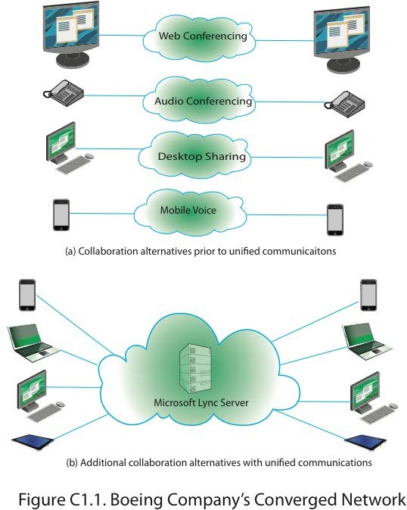

As collaboration technologies, the desktop sharing and conferencing systems worked well alone, but it was not easy to get them to use them simultaneously for a virtual team meeting. To use them in combination required scheduling conference rooms equipped with at least one phone lines

and data drop. It also required reserving conferencing time with one or both service providers, getting all locations logged in to each service, and performing some quick set up tasks and tests at the beginning of each session. Hence, while it was possible to use multiple collaboration capabilities at the same time, this was not easily or transparently done. Advanced planning was needed at all locations to have satisfactory interactive conferencing and desktop sharing sessions.

Over time, it became increasingly more apparent to Boeing that a superior collaboration platform was needed. While the company’s subscriptions to third-party services did support collaboration among geographically dispersed team members, Boeing began to feel that it needed something that was both easier and more robust to achieve the levels of collaboration, innovation and responsiveness that it aspired to have.

# Converged Network Project

In 2008, Boeing signed a $400 million contract with AT&T to consolidate its existing voice and data networks into an IP-network. Boeing began using AT&T’s WAN services, audio conferencing services, and wireless voice and data services. Moving the bulk of its communication facilities to a common IP-based network infrastructure enabled Boeing to roll out unified messaging services to more of its employees. The converged network project also set the stage for its subsequent move to unified communications.

To better serve its mobile workers, one of the first enterprise-wide applications that Boeing deployed on its converged IP network was Mircosoft’s Office Communication Server. This was implemented to provide desktop sharing, VoIP, audio conferencing, instant messaging, and presence capabilities to all of its workers worldwide. This quickly became a popular supplement or alternative to the company’s traditional collaboration services. Boeing subsequently made the decision to upgrade to Mircosoft’s Lync

Server to enable its employees to leverage enhanced presence, ad hoc collaboration, desktop sharing, and online meeting capabilities.

Boeing’s collaboration capabilities before and after the creation of the converged IP network are illustrated in Figure C1.1. It is important to note that Boeing continues to subscribe to many of the collaboration services that it used prior to implementing its unified communications solutions. Hence, UC is best observed to be a supplement not a replacement to the collaboration systems that were already in place.

One of the key changes associated with Boeing UC system has been the ability of employees to use the same softphone headset to support both office and mobile phone calls. Phone capabilities follow the mobile worker who can specify which device to route calls to on the fly. Their Boeing phone number is always the same whether they are in their office, at home, on the road, or working on the other side of the world. Detailed presence information about team members is provided via Lync’s location and activity feed capabilities. Supply chain partners are also able see the presence information of their key contacts at Boeing; this facilitates their interactions with engineering and maintenance teams at Boeing.

# UC Benefits

Boeing’s converged IP network and unified communications capabilities enable employees share information and knowledge more quickly and effectively, regardless of their location. Boeing’s geographically dispersed engineers use these systems to share expertise with one another just as they could if they were in the same place at the same time. The ability to support unified communications capabilities over the converged IP network facilitates knowledge sharing and has become an important facet of Boeing’s collaboration and knowledge management strategies.

The company’s unified communications system enables employees at remote locations to have the same capabilities that have in their home offices. Virtual teams benefit from being able to adjust their interactions to the communication mode that makes the most sense. For example, they are able to transition from instant messaging to a voice communication and/or desktop sharing session depending on what the situation requires. The UC system’s enhanced presence capabilities also provides real time information about the current availability and activities of other Boeing employees so that they can be brought into conversations about how to address time sensitive problem issues about parts, maintenance issues, or assembly line delays.

Boeing has benefitted from increased productivity and efficiency at both the individual and team levels. Its UC capabilities and converged IP network have also helped the company rein in its Web and audio conferencing costs. Prior to the UC implementation, Boeing experienced double-digit growth in costs associated with Web conferencing. Web conferencing continues to be widely used by Boeing employees, but the annual costs associated with Web conferencing have leveled off as employees increasingly use UC desktop sharing and audio conferencing capabilities instead of third-party conferencing services.

Boeing’s annual costs for audio conferencing services have decreased by more than 15% since implementing the UC system. While Boeing still subscribes to third-party audio conferencing services, these are being used less frequently for team meetings as the result of the company’s UC capabilities.

The UC system has been positively received by Boeing employees. It is widely viewed as a platform that facilitates collaboration in an engaging manner. Boeing continues to have the reputation of being one of the world’s most innovative companies and its decision to implement unified

communications on a converged IP network demonstrates its commitment to deploy technologies that enable innovation.

# Discussion Points

1. Some virtual teams at Boeing have discussions focused on military aircraft. Do some Internet research on UC security mechanisms and identify and briefly describe several that Boeing should have in place to ensure the privacy and integrity of such discussions.
2. To what extent do the UC benefits experienced by Boeing mirror those of other firms that have deployed UC capabilities over converged IP networks?
3. To date, Boeing has not implemented the full range of capabilities available through UC systems. If you were the CIO at Boeing, what additional UC capabilities would you implement? What benefits would you expect Boeing to derive from deploying these capabilities?

# Sources

**[MICR10]** Microsoft Case Studies. “Boeing Expects to Lower Costs and Improve Productivity with Messaging Solution.” March 16, 2010. Retrieved online at: [http://www.microsoft.com/casestudies/Case_Study_Detail.aspx?casestudyid](http://www.microsoft.com/casestudies/Case_Study_Detail.aspx?casestudyid=4000006703)

[=4000006703](http://www.microsoft.com/casestudies/Case_Study_Detail.aspx?casestudyid=4000006703).

**[MICR11]** Microsoft Case Studies. “Boeing Promotes Knowledge Sharing for Global Workforce with Communications Solution.” April 29, 2011. Retrieved online at: [http://www.microsoft.com/casestudies/Microsoft-Lync-Server-](http://www.microsoft.com/casestudies/Microsoft-Lync-Server-2010/Boeing/Boeing-Promotes-Knowledge-Sharing-for-Global-Workforce-with-Communications-Solution/4000009654) [2010/Boeing/Boeing-Promotes-Knowledge-Sharing-for-Global-Workforce-](http://www.microsoft.com/casestudies/Microsoft-Lync-Server-2010/Boeing/Boeing-Promotes-Knowledge-Sharing-for-Global-Workforce-with-Communications-Solution/4000009654) [with-Communications-Solution/4000009654](http://www.microsoft.com/casestudies/Microsoft-Lync-Server-2010/Boeing/Boeing-Promotes-Knowledge-Sharing-for-Global-Workforce-with-Communications-Solution/4000009654).

**[REED08]** Reed, B. “AT&T snags big Boeing voice/data contract.” *NetworkWorld*. August 12, 2008. Retrieved online at: <http://www.networkworld.com/news/2008/081208-boeing-att-contract.html>