This is the feedback for the Culture post
This is pretty limited, though the structure is right. ﻿﻿﻿﻿﻿﻿Include more and stronger sources (like Hofstede and the CIA Factbook, and using your links to get the reader there). Make your links open into a new page and increase your font size. You may add information for additional points

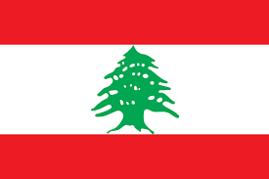
Beliefs and values
The Lebanese have their own set values and beliefs which they ensure that each and every person in the state follows to the letter. It is the beliefs and values of the state that make the Lebanese distinct and special form other people from other states.
Aesthetics
Women are allowed to wear casual dresses mainly during the daytime. The hotels and other restaurants require different guest who visits the premises to dress for dinner. Recently smoking in the country was strongly prohibited in different public places and only allowed in restricted areas.
Languages
The Lebanese mainly use Arabic as their primary language. French comes in second. The smallest language happens to be Armenian which is spoken by a relatively small percentage of people in the state
Religion
There are more than 18 regions section in Lebanon but the main ones being Islam and Christianity. Islam is the largest denomination accounting for 59.7% of the total population.
Education system
The education system of Lebanon has five different cycle splits including three phases i.e. Pre- school, basic and secondary education. The school latter ends with a Baccalaureat.
Social organization

In Lebanese society, a family gathering is something very important in there culture. The Lebanese people are mainly known for their hospitable nature. They mainly use a handshake as a normal form of greeting but a small gift is also appreciated.

____________________________________________________________________________________________________________________________________________________________

This is the feedback for the Political-LEGAL POST
Remember to include links to sources (no links or source cited) for all facts you include. Don't use APA style here (as with "Leenders, 2016"), save that for the formal papers we have in the class. The first paragraph got the font right, but after that it's too small. ﻿﻿﻿﻿﻿﻿﻿﻿﻿the first and last sections are about corruption (combine ideas). Not enough ideas covered - you needed to talk about 4+ for this assignment.

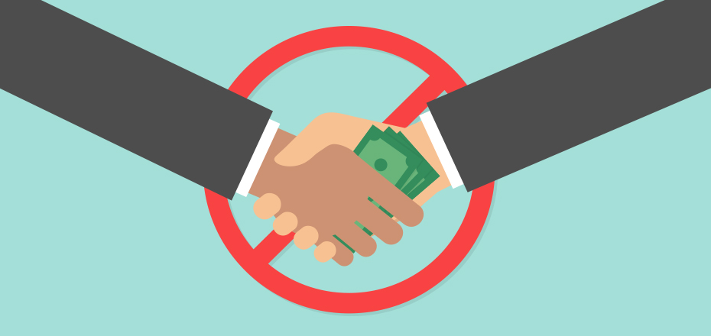
Corrupt Systems in Lebanon
Corruption has emerged as an acceptable norm in Lebanon. People have integrated it into their system and it's a normal way of life. Several factors have contributed to the corrupt state of Lebanon. After the end of the civil war to rebuild the state there emerged confessional groups, the political groups, and the unifying groups. Each of these groups had their interest which they needed to protect. All the groups eyed the state resources and their division and distribution have always been their concern. The magnitude of corruption has not only been felt by the citizens who campaigned for the existence of multiple groups to aid the equitable distribution of resources and but also by investors and foreigners (Leenders, 2016)
Ease of doing business
Business in Lebanon ought to integrate into the corrupt systems to thrive. Though it takes approximately 16 days to register a business in Lebanon one is faced with the challenge of bureaucratic delays hence necessitating for bribes to fasten the process. The acquisition of property is not transparent requiring one to offer gifts and bribes to the relevant authority to obtain licenses. Though the existence of an online system to pay taxes has eased the burden on businesses, meeting with the tax officials consist for audits requires one to part with bribes and gifts. The physical checks have made importing and exporting difficult in that the process takes a lot of time, necessitating for people to bribe to fasten the process.
The political system in Lebanon
The political system in Lebanon entails passing of power and leadership to individuals who belong to the elite class. Votes are bought in that people are given money and gifts to lure them in voting for a given individual while the election officials are bribed to alter the results in favor of a particular candidate. Lebanon can win the fight against corruption more so by empowering the judicial systems. In so doing people will be punished for their crimes and justice will thrive. Additional information with regards to corrupt systems in Lebanon can be found in this article.

______________________________________________________________________________

this is the feedback for the economic post
Some good information here, be sure your links fit the section they are placed in (Lebanon link ﻿﻿about inflation is in the "connections" section, which has no source link (all fact need a source link in blog posts). Wouldn't hurt to include more images, too.

Lebanon Economy Size
According to 2019 World Index, Lebanon is at 154thfreest economy with 51.1 freedom score. It has decreased 2.1 points according to previous record. It is at 12thnumber in the list of 14 Middle East countries as it has decreased score in trade freedom, effective justice and labor investment freedom. Population of Lebanon is around 6.06 million with $87.7 billion total GDP. Per capita of Lebanon is $19,439 while the unemployment rate is 6.6%. Inflation rate is 4.5% and FDI inflow is $2.6 billion.
Connections:
Lebanon share border with Syria in north and east while in south, it shares its boundaries with Israel. As the total population is 6.09 million, out of which 5.54 million people (91%) uses internet. 4 million people are active social media users and 4.56 million people are using mobile connections. The overall country index score is 63.22. The content and services availability is 72.72.
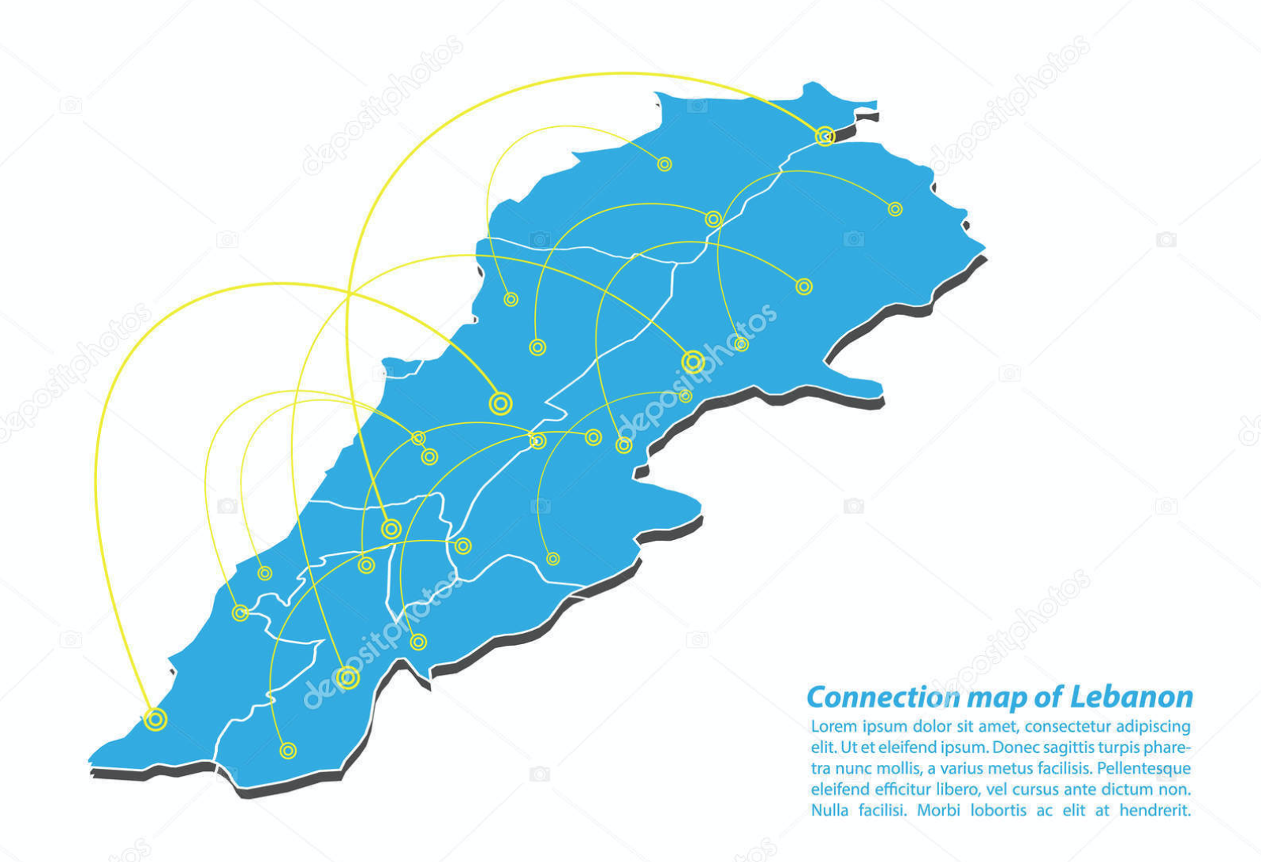
Trade:
Lebanon is basically a developing country and private sector is playing a major role in economy. The main focus of growth trade is tourism and banking. The industrial sectors of Lebanon include transport equipment, agriculture and metal products. The trading partners of Lebanon are UAE, South Africa, France, Italy, China, USA and Saudi Arabia. The exports of Lebanon are fruit, tobacco, electric power machinery and consumer goods. The exports total value is US$2,977 million and imports value of imports is US$18,703 million.
Inflation Rate:
The inflation rate of Lebanon has declined to 1.45% from1.69 in July of 2019. For health and communication, the prices have been declined. The inflation rate for education remained constant. Inflation rate of Lebanon was all time high in 2012 and lowest ever in 2015. 0.33 decrease in consumer price on monthly basis.

