Phase 2 Significant Events
Situation Awareness
Planning should consider the effect on all the phases in the 1AD ATROPIAN IRON OPORD. The division is located throughout the provinces of Hackzi, Vetlia, and Erdabli. Units located in vicinity of Imishli are in constant contact with Donovian regular forces and sustaining losses. No division maneuver units remain in Remzi. Communication is intermittent with Atropian forces in the division AO. Coordination with 4th ID is IAW graphic control measures.
The Donovian forces are attacking Imishli in force. They are effectively jamming EW assets. Donovian forces rely heavily on cellphone communications. The enemy is breaching obstacles, according to the Decision support matrix the breach of obstacles by the enemy is a critical event.
Donovian irregular forces and insurgent groups are engaging civilian populations, Atropian forces, and U.S. forces in the AO. Attacks are disrupting LOCs, and include terrorist-style attacks on population centers. The city of Imishli is a COG for insurgent organizations because of its importance to Donovia. Criminal organizations are sabotaging Atropia’s defense forces equipment and supplies.

Donovian forces attacked the historic and highly prestigious Imishli Military Garrison and Academy. Atropian forces knew the value of this target to the Donovians in their information war (Center of Gravity). The garrison’s location is northwest of the city; and not easily reached on the two lane road. The terrain is mountainous. The cadets and faculty, along with the small staff that run historic tours were completely caught off guard by the Donovian’s rapid advance. They held out for as long as they could, until they were completely decimated. The Atropian media’s constant reports of the siege and the annihilation of cadets has increased the populations’ dissatisfaction of the current situation. Atropian leaders in the division area are calling for a rapid response and retaliation to include an enemy body count.
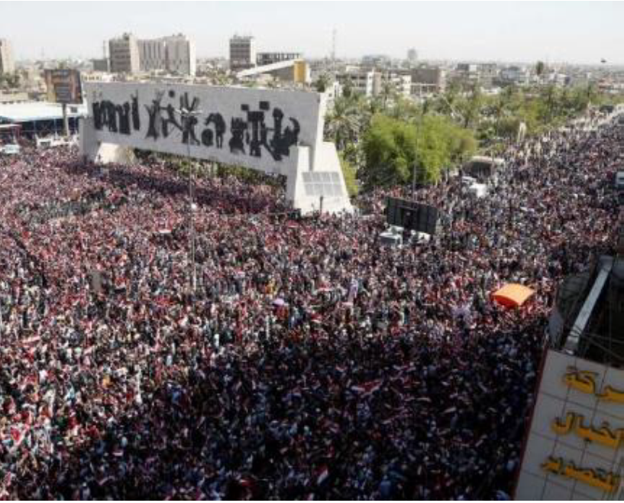
PROTESTS IN REMZI

Donovian special forces units are impersonating local police to move civilians into chokepoints.
Insurgent groups from Donovia are using the underground tunnel system under Imishli, whether in existing tunnels or by burrowing their way through the city using new high-tech drilling machines, for what they hope will turn into tunnel-on-tunnel warfare with the regime.
OSC-S is threatening to overtake Atropia, coming very close to the Southern boundaries of the Division’s AO. This threat is unifying the country bringing together various religious, cultural, and ethnic groups to defeat a common enemy.
Local police, NGOs, and MPs are distributing in the IDP camps the handbills requesting help in identifying and reporting threat jammers. Reports indicate a large number of threat jammers in the division AO.

During a courier mission, a convoy was disoriented while traveling at night from Imishli to Remzi and took longer than usual to arrive at DMAIN.
The real-time intelligence (INTEL) reporting requirements and intelligence indicators are not reaching the lowest levels to modify force protection measures and behavior. Numerous force protection/antiterrorism officers do not have the most current command intelligence requirements/threat streams or reports correlating to their area of interest/area of operation.

Donovian forces turned off nine Atropian television channels.

Atropian forces rely on, almost exclusively, their cell phones to coordinate tactical operations and do not use the communication systems the U.S. have provided. This continues to slow down the synchronizing of enablers, especially the ability to coordinate the clearance of fires, when assisting Atropian forces in contact.

Aerial observers have demonstrated limited capability to effectively observe and provide corrections to surface-to-surface delivered munitions. In several instances, the aerial observers have attempted to gain a spotting utilizing the FLIR system affixed to the aerial platform. The issue with this is that the round emits a small heat signature for a short window of time. Also, there are many heat signatures the FLIR system recognizes within the operating environment that resulted in a false spotting.
Firing units throughout the AO have experienced issues with achieving first round fire for effect. A deep dive into this issue highlighted the fact that there was a lack of tracking systems and records management. Therefore, resulting in units not meeting the five requirements for accurate fire.
Firing units within the AO do not possess the capability to send and receive fire missions beyond line of sight. This means the distance from a delivery platform to a FDC is limited to a maximum of 15km.
Donovian Units inherit ammunition from other units upon their relief in place (RIP), but tracking of this ammunition on the property books is lacking. This creates two issues. First, units have unauthorized ammunition which unnecessarily increases the Net Explosive Weight (NEW) footprint. This increases the potential damage that may result if an explosive incident occurs. Second, this ammunition isn’t being tracked for suspensions, restrictions, or shelf life. The potential that this ammunition is unserviceable or possibly hazardous to the users raises as the ammunition grows older.
CCIRS

- FP, GoB and Guardian Angel SOPs and TTPs;
- “Enemy” GoB trends and messaging techniques, and how to counter them;
- TTPs on preventing and mitigating civilian casualties;
- PPE usage TTPs by TAAC and base or outpost;
- Mood and level of trust with young Atropian Soldiers and leaders;
- Badging system and installation access TTPs and physical tools;
- Rapid equipping needs, TTPs and base defense plans and personnel needs;
- Route clearance threats, TTPs and equipment and personnel needs.

The Provincial Governor declared a state of emergency and requested 1,000 troops to assist the civilian authorities with defending Rimzi.

J3 reports a CBRN attack in the 4th ID AO.
Hundreds of refugees crossed through the engagement areas minutes before the enemy attack forces arrived. This created turmoil at critical times, affecting forward units ability to focus on the enemy’s conventional formations. The presence of civilians caused hesitation and confusion over how to avoid killing them instead of the enemy.
Initial contact with the enemy forces came almost immediately after the detonation of an improvised explosive device (IED) on the flanks of the battle positions. The distraction with the refugees almost immediately followed, causing confusion throughout the division on how to deal with civilians in the engagement area, knowing the enemy was closing rapidly. Forward units are unable to communicate effectively with the native-speaking refugees. That was the moment when radio communication became almost impossible. With only intermittent communication over the FM nets.

The enemy units were able to reach the initial obstacles relatively unimpeded and begin breaching operations relatively unhindered when the division was finally able to coordinate some sort of direct fire on the enemy. But no sooner had the division begun to make a semblance of an organized defense than enemy artillery fires rained on the forward units, taking a further toll on combat power and again disrupting communication and execution of the fight in the engagement area. The artillery came in precise
volleys, inflicting catastrophic damage. It was as if the enemy had the 10-digit grid locations for each vehicle.

Across the division emplaced obstacles were 500 meters beyond the maximum effective ranges of the long range weapon systems.

Reports of possible division friendly fire on Atropian units.

Resupply is affected throughout the division from civilian protests, IDP flooding MSRs, attacks on supply convoys.

Blue Force tracking systems are intermittent.
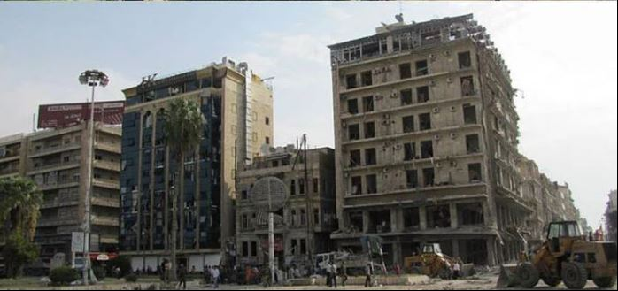

IMISHLI

