Welcome to Unit 8!
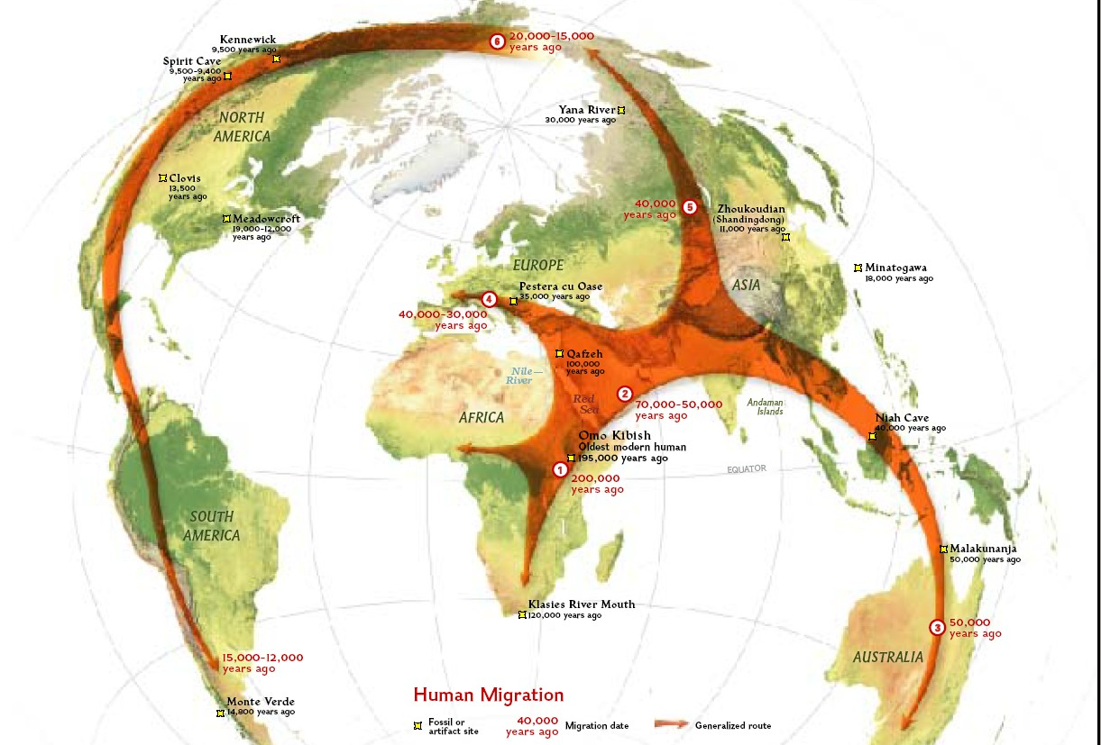
We continue with Chapter 12 in our discussion of human variation, and in this unit, we discuss human genetic diversity, and how we now can trace the ancestry and migration routes of our ancestors through the mitochondrial genome in our matrilineal or mother's line, and through the Y-chromosome genome in our patrilineal or father's line. These both provide unbroken links to our past, since the genetic sequences of both of these specific genomes are never reshuffled, and the only changes that occur in them are from point mutations, which slowly accumulate over time. The more DNA point mutations that we have in common with others tells us how closely we are related to one another, and when we shared a common ancestor. This allows us the incredible new ability to trace the most recent common ancestors of all humanity through these lines of descent, and to see when and where these common ancestors lived and how they migrated.
One common misconception in looking at genetic ancestry is that it somehow tells us about our "race" or identity. As we learned last week, "race" is not a true biological category, because there is more genetic variation within races than there is between them. In addition, though the mitochondrial and Y-chromosome DNA give us an exact lineage of our matrilineal and patrilineal ancestors, these are just a small fraction of our overall genome that we have inherited from MANY other ancestors, who we can not track in this precise way.
Other genetic tests can now allow us to get an estimate of the origins of the rest of our nuclear DNA (the majority of our 46 chromosomes), but this is also problematic, since it can only give us percentages of possibility that we have ancestors from populations in certain regions or continents, and this is based on reference populations of those who have been tested, which are continuously updated and revised.
Because people of European descent make up a greater proportion of those who have had their DNA tested, the results are often skewed to these populations, while populations in other parts of the world are under-represented. However, many people who have African descent now have much more access to knowing which specific regions in Africa that their ancestors are likely to have come from. It is important to recognize that genetic tests can not tell us about the languages and cultures of our ancestors, since DNA can only tell us approximate regions and does not equate with language and culture. However, these new genetic ancestry tests are allowing many people to learn about previously unknown ancestors, since many people of African descent have been robbed of knowing about their ancestry due to the legacy of human slavery.
In this unit, we will also be exploring that legacy of slavery, and how the concept of race was used to justify and rationalize slavery, colonization, and genocide. Following Darwin's proposals in the 19th Century, the Social Darwinists like Herbert Spencer misinterpreted and twisted the theory of natural selection to support their pseudo-scientific ideas about the racial "superiority" of Europeans that further attempted to justify institutional racism. This led to the dangerous ideas of Eugenics and Biological Determinism, which took hold in the early 20th Century, particularly in the United States—and especially here in California, which many Californians do not realize and are never taught—something we need to consider here. Why is it that we are not usually taught about this history?
Ultimately, the pseudo-science of "Race Hygiene" led to the horrors of Nazi Germany and the Holocaust, with the extermination and genocide of over 6 Million Jews, along with 11 Million others, including Poles, Russians, Ukrainians, Serbs, Roma, the physically and mentally disabled, Jehovas Witnesses, gay men, and Political Prisoners, all of whom were labeled as "inferior" and "unfit" and therefore enemies of the German state. We have all learned about the Holocaust—though there are still those that attempt to deny it ever even happened, despite all of the historical facts and records attesting to the horrors of what took place. But many Americans remain largely unaware of the ways in which Eugenics was used against people in our own country to prevent inter-racial marriage, and in the forced sterilization of those who some decided were "unfit" to procreate. Many of these racist ideas of biological determinism persist in some peoples' minds and worldviews, and this is especially damaging when it affects public policy, as it still does with the under-funding of urban public schools, and in the prison system.
In this unit, and in Project 2, we will be exploring some of these issues in an effort to help fill in the gaps of what we may not have learned in the past. This is ever more relevant today as it ever has been, since if we truly learn about the tragedies and misconceptions of the past, including those of our own nation, then we have a better chance of bringing these to our awareness and not repeating them again. There are those who think we should not explore the history of racism in our country, as if it somehow diminishes the greatness of our nation. But I think it is crucial to teach the next generation about this history, or else we remain ignorant about it, and how racism continues to persist and affect so many people today.
It is very easy to get humans to hate others who look differently or speak differently from themselves, and to blame others for their problems—both real and imagined— and this is a familiar tactic that has been repeatedly used by tyrants and political leaders who seek to gain power by dividing and distracting people and playing on our fears and prejudices. How is it that we are still so easily manipulated into believing in the damaging and dangerous ideas about race? I hope that we may all take the time to learn about these things as we help one another overcome racism in our time.

Unit-Level Outcomes
By the end of this unit you will be able to:
- Understand the problems with genetic testing for ancestry and race/ethnicity.
- Recognize the rich diversity of human phenotypes
- Understand how we trace mitochondrial and Y-chromosome DNA.
- Explain the genetic molecular clock.
- Explain what we mean by "Mitochondrial Eve" and "Y-Chromosome Adam".
- Describe the general history of race and racism.
- Understand the origins of the Eugenics movement in the US, and the pseudoscienece of "Race Hygiene."
- Explain the history of Eugenics in Nazi Germany that led to the Holocaust.
- Describe the Tuskegee Experiments and their supposed aims.
- Explain the problematic conclusions of "The Bell Curve" and their inaccurate correlation of IQ tests with class and race, and how the pseudoscience of race is still used to remove funding from inner city schools.
Must watch both lectures
https://www.youtube.com/watch?v=xbS00gH7OUw (Lecture part one)
https://www.youtube.com/watch?v=_9VlWlBDtYo (Lecture part two)

Lecture quiz (Highlight correct answers)
Some are highlighted, leave those alone
- The Genetic Molecular Clock allows us to:
determine our race.
determine the timing of genetic replications.
determine how long our lifespan will be.
estimate how long ago specific mutations arose.

- By testing the Y-chromosome genome in millions of men, we can see that we all share our most recent male common ancestor _______________________________________.
6 million years ago in Chad
190,000 years ago from East Africa
65,000 years ago in Africa
275,000 years ago in Africa

- Race is not a true biological reality because:
There is more genetic variation within "races" than there is between them.
We all come from a recent common ancestor.
We are all genetically the same.
Race has been used to assert that some people are inferior to others.

- Where was Eugenics widely practiced before being implemented in Nazi Germany?
California
Russia
China
Brazil
- If someone from Finland moves to Hawai'i and their skin begins to tan and darken, this is known as ______________________________.
adaptations
natural selection
acclimatization
biological determinism
- The forced sterilization of some people, and the promotion of procreation among others is known as ________________________________.
Holocaust
Eugenics
Adaptation
Population Control

- A local sheriff believes that the people of a town in his district who have high arrest and conviction rates are born thieves because of their genetic constitution. Which of the following would best describe this sheriff's attitudes:
ethnocentrism
relativism
biological determinism
xenophobia
- In the Tuskegee Experiments, 400 Black men were used as human guinea pigs over a 40 year "study" and deliberately lied to by the Public Health Service, and they were allowed to degenerate from a fully treatable condition cased by ____________________________.
Polio
AIDS
syphillis
Sickle Cell Anemia
- The 1927 Supreme Court case of Buck vs. Bell upheld the ___________________________________.
California Hysteria Laws
Virginia Eugenics Sterilization Law
ban on same sex marriage
Inter-racial marriage

- In the 1994 book "The Bell Curve", psychologists Richard Herrnstein and Charles Murray conclude that one's socioeconomic status is directly related to I.Q., and that intelligence is therefore determined by_____________________________.
social class
access to education
race
language

