Name #1 ______________________________ UBIT #1 _____________________________
Name #2 ______________________________ UBIT #2 _____________________________
Name #3 ______________________________ UBIT #3 _____________________________
Name #4 ______________________________ UBIT #4 _____________________________

MGE 302 Assignment #4
Due Thursday, May 5 @ 8:00 AM (US) and 8:00 PM (Singapore)

- Assignments may be completed individually or in groups of up to 4 people. Only one person from your group needs to upload the completed assignment to UBLearns.

- You may print the assignment and handwrite your work and then scan the completed assignment for submission, or you may type your answers. Please upload a .pdf (or Word .doc) version of your completed assignment to UBLearns.

- Please upload ONE file only, containing all your work. Please preview your homework file and make sure that the scan quality is good enough that it can be easily read. 5 Points will be deducted from the Assignment grade for submissions that are not submitted as one file or are not legible.

- The Tampa Tribune and the St. Petersburg Times compete for readers in the Tampa Bay market for newspapers. Recently, both newspapers considered changing the prices they charge for their Sunday editions. Suppose they considered the following payoff table for making a simultaneous decision to charge either a low price of $0.50 or a high price of $1.00.

St. Petersburg Times
Low Price High Price
Low  Tampa Tribune  High | $45,000 , $30,000 | $35,000 , $20,000
Low  Tampa Tribune  High | $40,000 , $45,000 | $50,000 , $40,000

- Does St. Petersburg Times have a dominant strategy? If so, what is it?

- Does Tampa Tribune have a dominant strategy? If so, what is it?

- Does St. Petersburg Times have a dominated strategy? If so, what is it?

- Does Tampa Tribune have a dominated strategy? If so, what is it?

- What is the Nash (strategically stable) equiblibrium?

Now, suppose the newspaper pricing decision is made sequentially. Using the payoff table on the previous page, complete the two sequential game trees below. In the first game, let St Petersburg Times move first and in the second game, let Tampa Tribune move first. Solve both games using the roll-back method and clearly mark the solution path on the game tree.

- Which of the newspapers (or neither or both) has a first-mover advantage? Which has a second-mover advantage?

- Can you predict which newspaper is likely to go first in this sequential decision? Explain.
- Although there is relatively little difference in the cost of producing hardcover and paperbook books, these books sell for very different prices. Explain this pricing behavior.

- The following payoff matrix shows the profit outcomes for three projects, A, B, and C, for each of two possible product prices. There is a 60% probability the price will be $10 and a 40% probability the price will be $20.
 | Profit
Project | P = $10 | P = $20
A | 20 | 80
B | 40 | 60
C | −26 | 140

Using the maximum expected value rule a decision maker would choose
a. A.
b. B.
c. C.
d. impossible to tell from the information

Using coefficient of variation rule a decision maker would choose
a. A.
b. B.
c. C.
d. can't use this rule under these circumstances

- The Financial Herald, a weekly newspaper specializing in corporate financial news, is purchased by both businesspeople and students. A research firm has estimated the two linear demand and marginal revenue functions shown in the graph below. MR_{B} is the marginal revenue estimated for business readers and MR_{S} is the marginal revenue estimated for students. The production department at the newspaper estimates a linear marginal cost function for the newspaper production, which is also shown in the graph. All quantities are in units of 1,000 per week.
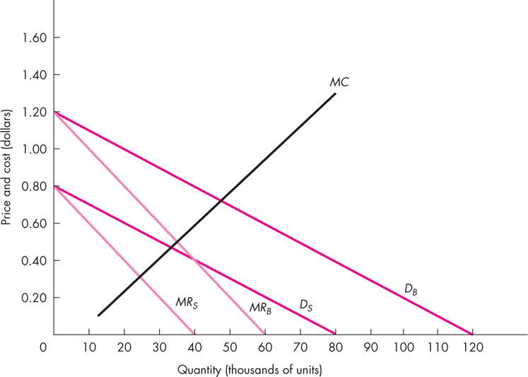

- On the graph above, construct and draw the total marginal revenue curve.

- How many total copies should the Financial Herald print each week?

- How many copies should be sold to business readers? How many copies should be sold to students?

- What price should business readers be charged? What price should students be charged?

- A firm is considering the decision of investing in new plants. The following is the profit payoff matrix under three conditions: it does not expand, it builds two new plants, or it builds one new plant. Three possible states of nature can exist--no change in the economy, the economy contracts and the economy grows. The firm has no idea of the probability of each state.

 | State of Economy
 | expands | contracts | unchanged
no new plants  1 new plant  2 new plants | $20 million  $30 million  $40 million | −$ 3 million  −$ 6 million  −$12 million | $4 million  $6 million  $8 million

Which option would the firm choose under each of the following rules?
a. Maximax rule _________________________________________________

b. Maximin rule __________________________________________________

c. Minimax regret rule _________________________________________________

d. Equal probability rule _________________________________________________

