Instructions: Enter all answers directly in this worksheet. When finished select Save As, and save this document using your last name and student ID as the file name. Upload the data sheet to Blackboard as a .doc, .docx or .rtf file when you are finished.

Question 1: (10 points). (Net present value calculation) Dowling Sportswear is considering building a new factory to produce aluminum baseball bats. This project would require an initial cash outlay of $4,000,000 and would generate annual net cash inflows of $900,000 per year for 7 years. Calculate the project's NPV using a discount rate of 5 percent. (Round to the nearest dollar.)

a. If the discount rate is 5 percent, then the project's NPV is: | $

Question 2: (30 points). (Net present value calculation) Big Steve's, makers of swizzle sticks, is considering the purchase of a new plastic stamping machine. This investment requires an initial outlay of $90,000 and will generate net cash inflows of $19,000 per year for 11 years. To answer Choose an item questions, click on the orange text and use the pull down menu to select the best answer.

a. What is the project's NPV using a discount rate of 7 percent? (Round to the nearest dollar.)

If the discount rate is 7 percent, then the project's NPV is: | $

Should the project be accepted?

The project Choose an item. accepted because the NPV is Choose an item. and therefore Choose an item. value to the firm.

b. What is the project's NPV using a discount rate of 16 percent?

If the discount rate is 16 percent, then the project's NPV is: | $

Should the project be accepted?

The project Choose an item. accepted because the NPV is Choose an item. and therefore Choose an item. value to the firm.

If the project's required discount rate is 16%, then the project Choose an item. accepted because the IRR is Choose an item. Than the required discount rate.

c. What is this project's internal rate of return? (Round to two decimal places.)

This project's internal rate of return is: | %

Should the project be accepted? Why or why not?

If the project's required discount rate is 7%, then the project Choose an item. accepted because the IRR is Choose an item. the required discount rate.

If the project's required discount rate is 16%, then the project Choose an item. accepted because the IRR is Choose an item. the required discount rate.

Question 3: (15 points). (Related to Checkpoint 11.2) (Equivalent annual cost calculation) Barry Boswell is a financial analyst for Dossman Metal Works, Inc. and he is analyzing two alternative configurations for the firm's new plasma cutter shop. The two alternatives that are denoted A and B below perform the same task and although they each cost to purchase and install they offer very different cash flows. Alternative A has a useful life of 7 years whereas Alternative B will only last for 3 years. The after-tax cash flows from the two projects are as follows:

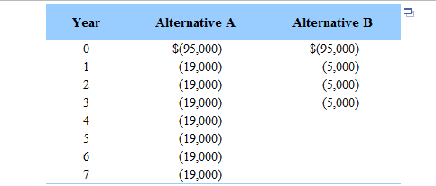

a. Calculate each project's equivalent annual cost (EAC) given a discount rate of 10 percent. (Round to the nearest cent.)

a. Alternative A's equivalent annual cost (EAC) at a discount rate of 10% is: | $
b. Alternative B's equivalent annual cost (EAC) at a discount rate of 10% is | $

b. Which of the alternatives do you think Barry should select? Why? (Select the best choice below.)

- This cannot be determined from the information provided.
- Alternative B should be selected because its equivalent annual cost is less per year than the annual equivalent cost for Alternative A.
- Alternative A should be selected because its equivalent annual cost is less per year than the annual equivalent cost for Alternative B.
- Alternative A should be selected because it has the highest NPV.
Answer:

Question 4: (10 points). (IRR calculation) What is the internal rate of return for the following project: An initial outlay of $9,000 resulting in a single cash inflow of $15,424 in 7 years. (Round to the nearest whole percent.)

a. The internal rate of return for the project is: | %

Question 5: (10 points). (IRR calculation) Jella Cosmetics is considering a project that costs $750,000 and is expected to last for 9 years and produce future cash flows of $180,000 per year. If the appropriate discount rate for this project is 17 percent, what is the project's IRR? (Round to two decimal places.)

a. The project's IRR is: | %

Question 6: (10 points) (IRR, payback, and calculating a missing cash flow) Mode Publishing is considering a new printing facility that will involve a large initial outlay and then result in a series of positive cash flows for four years. The estimated cash flows associated with this project are:

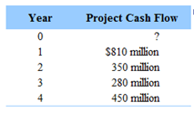
If you know that the project has a regular payback of 2.9 years, what is the project's internal rate of return?

a. The IRR of the project is: | %

Question 7: (15 points) (Mutually exclusive projects and NPV) You have been assigned the task of evaluating two mutually exclusive projects with the following projected cash flows:

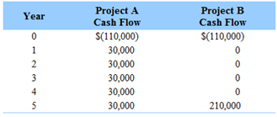
If the appropriate discount rate on these projects is 11 percent, which would be chosen and why? (Round to the nearest cent.)

a. The NPV of Project A is: | $
b. The NPV of Project B is: | $

Which project would be chosen and why? (Select the best choice below.)

- Cannor choose without comparing their IRRs.
- Choose A because its NPV is higher.
- Choose both because they both have positive NPVs.
- Choose B because its NPV is higher.
Answer:

