PART 1.
The next part of your marketing plan will be to identify and define the market segments you will target. You are required to identify and describe three segments for your product.
For the Segmentation component of the Marketing Plan, identify and define the market segments you will target. You are required to identify and describe THREE segments for your product.
The analysis should include:
1. A name for each segment (required). For example, if I were segmenting older consumers for a pet product, I might have "Empty Nesters" and "Little Old Lady Cat Lovers."
2. A narrative description of each of the segments. This is typically a paragraph and explains at a high level the characteristics of the segment (see example).
3. How you are segmenting the groups, including the characteristics of your target segments. Be VERY specific and use no less than THREE demographic and THREE psychographic variables for each of your segments. You may also need geographic variables. You may use BULLETS for this part of the assignment.
4. A summary chart.
5. At your option, you may include other charts and graphs however they are not required

PART 2.
The next part of your marketing plan is the Integrated Marketing Communications (IMC).
Marketing Plan: Integrated Marketing Communications (IMC) Guidelines and Rubric
This is the culmination of the Marketing Plan. Detail the advertising and promotional activities that will be used to promote the product or service.
This is a set of PowerPoint slides.
Develop 4-5 IMC action items. You may use any of the mediums or techniques found in the examples provided, those found in the text, or those that you create yourself. The sky is the limit, but pay particular attention to the following restrictions:
1. The medium must be available in your geographic market. This is rarely a problem.
2. It must fit your budget. You are a start-up, so think carefully about your budget. You may spend reasonably, but no prime time TV or Super Bowl. If you want to know what something costs, search the Web. The answers will not be perfect, but will give you a guideline.
3. Each of your action items must be a different medium.
4. NONE of your action items may be a brochure, flyer, or similar printed materials. You may use such printed materials ONLY in conjunction with another action item. The printed collateral is supporting the action item, NOT the action item itself. For example, you may produce a brochure to be used in a direct mail campaign and show an example of that brochure in your project. The direct mail campaign is the action item, not the brochure (it is supporting the direct mail campaign). Remember, printed materials are NOT marketing; it is what you do with those items that make it marketing.
Below is a partial list of potential promotional action items. There are many more, limited only by your imagination.
• TV commercial
• Radio commercial
• Magazine ads
• Newspaper ads
• Trade shows
• Local business association networking
• Direct mail
• Billboards
• Internet ads
• Web sites
• Email campaigns
• Outdoor advertising
• Events
• Movie theatre ads
• Car wraps

http://sohammweblog.blogspot.com/2014_08_01_archive.html
https://www.academia.edu/8310341/CHAPTER_17_Designing_and_Managing_Integrated_Marketing_Communications

The first is the chart below which explains your action item. The use of this chart is mandatory.

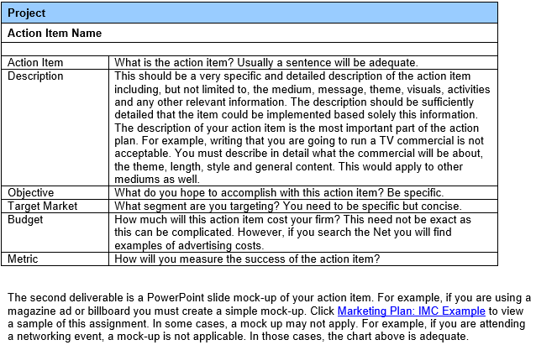
Project
Action Item Name
Action Item
Description
Objective
Target Market
Budget
Metric

