Using the following exercises, come to the exploration meeting ready to explain how to do each of the tasks in each situation:
Exercise 1: Proof
A busy, two-lane split highway crosses another busy split highway. Because of the complexity of this intersection, the traffic lights’ pattern causes substantial delays. A traffic engineer needs precise intersection measurements in order to design the new traffic flow down to each inch and second.
Given:
Prove: is parallel to
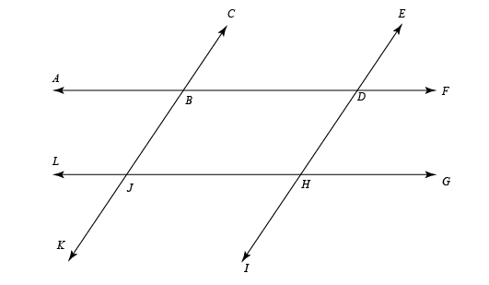
Exercise 2: Precision
In construction, the precision used to build a structure directly influences the strength of the structure. In the Rocky Mountains, many houses’ roofs are built using trusses, which are strong enough to support the heavy load from snow, but light enough to build in a stockyard and transport to the construction site. Chris works in the stockyard and has been told he needs to build a series of trusses for a new house using the pattern below. He has also been told the pattern may be inaccurate, so he needs to check and make sure the following features are all parallel and adjust the pattern before starting:
, , and
must all be parallel to each other, and
, , and
must also be parallel.
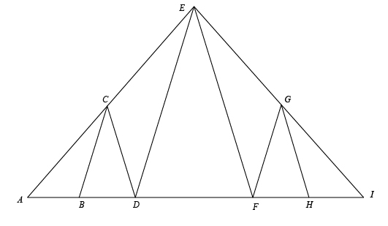
Come to the exploration meeting prepared to discuss the following:
1) What method(s) can Chris use to make sure the segments in the pattern are all parallel and ensure that his new trusses are built precisely and strongly?
2) What method(s) can Chris’s boss use to verify the precision of the trusses Chris builds?
3) If you lived in a mountain area with a lot of snow, how much leeway would you feel comfortable giving your home’s builders as they design and build your trusses? Why?
4) Identify any alternate interior angles, corresponding angles, and/or alternate exterior angles.
Exercise 3: Railroads
Railroad tracks’ rails must be a precise distance from each other. If the distance between the rails is too narrow or too wide, the train will derail. Come prepared to discuss the following questions:
1) If you traveled back to 1865 when railroads were being built all across the American frontier, what strategies could you teach the railroad workers about parallelism so they could always build tracks the right width apart?
2) Do you think it would be practical to use principles of parallelism for building railroads during that time period? Why or why not?
3) What other methods could be used to ensure parallel rails (any method, not just the geometry kinds)?

