- Determine which of the following points lies on the graph of the equation:
(0,7)
(0,6)
(0,5)
(6,5)
(1,5)
5 points

QUESTION 2
- Complete the table. Use the resulting solution points to sketch the graph of the equation.
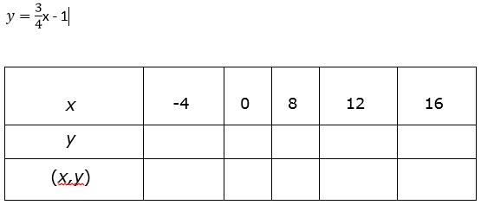
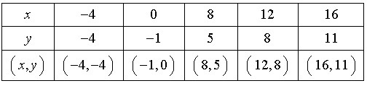
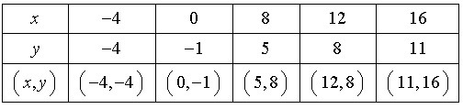
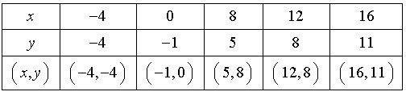
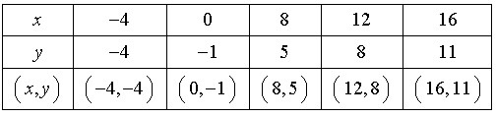
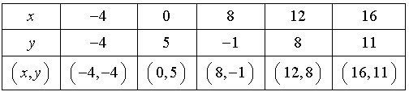
5 points

QUESTION 3
- Graphically estimate the x- and y- intercepts of the graph:
y = x³ - 9x
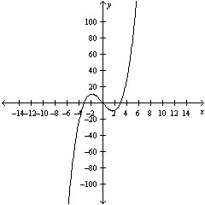
x-intercept: (±3,0),(0,0)
y-intercept: (0,0)
x-intercept: (3,0),(0,0)
y-intercept: (0,0)
x-intercept: (-3,0),(0,0)
y-intercept: (0,0)
x-intercept: (0,±3),(0,0)
y-intercept: (0,0)
x-intercept (0,3),(0,0)
y-intercept (0,0)
5 points

QUESTION 4
- Find the x- and y-intercepts of the graph of the equation
y=49-7x
x-intercept: (7,0)
y-intercept: (0,-7)
x-intercept: (49,0)
y-intercept: (0,7)
x-intercept: (-7,0)
y-intercept: (0,-49)
x-intercept: (49,0)
y-intercept: (0,49)
x-intercept: (7,0)
y-intercept: (0,49)
5 points

QUESTION 5
- Determine whether the value of x=7 is a solution of the equation:
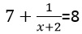
no
yes
5 points

QUESTION 6
- Solve the equation 8-5x=6
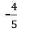
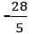
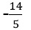
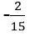
5 points

QUESTION 7
- Solve the equation and check your solution.
-2-4x=30
9
-11
-8
7
-10
5 points

QUESTION 8
- Solve the equation and check your solution.
5y + 1 = 6y - 5 + 8y
²/₃
³/₂
⁶/₅
⁵/₆
-²/₃
5 points

QUESTION 9
- Solve the equation and check your solution.
67x - 24 = 3x + 8(8x-3)
3
67
-3
-67
All real numbers
5 points

QUESTION 10
- Solve the equation and check your solution.
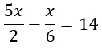
10
6
7
9
8
5 points

QUESTION 11
- Solve the equation and check your solution. (If not possible, explain why.)
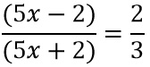
2
5
6
4
10
5 points

QUESTION 12
- Solve the equation and check your solution. (If not possible, explain why)
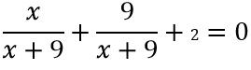
-18
7
11
No solution. The variable is divided out.
20
5 points

QUESTION 13
- Write the quadratic equation in general form.
4x² = 8 - 9x
4x² + 9x + 8 = 0
4x² + 9x = -8
4x² - 9x - 8 = 0
-4x² + 9x - 8 = 0
4x² + 9x - 8 = 0
5 points

QUESTION 14
- Solve the quadratic equation by factoring.
x² - 6x + 5 = 0
-1, 5
-1,-5
1,-5
1,5
6,5
5 points

QUESTION 15
- Solve the quadratic equation by factoring.
x₂ + 8x + 16 = 0
4
-¹/₄
-4
±4
¹/₄
5 points

QUESTION 16
- Solve the equation by extracting square roots.
(x+6)² = 5
6 + √5
-6 ± √5
-6 -√5
6 ± √5
-6 + √5
5 points

QUESTION 17
- Use the Quadratic Formula to solve
x² + 20x + 98 = 0
x = -8, x = -12
x = -√2 - 10, x = √2 - 10
x = -√3 - 10, x = √3 - 10
x = 10, x = -10
x = -√2 - 9, x = √2 - 9
5 points

QUESTION 18
- Write the complex number in standard form.
√ -9
3i
-3i
9i
4i
-9i
5 points

QUESTION 19
- Find real numbers a and b such that the equation is true.
a + bi = 14 + 2i
a=16, b=4
a=18, b=6
a=14, b=2
a=15, b=14
a=17, b=5
5 points

QUESTION 20
- Find all solutions to the following equation.
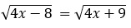
x = -¹⁷/₄
x=9
no solution
x=-17
x=-8

