A GUIDE TO HOW TO WRITE EFFECTIVE RESEARCH PROJECT/ THESIS/ DISSERTATION DISCUSSED

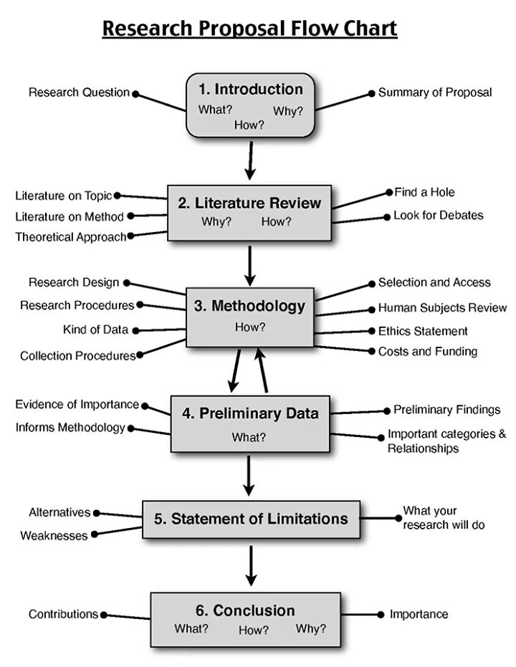
Thesis: A Thesis is the written product of a systematic study of a significant problem. It clearly identifies the problem; states the major assumptions; explains the significance of the undertaking; sets forth the sources for, and methods of gathering information; analyzes the data; and offers a conclusion or recommendation. The product must evidence originality, critical and independent thinking, appropriate organization and format, clarity of purpose, and accurate and thorough documentation (CSUS 2004-2006 Catalog)
Project. A Project is a significant undertaking appropriate to the fine and applied arts or to professional fields. It must evidence originality and independent thinking, appropriate form and organization, and a rationale. It must be described and summarized in a written abstract that includes the project’s significance, objectives, methodology, and a conclusion or recommendation (most recent CSUS Catalog)
Dissertation: A dissertation is a major research project normally required for use for a doctoral degree. It is expected to make new and creative contributions to the field of study or demonstrate one’s excellence in the field
Content of the Thesis/Research project/ Dissertation
Preliminaries
Chapter One: Introduction of the Study
Chapter Two: Literature Review
Chapter Three: Research Methodology
Chapter Four: Analysis and Discussion
Chapter Five: Conclusion
Chapter Six: Recommendations

The following section, which describes the components of the thesis/project, also demonstrates APA format
Preliminaries:

Title of the study

This is the summary of your research project/Thesis in a sentence: For example “Rate of Adoption of e-banking among the microfinances in a certain State or Country”

Dedication

Majorly who inspired you in the research for example, “I dedicate this project/Thesis to my beloved wife or Children”
- Declaration
Usually divided into the student/Researcher declaration and also your supervisors declaration
- Acknowledgement
This is to thank all those who inspired or helped you in one way way or the other to complete your research.
- Table of content
Usually the highlights of all your sub-topics throughout the research work in a table format.
- List of tables
Usually all the tables that are contained in your research work, then you present here in summary
- List of figures
Usually all the graphs, charts, figures etc that are contained in your research work, then you present here in summary

- Definition of terms

This is where you define major keywords that you use in your research for example in a title like “Rate of Adoption of e-banking among the microfinances in a certain State or Country”, you define Adoption, Microfinances, e-banking etc
- List of abbreviations and acronyms
This is where you list all the possible acronyms used in the research work for example: SPSS: Statistical Package for the Social Scientists.

Abstract

It is an executive summary with the following checklist:
Motivation: If the problem isn't obviously "interesting" it might be better to put motivation first; but if your work is incremental progress on a problem that is widely recognized as important, then it is probably better to put the problem statement first to indicate which piece of the larger problem you are breaking off to work on.
Problem statement: What problem are you trying to solve? What is the scope of your work (a generalized approach, or for a specific situation)?
Approach: Simply the research methodology: Research design, target population, sample size, data analysis techniques
Results: What's the answer?
Conclusions: What are the implications of your answer? Is it going to change the world (unlikely). Are your results general, potentially generalizable, or specific to a particular case?

CHAPTER ONE- INTRODUCTION
  - Background to the study
This section now introduces your topic in details but you tend to be more specific to the problem. This section has two purposes:
(a) To begin to be more specific about the problem; and,
(b) To convince the reader that what you are studying is truly a problem.
Use evidence and logical arguments to assemble materials to document that what you are studying is in fact a problem: where did it come from; how long has it been with us; how big is it; how extensive it is; what are the costs of not resolving the problem, etc.
  - Statement of the Problem
In this area the researcher is to State what aspect of the general problem s/he is going to be dealing with in the research project.
  - Research Objectives
Usually divided into two:
- General purpose or the objectives
- The specific purposes or objectives
The purpose is to do something to directly resolve the research problem identified in the previous section. It gives what you are trying to solve in the research. For example in the topic “Rate of Adoption of e-banking among the microfinances in a certain State or Country”, the research objectives can be:
- To evaluate the e-Banking adoption environment within the microfinances in the Country
- To investigate the determinants of the slow rate of adoption of e-Banking against technological, organizational and environmental factors among microfinances in the Country
  - Research Questions
These are the questions the research is trying to answer and Is usually in line with the research objectives. For example in the topic “Rate of Adoption of e-banking among the microfinances in a certain State or Country”, the research objectives can be:
- How is the adoption of e-Banking environment affected within the microfinances in the Country?
- How does a technological, organizational and environmental factor impact the adoption of e-Banking among microfinances in the Country?
1.5 Research Hypotheses/ Assumptions of the study
These are the premises upon which the researcher bases the logical arguments implicit and/or explicit in the research effort.
Research Hypotheses
For example in the topic “Rate of Adoption of e-banking among the microfinances in a certain State or Country”, the research objectives can be:
H₀: There is a significant relationship between e-Banking adoption on the perceived innovation characteristics (relative advantage, compatibility, complexity, Confidentiality, Trialability, and Observability)
Assumptions of the study
Usually in line with the objectives for example in the topic “Rate of Adoption of e-banking among the microfinances in a certain State or Country”, with the research objectives:
- To evaluate the e-Banking adoption environment within the microfinances in the Country
- To investigate the determinants of the slow rate of adoption of e-Banking against technological, organizational and environmental factors among microfinances in the Country
Then the assumptions is then:
- There is a slow rate of e-Banking adoption environment within the microfinances in the Country
- There are determinants for the slow rate of adoption of e-Banking against technological, organizational and environmental factors among microfinances in the Country
  - Significance of the study
States how your research project will benefit your profession, for example, how the outcomes of this research study can be used to accomplish the aims of the profession.

1.7 Scope of the Study
A scope of study is a very important component of research, since it explains why certain data is excluded from the research.

CHAPTER TWO- LITERATURE REVIEW
2.1 Empirical literature
2.2 Theoretical literature
2.3 Conceptual framework
CHAPTER THREE- RESEARCH METHODOLOGY

3.1 Research design
This is the design employed: It can be
- Comparative research design: an example is the comparison of performance among the private and public university.
- Experimental design: majorly used in designing of habits such as “creating a toilet habit among the slum dwellers”
- Correlation design: to explore the relationship between variables.
- Descriptive design: Explores why something happened. Commonly used
3.2 Area of the study
The area you are to collect the data or area of study
3.3 Study population
Your target population are your specific people or instruments
3.4 Sampling techniques
How you will select the sample. Can either be:
- Simple Random sampling
- Stratified sampling
- Cluster sampling
- Multi stage sampling
- Systematic sampling

3.5 Sample size
This is the size of the sample you draw from the population of interest. There are formulas to help in this:
Sample size will be obtained using the following formula, Yamane (1973) and the appropriate sample size based on below formula. Where N is the total population, n being the sample size to be drawn from the total population and Ҽ is the acceptable the sampling error rate during sampling and approximated to be 5% or 0.05
n= N
1 +N (Ҽ) ²
3.6 Research instruments
These are what you are going to use to collect your data:

ASSESMENT METHOLOGY APPROACH
 | METHODOLOGY
Quantitative data | - Questionnaires  - Interviews
Qualitative data | - Focus group discussions (FGD)  - Key Informant surveys

3.7 Data collection procedure
This includes
3.7.1 Pilot test
In order to establish the reliability of the questionnaire a pilot study will be carried out on a sample of selected using purposive sampling
3.7.2 Validity and reliability
Reliability is the degree of consistency with which a tool measures a variable. Construct validity testifies how well the results obtained from the use of the measure fit the theories around which the test is designed.
3.8 Data analysis and presentation
These are the statistical aspects you will use in your report as
  - Descriptive statistics
  - Inferential Statistics
3.9 Data management and ethical considerations
There are a number of ethical considerations to be kept in mind during the research process.
- Confidentiality
- Anonymity of respondents.
- Participation in the study will be entirely voluntary

CHAPTER 4-RESULTS AND ANALYSIS
4.1 Demographic/ Background information
4.2 Research objectives findings
4.3 Discussions
CHAPTER 5- CONCLUSION
5.1 Conclusion from the data results in chapter four
CHAPTER 6: RECOMMENDATIONS
6.1 The recommendations from the study
REFERENCES.

APPENDICES
Appendix 1: questionnaire
Appendix 2: proposed work plan of the study

Citations
http://www.csus.edu/gradstudies/currentstudents/thesis-project-dissertation/index.html
https://users.ece.cmu.edu/~koopman/essays/abstract.html
http://www.csus.edu/coe/academics/graduate/handbooks/assets/eds-master-thesis-project-guideline.pdf

