**Touch Point Report 4**

**Centennial College Parking Lot Striping and Signaling Update**

Group 9

Vasireddy, Narasimha Rao

Gajula, Sravya Keerthana

Igwe, Chinazam

Perera, Muhandiramge Chanuka

Rojas Ramirez, Jose

Centennial College

Project Scheduling Management PMGT 734 - 006

Farhad Moayeri

July 12, 2023.

**Meeting Minute**

|  |  |
| --- | --- |
| **Project name** | **Meeting date** |
| Parking Lot Striping and Signaling Update | 06/22/23 |
| **Meeting place** | **Duration** |
| Microsoft Teams | 15 min (19:00-19:15) |
| **Meeting Purpose** | |
| Weekly follow up meeting | |

**In attendance**

|  |  |  |
| --- | --- | --- |
| Sravya Keerthana (SK) | Igwe, Chinazam (CI) | Perera, Muhandiramge (MP) |
| Rojas Ramirez, Jose (JR) | Vasireddy, Narasimha (NV) |  |

**Agenda**

|  |  |
| --- | --- |
| **Discussed item** | **Owner** |
| Distribution of task to prepare Touch Point Report 4 | ALL |
| Commented on the importance of including the applied changes in the next Touch Point Report | JR |
|  |  |

**Takeaways**

|  |  |
| --- | --- |
| **Action item** | **Owner** |
| Risk Register and Quality Management Plan | JR |
| Requirements List & Requirements Traceability Matrix | SK |
| WBS & WBS dictionary | CI |
| Procurement Management Plan | NV |
| Stakeholder Management Plan | MP |

**Meeting Minute**

|  |  |
| --- | --- |
| **Project name** | **Meeting date** |
| Parking Lot Striping and Signaling Update | 07/06/23 |
| **Meeting place** | **Duration** |
| Microsoft Teams | 30 min (19:00-19:30) |
| **Meeting Purpose** | |
| Touch Point 4 report preparation & feedback discussion | |

**In attendance**

|  |  |  |
| --- | --- | --- |
| Sravya Keerthana (SK) | Igwe, Chinazam (CI) | Perera, Muhandiramge (MP) |
| Rojas Ramirez, Jose (JR) | Vasireddy, Narasimha (NV) |  |

**Agenda**

|  |  |
| --- | --- |
| **Discussed item** | **Owner** |
| The importance of use the appropriate template for each subsidiary plan was reinforced | JR |
| The submission date for the TP Report 4 was extended until 07/12 | JR |
| The professor requested to use MS Project for the TP Report 4 | JR |

**Takeaways**

|  |  |
| --- | --- |
| **Action item** | **Owner** |
| Define task, resources and dependencies using MS Project | JR |
| Update all the remaining subsidiary plans missing no later than Tuesday 07/11 | ALL |
| Include the applied changes and lessons learned for the TP Report 4 | JR |
| Submit the TP Report before the due date and make questions to the others team lead of the week | JR |

1. **Applied Changes and Lessons Learned**

**Touch Point Report 1:**

1. Include meeting minutes. The meeting minutes were included since the weekly update discussion post for week 3.

1. Develop a comparative analysis. The comparative analysis between the 3 different options was presented in the weekly update post for week 3. Here we compared the potential problems of each option (red color). Then the possible solutions for those identified problems (green color). After that, in blue color, we identified the group of people that would be benefiting from the improvement of that condition. Then, the potential cost impact and complexity of implementing each improvement. In conclusion, we selected the Parking Lot since it is the option with less complexity and less cost. It is also the option that would benefit the greatest number of people in the College.

1. How did we select the problem to be solved? For a better understanding of the situation, we used an Ishikawa Diagram (Fishbone Diagram). Here we have previously identified the high risk of a car accident as possible consequence. So, we used the fishbone diagram to help us identify the possible causes that could lead to a car accident in the parking lot of the College. We reviewed the possible causes: environment (winter season), the method (lack of information, the people (hurry in rush hours and lack of caution). Finally, in the infrastructure we identified the Lack of Proper Striping as the most relevant factor that could lead to a car accident. The Ishikawa Diagram was presented in the weekly update discussion post for week 3.

**Touch Point Report 2:**

1. What type of analysis have you done to identify the problem? We used comparative analysis and Ishikawa Diagram. However, both were presented in the weekly update discussion rather than in the Touch Point Report 2.
2. What tools did you use? We used SWAO analysis. Unfortunately, it was also presented in the weekly update post instead of the Touch Point Report 2.

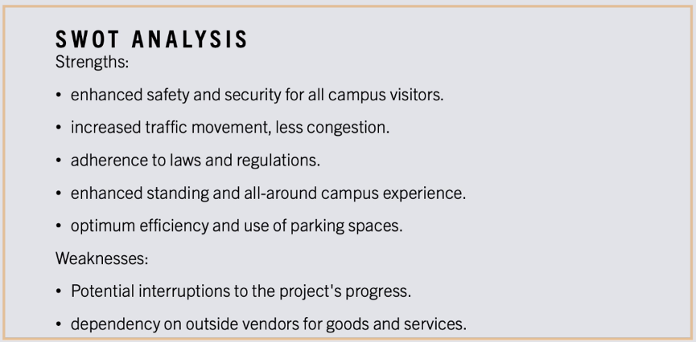

**Touch Point Report 3:**

1. Business Objectives Vs Project Objectives: The business objectives should be determined before the project objectives. In fact, the first moment you mention the business objectives is in the business case. In our case the business objectives are to guarantee a safe environment, compliance with traffic regulations and avoid sanctions fees or even lawsuits. The project objectives are closely related to the deliverables.
2. Project Management Methodology: We are using the waterfall methodology since the scope and time are quite clear for this project.
3. Main stakeholders: The project team must be considered as a stakeholder.
4. **Requirements**



1. **Requirements Traceability Matrix**



1. 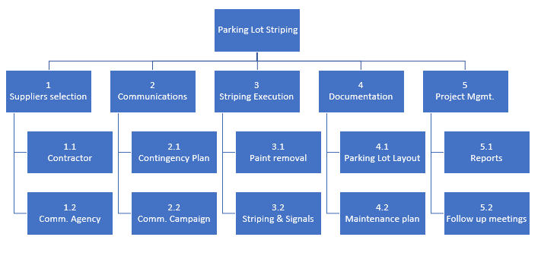**WBS**
2. **Checklist**
3. **L-Shape**

