PROJECT CHARTER for centennial college progress campus parking lot striping and signaling

GROUP: 08

Vasireddy, Narasimha Rao

Gajula, Sravya Keerthana

Igwe, Chinazam

Perera, Muhandiramge Chanuka

Rojas Ramirez, Jose

Meeting Minute

Project name | Meeting date
Parking Lot Striping and Signaling Update | 06/15/23
Meeting place | Duration
Microsoft Teams | 15 min (19:00-19:15)
Meeting Purpose
Touch Point 3 report preparation & feedback discussion

In attendance
Gajula, Sravya Keerthana (SG) | Perera, Muhandiramge (MP) | Rojas Ramirez, Jose (JR)

Agenda
Discussed item | Owner
The importance of including meeting minutes in the TP3 report | JR
It was explained how to reach the 3 answers target | JR
Project Scope agreement | ALL
Deliverables and Acceptance Criteria | ALL
Constrains and Risks discussion | ALL

Takeaways
Action item | Owner
Stakeholders’ analysis (stakeholders’ matrix) | SG
Share meeting minute | JR
Touch Point 3 report and video submission | MP

Project Charter

Project Name | Centennial College Progress Campus Parking Lot Striping and Signaling Update
Project Sponsor | Farhad Moayeri
Project Manager | Sravya Keerthana Gajula
Project Team | Chinazam Igwe  Muhandiramge Chanuka Perera  Jose Rojas Ramirez  Natasha Rao Vasireddy
Stakeholders | City of Toronto – Transportation Services  Centennial College Board members  Centennial College Student Association  Contractor workers  Suppliers  Corporate Safety  Environment, Health, and Safety Department  Facilities Operations Department
Project Scope | To carry out the project, it is necessary to have a clear understanding of the traffic regulations applicable to parking lots in the City of Toronto. For this, the services of an expert consultant will be hired. This same contractor will be responsible for executing the paint removal works, new crosswalks and new signs. In addition, a robust communication strategy will be implemented not only to inform the benefits and potential changes in the flow of pedestrians and vehicles, but also to communicate the execution phases of the project and how this could affect the parking lot users. Moreover, is required a technical report that includes the parking lot new layout, the chemical composition of the paint used, the volume of paint used and a maintenance plan that suggests the frequency with which it should be painted to maintain the standard.
Deliverables | - New parking lot striping proposal  - Previous striping paint removal  - Communication strategy  - Maintenance plan and painting suggested frequency
Acceptance Criteria | - Parking lot markings correctly pained in-accordance to the correct dimensions.  - Traffic flow arrows correctly painted in-order to the traffic flow and entrance/exit ways.  - Disability/ Priority parking markings painted on the correct locations.  - Crosswalks correctly painted on the suitable location.  - All the documentation works finishes.
Scope Exclusions | - Repairing the curbs damaged on the parking lot.  - Replace or repair the lights/ guards/ railings of the car park.
Constrains | - Project should be completed within CAD 20,000  - Project should be completed within allocated two weeks.  - Car- park should operate partially when the project goes on.
Assumptions | - The weather condition of the project period will be suitable for the project.  - Surface area should be appropriate in condition to paint.  - All the government permits will be gain on time.  - All the resources including exact paint should be readily available to purchase.
Risks | - Unpredictable weather can delay the project.  - Day to day traffic can affect and hold the project in the daytime.  - Unpredictable time spending to surface preparation.  - Health and safe hazard for people involving the project.  - Undetermined surface to paint during the project.  - Quality defects after work completion.
We agree that this is a viable project, and we will support it
Project Sponsor | Farhad Moayeri | Date: 06/18/2023
Project Manager | Sravya Keerthana Gajula | Date:06/18/2023

Identifying Stakeholders

- City of Toronto – Transportation Services
- Centennial College Board members
- Centennial College Student Association
- Contractor workers
- Suppliers
- Corporate Safety
- Environment, Health, and Safety Department
- Facilities Operations Department

Analyzing Stakeholders

Power
High
Interest
Low
Low
High
High
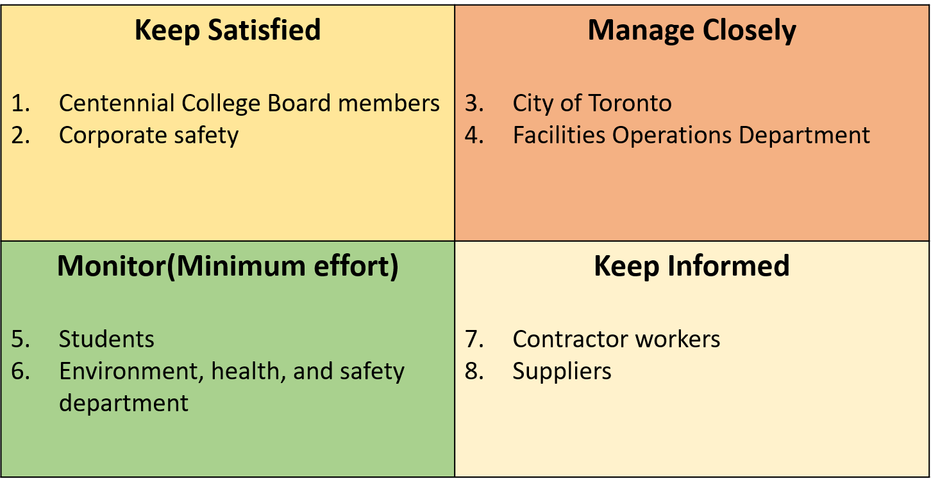
Stakeholders

