Touch Point Report 4
Centennial College Parking Lot Striping and Signaling Update

Group 9
Vasireddy, Narasimha Rao
Gajula, Sravya Keerthana
Igwe, Chinazam
Perera, Muhandiramge Chanuka
Rojas Ramirez, Jose

Centennial College
Project Scheduling Management PMGT 734 - 006
Farhad Moayeri
July 12, 2023.
Meeting Minute
Project name | Meeting date
Parking Lot Striping and Signaling Update | 06/22/23
Meeting place | Duration
Microsoft Teams | 15 min (19:00-19:15)
Meeting Purpose
Weekly follow up meeting

In attendance
Sravya Keerthana (SK) | Igwe, Chinazam (CI) | Perera, Muhandiramge (MP)
Rojas Ramirez, Jose (JR) | Vasireddy, Narasimha (NV)

Agenda
Discussed item | Owner
Distribution of task to prepare Touch Point Report 4 | ALL
Commented on the importance of including the applied changes in the next Touch Point Report | JR

Takeaways
Action item | Owner
Risk Register and Quality Management Plan | JR
Requirements List & Requirements Traceability Matrix | SK
WBS & WBS dictionary | CI
Procurement Management Plan | NV
Stakeholder Management Plan | MP

Meeting Minute
Project name | Meeting date
Parking Lot Striping and Signaling Update | 07/06/23
Meeting place | Duration
Microsoft Teams | 30 min (19:00-19:30)
Meeting Purpose
Touch Point 4 report preparation & feedback discussion

In attendance
Sravya Keerthana (SK) | Igwe, Chinazam (CI) | Perera, Muhandiramge (MP)
Rojas Ramirez, Jose (JR) | Vasireddy, Narasimha (NV)

Agenda
Discussed item | Owner
The importance of use the appropriate template for each subsidiary plan was reinforced | JR
The submission date for the TP Report 4 was extended until 07/12 | JR
The professor requested to use MS Project for the TP Report 4 | JR

Takeaways
Action item | Owner
Define task, resources and dependencies using MS Project | JR
Update all the remaining subsidiary plans missing no later than Tuesday 07/11 | ALL
Include the applied changes and lessons learned for the TP Report 4 | JR
Submit the TP Report before the due date and make questions to the others team lead of the week | JR

- Applied Changes and Lessons Learned
Touch Point Report 1:
- Include meeting minutes. The meeting minutes were included since the weekly update discussion post for week 3.
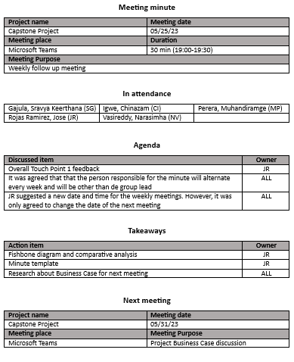

- Develop a comparative analysis. The comparative analysis between the 3 different options was presented in the weekly update post for week 3. Here we compared the potential problems of each option (red color). Then the possible solutions for those identified problems (green color). After that, in blue color, we identified the group of people that would be benefiting from the improvement of that condition. Then, the potential cost impact and complexity of implementing each improvement. In conclusion, we selected the Parking Lot since it is the option with less complexity and less cost. It is also the option that would benefit the greatest number of people in the College.

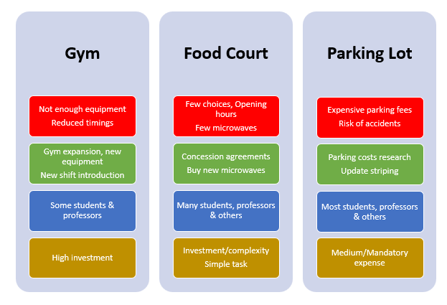

- How did we select the problem to be solved? For a better understanding of the situation, we used an Ishikawa Diagram (Fishbone Diagram). Here we have previously identified the high risk of a car accident as possible consequence. So, we used the fishbone diagram to help us identify the possible causes that could lead to a car accident in the parking lot of the College. We reviewed the possible causes: environment (winter season), the method (lack of information, the people (hurry in rush hours and lack of caution). Finally, in the infrastructure we identified the Lack of Proper Striping as the most relevant factor that could lead to a car accident. The Ishikawa Diagram was presented in the weekly update discussion post for week 3.

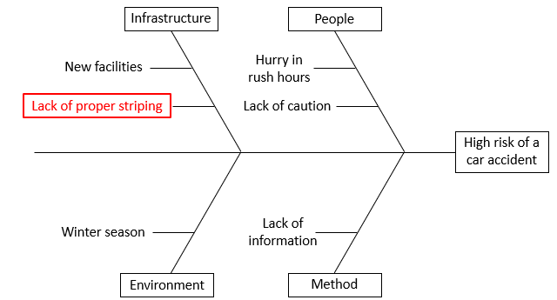

Touch Point Report 2:
- What type of analysis have you done to identify the problem? We used comparative analysis and Ishikawa Diagram. However, both were presented in the weekly update discussion rather than in the Touch Point Report 2.
- What tools did you use? We used SWAO analysis. Unfortunately, it was also presented in the weekly update post instead of the Touch Point Report 2.
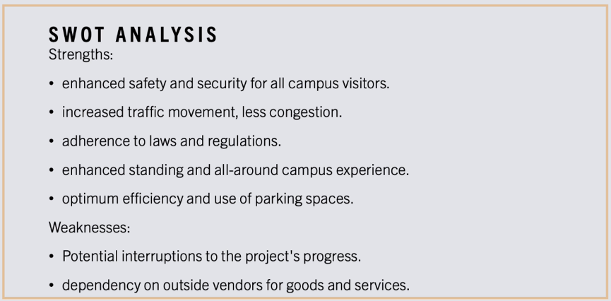

Touch Point Report 3:
- Business Objectives Vs Project Objectives: The business objectives should be determined before the project objectives. In fact, the first moment you mention the business objectives is in the business case. In our case the business objectives are to guarantee a safe environment, compliance with traffic regulations and avoid sanctions fees or even lawsuits. The project objectives are closely related to the deliverables.
- Project Management Methodology: We are using the waterfall methodology since the scope and time are quite clear for this project.
- Main stakeholders: The project team must be considered as a stakeholder.

- Requirements

- Requirements Traceability Matrix

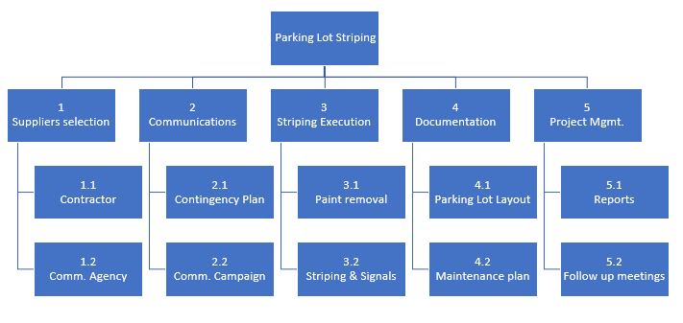
- WBS

- Checklist

- L-Shape

