1.5.3 Test (TS): Humans and the Environment

The figure below shows the age distribution of the human population of an island nation in the South Pacific
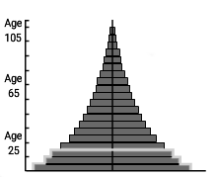
- According to the figure, is this population more likely to grow or shrink in the next 10 years? Explain your answer.

a. According to the figure, is this population more likely to grow or shrink in the next 10 years? Explain your answer. (2 points)

b. What are three things that are likely to happen if the population exceeds the resources on the island? (3 points)

2. A large city is located on the shore of an ocean. The city is powered by coal that is burned in a large electrical plant. The city gets rid of wastes, including sewage, by dumping them into the ocean.
a. How could the city be negatively affecting local and global communities? (2 points)

b. What changes could the city make in order to obtain power while causing fewer negative impacts? (2 points)

c. What changes could the city make in order to get rid of wastes while causing fewer negative impacts? (2 points)

3. Humans need clean air, freshwater, food, and shelter to survive.
a. How could one person living alone in the wilderness obtain food without help from anyone else? (2 points)

b. How could many people living in a community obtain food? (2 points)

c. How could living in a community increase the survival rate of individuals when it comes to obtaining food resources? (1 point)

4. A pioneer community was established on a prairie, next to a large river.
a. What are two natural resources that would have been available to the community in this area? (2 points)

b. What natural resource was not likely to have been available? (1 point)

c. Describe how the community most likely developed over 50 years in this area. (2 points)

5. Fossil fuels are nonrenewable energy resources that are rich in carbon. Examples of fossil fuels include oil, natural gas, and coal.
a. How are oil and natural gas resources extracted? (2 points)

b. Why are fossil fuels considered unsustainable? (1 point)

c. How can energy-efficient water heaters and furnaces reduce the use of fossil fuels? (2 points)

6. A city in the desert has an entertainment district full of theaters, shops, and restaurants.
a. What biological resource from outside the city was used to build the entertainment district, and where did this resource come from? (2 points)

b. What biological resources from outside the city are used every day in restaurants within the district, and where do these resources come from? (2 points)

7. A desert area has a large river flowing through it. A city develops near this river.
a. What three resources could the river provide to humans in the area? (3 points)

b. How would the infrastructure that is built to use the energy resource provided by the river also increase the availability of the other resources? (2 points)

8. Miners can extract coal at Earth's surface or underground.
a. Which type of coal mining is likely to be more dangerous to workers? Explain. (2 points)

b. Which type of coal mining is likely to cause more environmental damage to land and water? Explain. (3 points)

9. Energy can be derived from fossil fuels and alternative natural sources.
a. What are two advantages of using nuclear fission as an energy resource instead of coal? (2 points)

b. What are two disadvantages of using wind power as an energy resource instead of oil? (2 points)

c. Which alternative energy resource is likely to be most reliable in a desert? (1 point)

10. A developer wants to build a neighborhood of eight single-family homes in an area that is currently forested. The developer puts together two possible plans to be studied by a city council. These plans are represented by the pictures below.

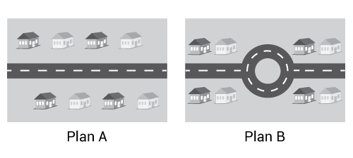

a. In plan A, houses would be evenly spaced within the development. How is this plan likely to affect the remaining forest ecosystem in the development? (2 points)

b. In plan B, houses would be clumped closer together in two smaller areas, and a forest area would remain in the middle of the development. How is this plan likely to affect the remaining forest ecosystem in the development? (2 points)

c. If you were on the city council, which plan would you approve as being more environmentally friendly? Explain your answer.

