Part 1: Linear Equation: Straight line
Question 1 Determine if intersection point coordinate exists between theses 3 linear equations and make graph demonstrating this intersection: 1 Mark
- 2x=4y-1/2
- 2/3x-7/2y=-1/2
- 2y=x-6
INSTRUCTION: This Question is about solving equations of the three lines that having 2 unknowns (x, y). You can use one of the following methods:
- elimination
- substitution
- comparison
Example: To solve these
- 2x=4y-1/2 Equation (1)
- 2/3x-7/2y=-1/2 Equation (2)
- 2y=x-6 Equation (3)

Consider only the 2 equation (1) and (2): you add (or subtract) the first two equations, you will find that (x), do similar things for the second and third equation (eliminate y), finally solve equation 1 and 2 as system of tow equations.
GRAPH:
INSTRUCTION:
To graph, there are many online function graphers available on net.
You can use this link to graph:
https://www.desmos.com/calculator/mtzswssz7w
Question 2: Microsoft and Dell are 2 competitive companies. Knowing that Microsoft hardware selling has been increased from: $55.9 billion in 2013 to $64.4 billion in 2015, however Dell hardware selling has been increased only from: $35.2 billion in 2013 to $44.4 billion in 2015. Find out the intersection point for Microsoft and Dell hardware in 2017. 1 Mark
INSTRUCTION: To answer this question, you need to:
- determine first Slope-intercept equation for Microsoft
- determine first Slope-intercept equation for Dell
- predict Microsoft hardware selling in 2017 (write as equation)
- predict Dell hardware selling in 2017 (write as equation)
- Find out the intersection point for equation Microsoft and equation Dell hardware in 2017.

Part 1: Quadratic equation: Parabola

Question 1:
In how many points do theses quadratic equations: y=3x²+2x-9 and y=2x²+4 intersect?
INSTRUCTION: where two parabolas cross is called their points of intersection. these points have (x, y) coordinates, and at the points of intersection both parabolas share the same (x, y) coordinates, which mean the 2 quadratic equations are equals, so :
3x²+2x-9 =2x²+4
This will be one quadratic equation:
You can use the discriminant to determine the number of points of intersection of 2 quadratic function:
Example: to solve this quadratic equation: y=ax²+bx+c, you use:  Quadratic Formula:  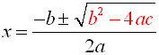 | Discriminant of Quadratic Formula:  Is:  ∆=

There are 3 Possible solutions:
Case 1: If: , There are two real roots (x1, x2).
In this case, there will be tow intersection points A (x1, y1) and B (x2, y2) between 2 quadratic equations. Example: 2 parabolas intersect at two points:
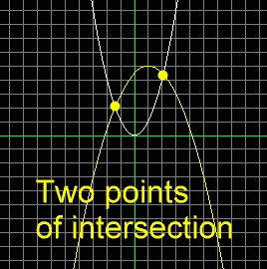
Case 2: If:, There is one real root (x1).
In this case, there will be only one intersection points A (x1, y1) between 2 quadratic equations. Example: 2 parabolas intersect at one points:
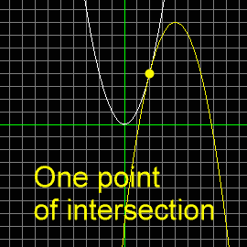
Case 3: If There is no real root.
In this case, there will be no intersection points between 2 quadratic equations. Example: 2 parabolas do not intersect at any points:

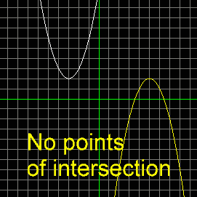
Question 2:
Determines if intersection point coordinate exists between theses 3 equations draw the graph 1 Mark
You can apply the same previous process in Question.
- -Linear equation: 1/3x-3/2y=-1/2 ( equation 1)
- -Quadratic equation: y=x²+4x+6 ( equation 2)
- Quadratic equation: 2y =x²+5 ( equation 3)
INSTRUCTION:
Consider 2 quadratic equations (2) and (3).
y=x2+4x+6 and 2y =x2+5 are equals, so it will become as new one quadratic equation (equation 4).
Now, you need to find intersection point between this new one quadratic equation (equation 4) and Linear equation: 1/3x-3/2y=-1/2.
Intersection of Quadratic equation and linear equation will have occurred at 2 intersection points, because Quadratic equation is solved as 2 solutions
When Straight line and parabola intersect at Point (x, y) means that:
1/3x-3/2y=-1/2 and new one quadratic equation (equation 4) are equal at this point A (x, y), which mean:
1/3x-3/2y=-1/2 = new one quadratic equation (equation 4)
Now continue the process to find out the result.

