Complete BOTH parts of this assignment.
Part A: Write a 500-1000 word paper using Word discussing two of the additional DBA responsibilities mentioned briefly at the end of Chapter 6 under the “Additional DBA Responsibilities” heading. Use at least two sources outside your text for this paper. Do not use Wikipedia. Use APA format for the paper, and be sure to cite all your sources using APA format. Submit your Word document for grading.
Part B: In Microsoft Access, create and populate the following three database tables, including foreign keys, using SQL. Save all queries in the database. Assume the ID for each table is the primary key. Assume all fields are required. Assume all fields that contain only numbers are numeric type. Save the database as Personnel.accdb. Once the tables have been created, encrypt the database with a password. Be sure the password is strong. It should be at least 16 characters in length, and contain at least one of each of the following: upper-case letters, lower-case letters, numbers, and special characters. Submit the Personnel.accdb file. Submit the password in the comments section of the assignment submission area.
Employees
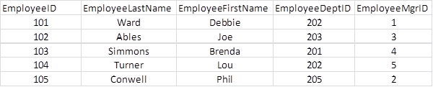
Managers
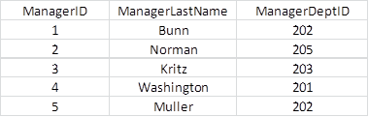
Departments
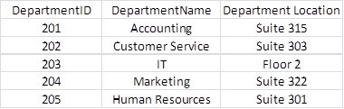
You will have two files submitted for this assignment: the Word document for your paper in Part A, and the Microsoft Access database file (Personnel.accdb) from Part B.

