Grantham University
14 November 2016

List the characteristics that a table must have to be considered a relation.

The tables of a relational database have some important characteristics
There is no sensible essentialness to the request of the segments or lines. Be that as it may, the segment arrange affects a couple of exceptional questions. In like manner, the line arrange affects the request in which a few questions give back the column, and can influence the execution of inquiries. In the event that you think about the request of the columns, then the question ought to indicate the request in which the lines are to be returned. On the off chance that a specific request is exceptionally basic and every single other request are phenomenal, it might be best to keep the lines in that specific request.
Each row contains either no value (a NULL column) or contains one and only one value for each column
Each value for a given column is of the same type
Simple characteristics
rows= records
columns=attributes of the entity
cells=hold values
each column has a unique name
order of columns/ row unimportant

List two synonyms for “file,” two for “record,” and two for “field.
synonyms for “file
table
relation
synonyms for “record
tuple
row
synonyms for “field
attribute
column
What are the four uses of a primary key?
These are the uses of primary key:
To identify a row
To represent the row in foreign keys
To organize storage for the relation
As a basis for indexes and other structures to facilitate searching in storage

What are the desirable characteristics of a primary key?

The primary key has some important characteristics

Stable: does not change after some time

Minimal: least properties fundamental

Fact less: no hidden information

Definitive: value always exists

Accessible: accessible when information made

Unique: definitely no copies
What is a surrogate key and when do you use them?

A surrogate key is a one of a kind, numeric identifier that is affixed to a connection to serve as the essential key.
Surrogate key is a one of a kind recognizable proof key, it resembles a manufactured or option key to creation key, bz the generation key might be alphanumeric or composite key yet the surrogate key is constantly single numeric key
While making a dimension table in an information distribution center, we for the most part make the tables with a framework produced key to interestingly distinguish a column in the measurement. This key is otherwise called a surrogate key. The surrogate key is utilized as the essential key as a part of the measurement table.
The surrogate key will likewise be set in the reality table and a remote key will be characterized between the two tables. When you at last join the information it will join pretty much as some other join inside the database.
What is a foreign key?

A foreign key is a segment or gathering of sections in a relational database table that gives a connection between information in two tables. It goes about as a cross-reference between tables since it references the essential key of another table, along these lines building up a connection between them.

The larger part of tables in a relational database framework hold fast to the remote key idea. In complex databases and information distribution centers, information in a space must be included over different tables, in this manner keeping up a relationship between them. The idea of referential respectability is gotten from remote key hypothesis.

Foreign keys and their execution are more intricate than essential keys

What is referential integrity and why is it important?

Referential integrity is a relational database concept in which multiple tables share a relationship based on the data stored in the tables, and that relationship must remain consistent.
Entity integrity and referential integrity are two types of information uprightness that are especially imperative in social databases. Social databases separate the capacity of information into components that more often than not need to be consolidated back again with a specific end goal to create important results. Without certifications of these two sorts of uprightness, information would get dropped or copied
Referential integrity ensures that the link between the transactions table and the parts table is correctly formed. In the transaction table, the item number forms the foreign key, which is the attribute that links to the primary key of the parts table. Only item numbers listed in the parts table can appear in the transaction table. This is referential integrity. If the transactions table contains an item number that is not also in the parts table, joining the tables together would cause transactions with the missing item number to be left out of the results
What are the three possible interpretations of a null value?
Three possible interpretations are:
Value not appropriate
2. Value known to be blank
3. Value appropriate and unknown

What is normalization? Why is it important?

Normalization typically includes separating a database into at least two tables and characterizing connections between the tables. The goal is to detach information so that augmentations, cancellations, and adjustments of a field can be made in only one table and afterward engendered through whatever is left of the database by means of the characterized connections.
Normalization is vital for DBMS since It is a procedure of breaking down the given connection patterns in view of their Functional Dependencies (FDs) and essential key to accomplish the properties
Minimizing redundancy
Minimizing insertion, deletion and update anomalies
Advantages
Avoids data modification (INSERT/DELETE/UPDATE) anomalies as each data item lives in One place
Greater flexibility in getting the expected data in atomic granular
Normalization is conceptually cleaner and easier to maintain and change as your needs change
Fewer null values and less opportunity for inconsistency
A better handle on database security
Part 2
Steps of creating database in Microsoft access
These are steps for creating database in Microsoft access

Start Access. ...
Click the “Blank desktop database” template. ...
Type a file name for the database you're about to create. ...
Choose the folder where you want to store your database. ...
Click the big Create button (under the File Name box)

Relation table 1
Design view
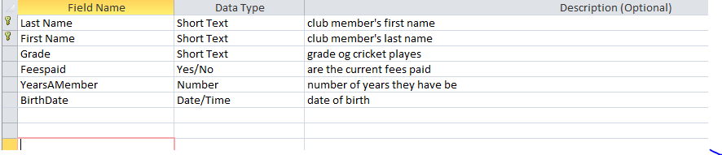
Datasheet view
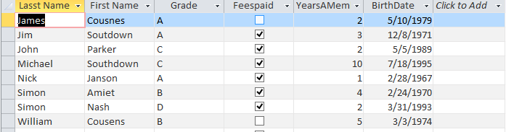

Relational table 2
Design view
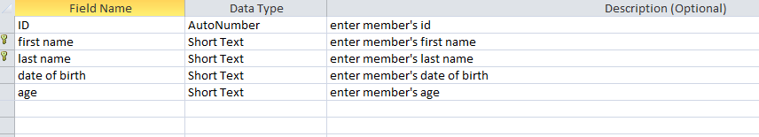

Datasheet view
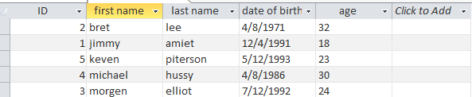

First name and last name are primary keys in both tables
Note
Microsoft access file is also attached with solution

Reference
Citation: Kroenke, D., & Auer, D. (2014). Database concepts (Seventh ed.). Cpt 2,Prentice Hall.

