Ishmael Owusu
Grantham University
IS259 Database Application
29 November 2016

Question1. Give an example of a data constraint and an example of a business rule. Be sure to label, which is which so I can tell you know the difference
Answer:
- Example of constraint is that, the primary constraint imposed on a column enforces the entity integrity, which in turn uniquely identifies each row as it requires each row to have a unique identify. Like in Customer table, the customer id can be a primary key, which will uniquely identify each customer record.
- Example of BUSINESS RULE is that, In order to define attributes entities, constraints and relationships, business rules are greatly used by the business organizations which uses data to be an explanation of a principle. Business rules are necessary for the data to be considered significant.
Example:
In a university, there are multiple entities like department, courses, classes, professor, subject, etc. As per business rule, department may offer courses, professor may teaches classes, and courses may generate classes. Thus, business rules are:
- Departments ------offers---------Course,
- Course----------generates---------Class, and
- Professor --------teaches----------Class (Database Management).
- Question 2. Explain the difference between an entity class and an entity instance, and give an example other than those used in the text or the lectures.
Answer:
 | ENTITY CLASS | ENTITY INSTANCE
DEFINITION | Entity is everything about which the data is collected and it can be any person, place or thing (Galen). | Entity instance is an occurrence of an entity class (Galen).
EXAMPLE | Customer is an entity class. | John is an instance of the customer.

- Question 3. Define the term “weak entity” and give an example other than those used in the text.

Answer:
Weak Entity
The entity that depends on another entity is known as weak entity. The existence of the weak entity in the database requires a strong entity to be present in the database (Week 04 Notes 01 ERD Practice).
Example:
Room is dependent on building, because room exists in the buildings. If building does not exist, then the room will also not exist.
Question 4. Define super type, subtype and discriminator.

Answer:
Supertype: An entity type having relationship with one or more subtypes is known as supertype.
Subtype: Subgrouping of entities in an entity type which has different attributes than other subgroupings.
Discriminator: In order to denote which subtype an entity is, the subtype discriminator is used which is an attribute of the supertype (ENHANCED E-R MODEL and BUSINESS RULES, 2001).
Question 5. Explain the difference between and inclusive subtype relationship and an exclusive subtype relationship.

Answer:
Inclusive Subtype Relationship: In inclusive subtype relationship, Supertype is associated with atmost one subtype.
Exclusive Subtype Relationship: In exclusive subtype relationship, Supertype is associated with one or more subtypes (Entity-Relationship Model ).
- Question 6. Using Microsoft Visio 2013 (available through Microsoft Imagine) draw an IE Crow’s Foot E-R diagram for the entities DEPARTMENT and EMPLOYEE. A DEPARTMENT may have more than one EMPLOYEE, but an EMPLOYEE is only assigned to one DEPARTMENT. Assume that a DEPARTMENT does not need to have an EMPLOYEE, but that every EMPLOYEE is assigned to a DEPARTMENT. Include at least three appropriate identifiers and attributes for each entity.

Answer:
The IE Crow’s foot E-R diagrams for entities department and employee is below
Fig: (IE Crow’s foot E-R diagram)

- Question 7. Explain the following crow’s foot E-R diagram. Be sure to include entities, keys, attributes, cardinality. What is the special type of entity represented by COMMISSION_RATE?
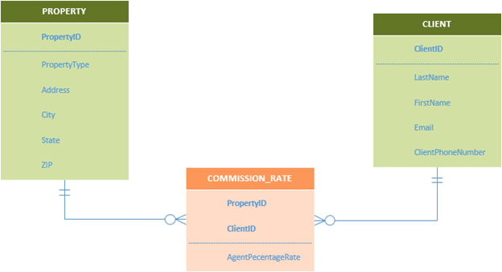

Answer:
The entities, attributes, and keys in the given crow’s foot E-R diagrams are as follows:
ENTITIES | ATTRIBUTES | Primary/Foreign KEYS
PROPERTY | PropertyID, PropertyType, Address, City, State, and ZIP. | PropertyID is a primary key.
CLIENT | ClientID, LastName, FirstName, Email, and ClientPhoneNumber. | Client ID is a primary key.
COMMISSION_RATE | PropertyID, ClientID, and AgentPercentageRate | Property ID and ClientID are foreign keys.

Cardinality:
- One-to-one relationship:
- Between PROPERTY and CLIENT entities.
- One-to-many relationship:
- Between PROPERTY and COMMISSION_RATE entities.
- Between CLIENT and COMMISSION_RATE entities.
Special type of entity represented by COMMISSION_RATE is the AgentPercentageRate.

References

- Entity-Relationship Model . (n.d.). Retrieved July 21, 2015, from http://www.usna.edu: http://www.usna.edu/Users/cs/adina/teaching/it360/spring2010/slides/it360_Set2_ERModel.pdf
- Reilly, M. D. (1999, October 23). Certifiably SQL: Data Constraints and Integrity. Retrieved July 21, 2015, from http://sqlmag.com: http://sqlmag.com/database-performance-tuning/certifiably-sql-data-constraints-and-integrity
- Citation: Kroenke, D., & Auer, D. (2014). Database concepts (Seventh ed.). Prentice Hall

