EN361 Technical Writing

Grantham University
Writing Report

Owusu Ishmael
5 December
Respected Sir,
I am pleased to submit my report on the launching of your product or service could be provided in a more efficient and effective way. I have tried my best to come up to your mark by providing unique ideas and elegant presentation. I am thankful to you for giving me an opportunity to survey, analyze and enhance my knowledge.
In this era of tight competition from domestic and global firms the firm who don't come out with new products are putting themselves at great risk because their existing products are prone to changing customer needs, shorter product life cycles, new technologies and increased competition. Despite years of research and huge capital being pumped in to understanding the consumer, making a launch successful is still a difficult task. The new product largely depends on the product quality and the marketing tactics of the firm, there are many occasions were the product failed miserably even after using the best technology and quality the reasons that the new product is not worth for the customers. The prime factor for the new product success is - customer value. Value is what the customer thinks is value. (Song H., Cadeaux J, 2015)
Objectives:
- To increase the 25% market share
- To increase the length of product line
- To increase profits
- To face strong competitors
SWOT Analysis:
- Strength
- Weakness
- Opportunity
- Threat

- Strengths:

- Updated technology plant
- Quality product
- Specialists available for specialized jobs and tasks
- Hire experienced staff
- Medical insurance of employees

- Weaknesses:

- Small distribution network
- Strong competitor
- No market share
- Limited experience of customers

- Opportunities:

- Increase the distribution network
- Acquiring the newer technology and techniques
- Market is very big and attractive
- Takeover of the distribution

- Threats:

- Political instability
- New entrance from the competitors
- So many competitors
- Retaining consumers
- Economic instability
- Increase of general sales tax
- Development of plant
(P. Kotler et al, 2013)
- Faulty product idea
The product often fail because faulty of product idea. A good idea can revolutionize the market but a bad idea may prove bitter to the firm or it may backfire.
- Distribution related problems
The new product fails if the product is unable to meet the channel requirements. While developing the product the channel requirements must be given adequate consideration.
- Poor timing of lunch
- Improper Positioning

- Pricing
Pricing objectives should flow from and be consistent with corporate and marketing objectives and the overall company mission these objectives should be started explicitly because they directly affect pricing policies and the methods used to be set.
- Objectives
Profit oriented profit goals may be set for the short or long term. Accompany may select one of two profit – oriented goals for its pricing policy.

- To achieve a target returns
The pricing objective of marking as much as money as possible is probably followed more than any other goal. The trouble with this goal is that some people profit maximization has an ugly connotation suggesting profiteering, high prices and monopoly.

- To maximize profit
A profit maximization objective seeks to achieve as much profit as possible.
It might be stated as desire to earn a high return an investment or more sonly to
Change “what the method will bear”

(Parasuraman, A, 2000)
- Sale Oriented
In some companies management’s pricing is focused on sales volume.
The pricing goal may be to increase sales volume or to maintain or increase the firm's market share.
- To increase sale volume
- To maintain or increase

- Market share
Many organization seek to gain same specific share % of a market. The advantage of a market-share price object is that its force a managers to pay attention to the performance of the competitions. It is usually easier to measure an argumentation market share than to determine if profit are buying maximized since market share is a relation measure it is often the preferred measurement of an argument competitive.
- Pricing policies can be established in three ways:

- Cost-orientated

The costs involved in manufacturing the product and then adds on a percentage of the cost as a mark-up in order to set the price.

- Demand-orientated

High demand means high prices – low demand means low prices.

- Competitor-orientated

Pricing is usually found where a group of organizations is selling the same product i.e. petrol, finance, etc.

Customers are happy to pay and accepted the product as the “market price”.
(Baker et al, 2007)

- Place
Initially, we will make this product available at all departmental stores and superstores. Once the product gets off to a good start availability will be increased to other cities and small shops.

- Promotion
There will be extensive promotion for the product. All our promotion efforts will be to persuade people to buy anti-bacterial detergent product
We will not have to spend money on creating awareness of the importance of germ prevention, because the general awareness has been created by anti-bacterial product industry.
We will mainly use 3 media type.

- Electronic Media

- Print Media

- Outdoor media

- Types of new product
- Innovative products

- New product line to allow the firm to enter an existing market

- Addition to product line to supplement the firm’s existing product line

- Improvements and revisions of existing product

- Repositioned products existing products targets at new market

- Cost reduction new product that provide similar performance at lower cost

- New Product can be used to….

- Increase/defend market share by offering more choice or updating older products

- Appeal to new segments

- Diversify into new markets

- Improve relationship with distributors

- Maintain the firm’s reputation a leading-edge company

- Even out peaks and troughs in demand

- Make better use of the organization's resources

(Neil Rackham, John De Vincentis, 2003)

- New product development

In business and engineering, new product development (NPD) is the term used to describe the complete process of bringing a new product or service to market.

There are two parallel paths involved in the NPD process:
- The idea generation, product design, and detail engineering;
- Involves market research and marketing analysis.
Companies typically see new product development as the first stage in generating and commercializing new products within the overall strategic process of management used to maintain or grow their market share.
OR
- Development of original products
- Product improvements
- Product modifications
- New brands through the firm’s own R & D efforts

New product development is a process which is designed to develop, test and consider the viability of products which are new to the market in order to ensure the Growth or survival of the organization.
(Anderson et al, 2006)

- Idea Generation
Idea Generation is the Systematic Search for New Product Ideas Obtained Internally from Employees and Also From:
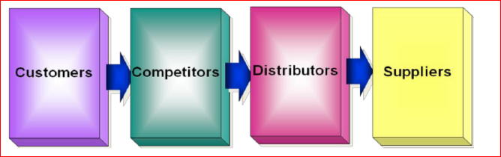
Ideas for new products can be obtained from basic research using a
SWOT analysis, Market and consumer trends, company's R&D department, competitors, focus groups, employees, salespeople, corporate spies.

More Ideas
Idea Screening “Process to spot good ideas and drop poor ones”
Concept Development and Testing “Develop the marketing and engineering details”

Marketing Strategy Development “Essentially a pattern or plan that integrates your organization's major goals”

Business Analysis “Estimate likely selling price based upon competition and customer feedback”

Test Marketing “Involves placing a product for sale in one or more selected areas”

Test Marketing is the Stage Where the Product and Marketing Program are Introduced into More Realistic Market Settings
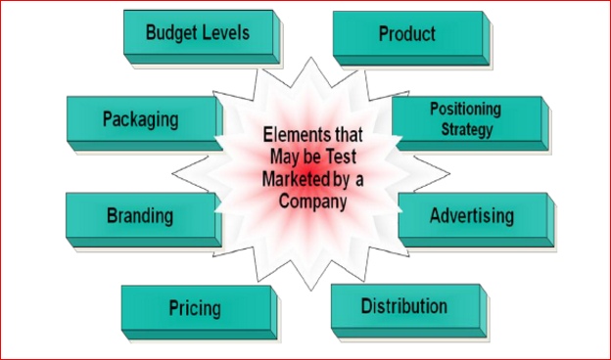
Key Success Factors in NPD
- Operating Philosophy
- Organization Structure
- The Experience Effect
- Management Style

(Song H., Cadeaux J, 2015)

References
- Song H., Cadeaux J., Yu K. (2015). The effects of service supply on perceived value proposition under different levels of customer involvement
- P. Kotler, S. Burton, K. Deans, L. Brown, G. Armstrong. (2013). Marketing (9th edition)
- Investopedia. (2010). "Value Proposition"
- Parasuraman, A. (2000). Reflections on gaining competitive advantage through customer value. Journal of the Academy of Marketing Science, 154-161
- Baker, Michael John; Hart, Susan J (2007). Product Strategy and Management
- Neil Rackham, John De Vincentis. Rethinking the Sales Force; Redefining Selling to Create and Capture Customer Value, McGraw Hill, 2003
- Anderson J.C, Narus J.A, Rossum W.V. (2006). "Customer Value Propositions in Business Markets"

