Module 2 Written Assignment Worksheet
Getting from Shenzhen, China (SK) to St Louis MO (SL): As depicted in the diagram, your shipment originates in Shenzhen, China and will need to be transported by truck to a water port in either Hong Kong (HK) or Yantian, China (Y). From Yantian you can only ship to Los Angeles (LA) while from Hong Kong, you may choose to either ship to Los Angeles or New York (NY). Once in the U.S., both LA and NY have options of shipping via truck, while only NY has an option to ship via rail with a short truck distance once in the St. Louis, Missouri (MO) area. Note that each segment is provided with the cost (U.S. $) and the time in days (d). Upon entry into the U.S. at either LA or NY, there is a delay due to customs and traffic at the port- these are noted with the location nodes.
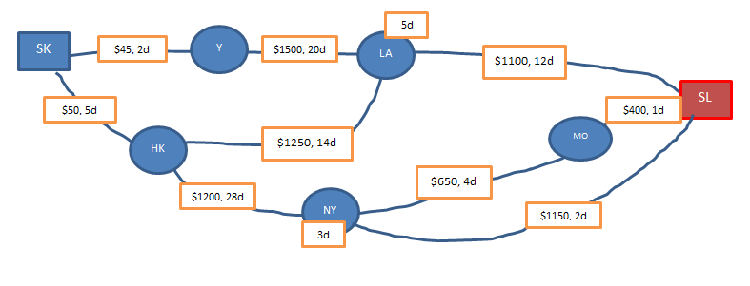
Route (first route is filled out for you as an example) | Transit Time (days) | Total Transit Cost (US $) | Transit Cost per Basketball (US $ round to two decimal places)
Y-LA-SL

