Module 01 Case Scenario – Applying Conversions in the Pharmacy

A patient presents to your pharmacy with the following prescriptions:
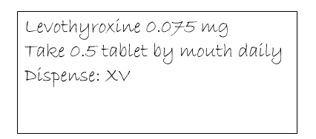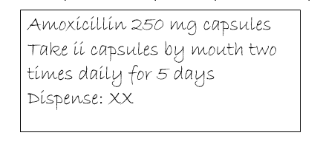

Scenario Regarding Levothyroxine Rx:

1. When you enter levothyroxine into the computer, the only choices are given in mcg. How many mcg does Levothyroxine 0.075 mg equal?

2. The current prescription requires the patient to take one half of a tablet. The patient is wondering if there is a tablet available that she would not need to cut in half. What strength of levothyroxine (in mcg) could she take as a whole tablet?

3. How many tablets of levothyroxine will be dispensed?

Scenario Regarding Amoxicillin Rx:

4. How many total capsules of Amoxicillin will the patient take per day?

5. How many mg of Amoxicillin will the patient be getting per day?

6. How many capsules will be dispensed?

7. The patient informs you that she cannot swallow these large capsules. You have a suspension of Amoxicillin 250 mg per 5 ml available. The pharmacist asks you to rewrite the prescription for verification. How many ml’s will the patient get per dose? How many ml’s should be dispensed?

8. The patient’s total at the cash register comes to $15.84. The patient asks you to ring 20% of her bill as cash and the rest charge to her credit card. How much will she pay in cash? How much will be charged to her credit card?

