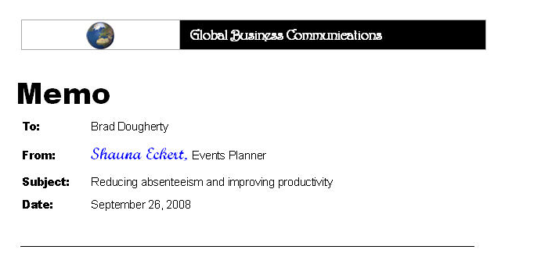
Ive just been reading about what some other companies are doing for the workplace blahs which stimulated a fabulos rockin idea to implemnt at Global Business Communications.
Perhaps youve heard of the man with cancer who cured himself by watching funny movies. Consultants are now available to help companies apply this technique in the workplace. They claim it improves employee morale, reduces absenteism, and fostors creativity. This approach has been successfully tested by other corporations and is backed by experts.
For example, consultant Matt Weinstein says that “laughter, play, and human values in the workplace” can increase “productivity, teamwork, and physical well-being.” Sounds good, huht?
Women’s physician and consultant to the Oprah Winfry franchise, Dr. Tracy Gaudet, says researchers have found that a good laugh lowers blood pressure, decreases heart strain, and lowers blood levels of the stress hormone cortisol. It gives the heart and lungs an aerobic workout, releases “feel-good” endorphins, and relaxes muscles—all of which reduces stress.
Some companys that tried using humor in the workplace report unexpected sucess. They were initially afraid laughing in the workplace would cause employees to slack off.
This effort need not interfere with our work time. Companies such as Sprint have used simple on-site tactics, such as setting up days where employees wear their clothes backward. Others have held offsite weekend events to liten the mood. Considering the ages, tastes, and 24/7 schedule of Global Business Communications staff, we could try a simple, on-site event that has been used at Charleton Memorial Hospital—a petmatching contest.
Employees bring in pictures of their pets which are shuffled and posted anonymously. We also shuffle and post pictures of ourselves. Prizes are awarded to those who match the largest number of employees and pets correctly but the biggest prize will be the positive effect our laughter will have on our work. The contest can go on long enough so that every employee has a chance to participate. Did you know its been proven that people who own pets are healthier and live longer than those who dont?
Whatta ya think? I think we should do it soon. Having fun in the workplace means a better attitude which is something Global Business Communications customers are sure to appreciate. If we occasionally find time to share some fun together well like each other better and coordinate our work more easily.

