**Critical Path Calculations**

**Purpose:** Use this job aid as a reference to the calculations used in the critical path method.

**One-to-one dependency between tasks**

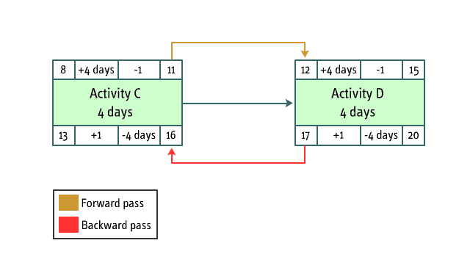

**One-to-one dependency between tasks**

**Forward pass**

Early start date + Duration - 1 = Early finish date

The early start date of an activity should fall on the next working day after the early finish date of the previous activity.

**Backward pass**

Late finish date - Duration + 1 = Late start date

The late finish date of an activity should fall on the working day before the late start date of the following activity.

**One-to-many dependency between tasks**

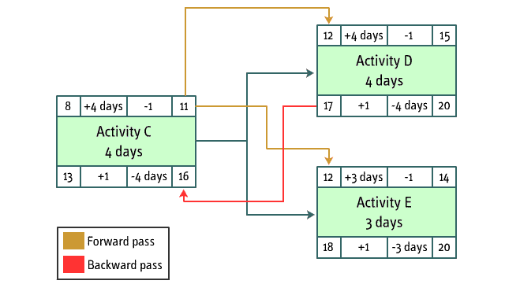

**One-to-many dependency between tasks**

**Forward pass**

Early start date + Duration - 1 = Early finish date

The early start date of the dependent activities should fall on the next working day after the early finish date of the previous activity.

**Backward pass**

Late finish date - Duration + 1 = Late start date

The late finish date of the previous activity should fall on the working day before the smaller late start date of the succeeding activity – that is, the working day before the late start date of the critical path activity.

**Many-to-one dependency between tasks**

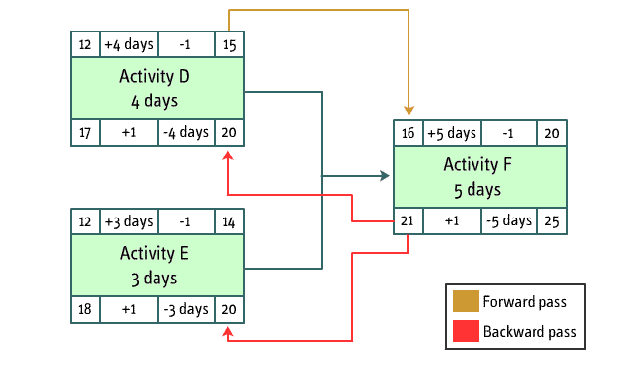

**Many-to-one dependency between tasks**

**Forward pass**

Early start date + Duration - 1 = Early finish date

The early start date of the dependent activity will be the working day after the larger early finish date of the previous activities.

**Backward pass**

Late finish date - Duration + 1 = Late start date

The late finish date of the preceding activities will be the working day before the late start date of the dependent activity.

**Course:** Developing and Controlling the Project Schedule  
**Topic:** Critical Path Method