**Interpreting Political Cartoons**

In the Gilded Age, political cartoons provided important commentary on the major economic, political, and social issues of the day. Cartoon artists employed symbolism, exaggeration, labeling, analogy, and irony to express their viewpoint.

To understand how to analyze political cartoons, make sure to complete the “Analyzing Primary Sources” activity in section 4.3 of your textbook, and then visit the Library of Congress’s [Political Cartoon Analysis](http://www.loc.gov/teachers/classroommaterials/presentationsandactivities/activities/political-cartoon/index.html) page. Once you have a good idea of how to analyze political cartoons, choose **one** of the cartoons below and respond to the following:

1. Identify the character(s) in the cartoon.

1. Identify the symbols and actions the artist employs in the cartoon.

1. Explain the cartoon’s message, intended audience, and if the artist was persuasive to their intended audience.

The combined answers should be one page, including your reference list. Your answers to these questions should be accurate, thorough, written in complete sentences. Be sure to cite the textbook at least once and reference the textbook in APA formatting.

If you need more guidance, you can read this [Sample Assignment](http://vizedhtmlcontent.next.ecollege.com/pub/content/0e206d54-f377-4ff9-bdee-128f9ce266b5/HIS206.W2.Sample_Assignment.pdf), so you will have an idea about the type of response your instructor will be looking for.

*Cartoon 1*  
   
*Jerry Tavin/Everett Collection*

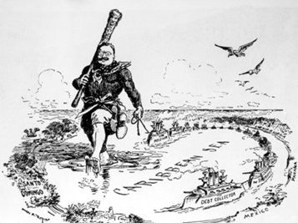

*Cartoon 2*

