PHY-102: Energy and Circular Motion Exercises
Complete the following exercises.
- A rifle with a longer barrel can fire bullets with a larger velocity than a rifle with a shorter barrel.
a. Explain this using the impulse-momentum theorem.
b. Explain this using the work-energy theorem

- Use physics terms to explain the benefits of crumple zones in modern cars.

- When a gun is fired at the shooting range, the gun recoils (moves backward). Explain this using the law of conservation of momentum.

- Rank the following in terms of increasing inertia:
  - A 10,000 kg train car at rest
  - A 100 kg person running at 5 m/s
  - A 1200 kg car going 15 m/s
  - A 15 kg meteor going at a speed of 1000 m/s

- Rank the following in terms of increasing momentum:
  - A 10,000 kg train car at rest
  - A 100 kg person running at 5 m/s
  - A 1200 kg car going 15 m/s
  - A 15 kg meteor going at a speed of 1000 m/s

- Rank the following in terms of increasing kinetic energy:
  - A 1200 kg car going 15 m/s
  - A 10,000 kg train car at rest
  - A 15 kg meteor going at a speed of 1000 m/s
  - A 100 kg person running at 5 m/s

- Ben (55 kg) is standing on very slippery ice when Junior (25 kg) bumps into him. Junior was moving at a speed of 8 m/s before the collision and Ben and Junior embrace after the collision. Find the speed of Ben and Junior as they move across the ice after the collision. Give the answer in m/s. Describe the work you did to get the answer.

- Identical marbles are released from the same height on each of the following four frictionless ramps.
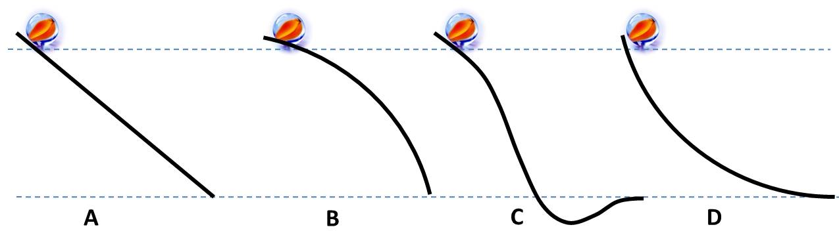
Compare the speed of the marbles at the end of each ramp. Explain your reasoning.

- A force of only 150 N can lift a 600 N sack of flour to a height of 0.50 m when using a lever as shown in the diagram below.
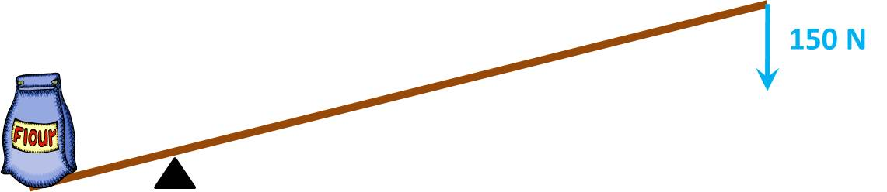

  - Find the work done on the sack of flour (in J).
  - Find the distance you must push with the 150 N force on the left side (in m).
  - Briefly explain the benefit of using a lever to lift a heavy object.

- Rank the following in terms of increasing power.
  - Doing 100 J of work in 10 seconds.
  - Doing 100 J of work in 5 seconds.
  - Doing 200 J of work in 5 seconds.
  - Doing 400 J of work in 30 seconds.

- A student lifts a 25 kg mass a vertical distance of 1.6 m in a time of 2.0 seconds.
  - Find the force needed to lift the mass (in N).
  - Find the work done by the student (in J).
  - Find the power exerted by the student (in W).

- A satellite is put into an orbit at a distance from the center of the Earth equal to twice the distance from the center of the Earth to the surface. If the satellite had a weight at the surface of 4000 N, what is the force of gravity (weight) of the satellite when it is in its orbit? Give your answer in newtons, N.

- Consider a satellite in a circular orbit around the Earth.
  - Why is it important to give a satellite a horizontal speed when placing it in orbit?
  - What will happen if the horizontal speed is too small?
  - What will happen if the horizontal speed is too large?

- If you drop an object from a distance of 1 meter above the ground, where would it fall to the ground in the shortest time: Atop Mt. Everest or in New York?

- Why do the astronauts aboard the space station appear to be weightless?

- Why do the passengers on a high-flying airplane not appear weightless, similar to the astronauts on the space station?

- A ranger needs to capture a monkey hanging on a tree branch. The ranger aims his dart gun directly at the monkey and fires the tranquilizer dart. However, the monkey lets go of the branch at exactly the same time as the ranger fires the dart. Will the monkey get hit or will it avoid the dart?

The remaining questions are multiple-choice questions:

- Compared to its weight on Earth, a 5 kg object on the moon will weigh
  - the same amount.
  - less.
  - more.

- Compared to its mass on Earth, a 5 kg object on the moon will have
  - the same mass.
  - less mass.
  - more mass.

- The reason padded dashboards are used in cars is that they
  - look nice and feel good.
  - decrease the impulse in a collision.
  - increase the force of impact in a collision.
  - decrease the momentum of a collision.
  - increase the time of impact in a collision.

- Suppose you are standing on a frozen lake where there is no friction between your feet and the ice. What can you do to get off the lake?
  - Bend over touching the ice in front of you and then bring you feet to your hands.
  - Walk very slowly on tiptoe.
  - Get on your hands and knees and crawl off the ice.
  - Throw something in the direction opposite to the way you want to go.

- A car travels in a circle with constant speed. Which of the following is true?
- The net force on the car is zero because the car is not accelerating.
- The net force on the car is directed forward, in the direction of travel.
- The net force on the car is directed inward, toward the center of the curve.
- The net force on the car is directed outward, away from the center of the curve.

- A job is done slowly, and an identical job is done quickly. Which of the following is true?
  - They require the same amount of force, but different amounts of work.
  - They require the same amount of work, but different amounts of power.
  - They require the same amounts of power, but different amounts of work.
  - They require the same amounts of work, but different amounts of energy.

- How many joules of work are done on a box when a force of 60 N pushes it 5 m in 3 seconds?
  - 300 J
  - 12 J
  - 100 J
  - 36 J
  - 4 J

- A 1 kg cart moving with a speed of 3 m/s collides with a 2 kg cart at rest. If the carts stick together after the collision, with what speed will they move after the collision?
  - 3 m/s
  - 1.5 m/s
  - 1 m/s
  - 2 m/s

