Helpful Information
Remember that when you make a claim in your paper, you have to offer support. In talking about literature, you do that through quoting passages of the text & you have to do something similar here. The only way to offer real support or evidence is to make specific reference to very particular instances in the film. Use this chart to refresh your memory about these units - shots, which make up scenes, which are presented in sequence:
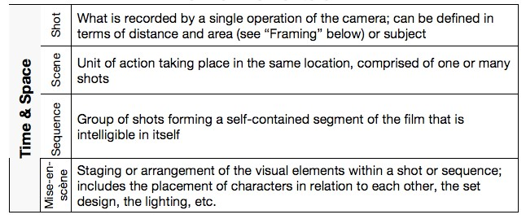
Within the individual units that you want to discuss, you've got to be very particular about the different elements & their importance. Here's another handy reference to remind you about the importance framing of different types of shots:
