Bethesda Softworks

Contents
- INTRODUCTION
- HISTORY
- PRODUCTS AND SERVICES
- STAKEHOLDERS
- OLD DATA INFRASTRUCTURE
  - Current Infrastructure
  - Benefits of Cloud Computing
  - Cloud Supporting Vendors
- Cloud Model and Deployment Method
  - Implementation
  - Challenges

I. INTRODUCTION
II. HISTORY OF BETHESDA SOFTWORKS (Rodney)
Founded in 1986 by Christopher Weaver in Bethesda Maryland and later moved to Rockville Maryland. Bethesda Softworks has been a developer and publisher of interactive entertainment for well over two decades now. In 2001 the company split into two parts, Bethesda Softworks became the publisher side and Bethesda Game Studios became the developing side. Bethesda Game Studios has been credited for creation the first physics-based sports simulation game, “Gridiron” for the Atari ST.
The biggest accomplishment by ZeniMax Media, the parent company of Bethesda’s came in June of 2009 when it acquired “id Software”, and its game titles such as Rage that had a Game Ranking of 81.79% and sales of 2.3 million copies.
III. PRODUCT AND SERVICES (Rodney)
Bethesda Game Studios is best known for the creation of The Elder Scrolls series. The latest Elder Scrolls: Skyrim that took 3.5 year to make with a developing and marketing budget of $85 million. There were a total of 90 game developers and 83 voice over actors employed in the designing of The Elder Scrolls. The finished produced sold 22.7 million copies and $620 million in sales. Other well-known titles produced by Bethesda Games Studios based upon popular movie franchises includes The Terminator, Star Trek and The Pirates of the Caribbean. In 2004 Bethesda Games Studios acquired the Fallout Franchise from Interplay Productions, with a release as current as Nov 2015. Other great title include Anchorage, The Pitt, Broken Steel, Point lookout and Mothership Zeta.
IV. STAKEHOLDERS (Rodney)
The major stockholder in Bethesda softworks is ZeniMax Media INC, founded in May of 1999 by Christopher Weaver and Robert A Altman. ZeniMax Media is backed by major investors such as Providence Equity Partners a Rhode Island based Investment Company, Leslie Moonves president and chief executive officer of CBS, Cal Ripken Jr, ProSiebenSat.1 Media SE a German Mass Media company, Harry E. Sloan former CEO of Metro-Goldwyn-Mayer and now Director at ZeniMax Media, ZM Investment, and ZeniMax private investor Tony Coelho. The stakeholders are also any people who are interested in buying games developed by the company as well as investors who have stock in the company. They have shareholders that are smaller and larger so anybody who has anything invested into the company is a stakeholder.

V. OLD DATA INFRASTRUCTURE
i. Current infrastructure (Jonathan Bogner)

ii. Benefits of cloud services (Amadou)
Moving from data centers to the cloud will be very beneficial to a company like Bethesda Softworks. In fact, instead of running applications or programs from software downloaded on a physical computer or server in their building, cloud computing will allow the company to have access to the same kinds of applications through the internet. Here is a few areas where cloud computing will be beneficial to Bethesda Softworks:
Flexibility: for growing companies like Bethesda Softworks, the needs for bigger servers and data centers increase rapidly. Therefore, it would be easy to scale up the cloud capacity, drawing on the service’s remote servers. Alternatively, in cases where the company needs to scale down again, the flexibility is baked into the service. Moving to the cloud will give the company a real advantage over competitors, based on the level of agility.
Disaster recovery: this is an important aspect to consider for businesses of all sizes. However, for a growing game development company like Bethesda Softworks , it is highly recommended to have a robust disaster recovery plan ready for deployment. Cloud services will allow the company to benefit from cloud-based backup and recovery solutions that save time, avoid large up-front investment and roll up third-party expertise as part of the deal.
Automatic software updates: this cloud computing service will help the company focus more on their key responsibilities. For instances, with cloud computing, the off-premise servers are handled by the suppliers who update the software automatically. This will be very beneficial because the company won’t have to hire IT specialists to maintain the servers and handle the security issues. In this case Bethesda Softworks can focus more on the things that matter and help grow the company like developing games.
Cost friendly: the adoption of cloud computing will help cut the cost of expensive hardware. Rather than purchasing large amounts of hardware that are usually paid up front, the company can simply use the “pay as you go” cloud service and enjoy a subscription-based model that fits their need. In addition, these services are easy to set up and manage, making the projects easier to complete and handle.
Increased collaboration: not only that this will allow the company’s developers to work from different locations, it will also help them collaborate more by sharing all the work on the cloud. Only thing needed is an internet connection. In fact, game developers will face fewer restrictions when they have the possibility to access, edit and share documents anytime, from anywhere. Cloud-based workflow and file sharing apps help them make updates in real time and gives them full visibility of their collaborations.
Work from anywhere: working through the cloud made work easier than ever. For instance, employees can now work from home or any other location as long as they have an internet connection. In this case, Bethesda can now offer their employees more flexible working perks so they can enjoy the work-life balance that suits them without affecting their productivity.
Files control: moving to the cloud will help Bethesda store all files (codes, prototypes, design, deliverables, etc…) centrally so that every employee have access to only one version of the document. This increase in accuracy will improve the collaboration, which ultimately means better work and a healthier bottom line.
Security:

ii. Benefits of cloud services cont. (Jonthan Bogner)
There are many benefits to cloud computing. You can work collaboratively on almost anything, you can run high demand programs on incredibly powerful computers. You save money by using existing equipment versus having to invest hundreds of thousands, if not millions of dollars on your own hardware. Cloud computing also allows for flexibility letting you expand to meet your needs and lets you pay as you go with companies like Amazon. The main benefits are cost, agility in the use of the hardware and the focus you can put on the work itself, not having to worry about the hardware. You also reduce the risk of underestimating the need of processing power, and there is much less downtime because of the existing redundancy of the cloud service you are using to keep you running.

iii. Cloud Supporting vendors (Rodney)
As fairly new as Cloud storage is, there is number of company currently offering various types of cloud services, with dynamic Scalability and maintenance. Some known Provider of PaaS ( NOT DONE )
VI. NEW DATE INFRASTRUCTURE
i. Cloud Model (Rodney)
The best choice of Cloud Service that falls in line with the visions of cutting cost and limiting down time would be Platform as a Service (PAAS). PaaS will allow Developer to run and manage game applications from within the cloud, allowing for joint effort from satellite locations and telecommuter. Creation Engine is based on the Gamebryo Engine that was developed by Bethesda, and is the primary game developing engine utilized by Bethesda in games such as Skyrim and Fallout 4. Creation Engine can be setup on a PaaS in which developer can work collaboratively on project.
There are three (3) types of PaaS, Public PaaS, Hybrid PaaS and Private PaaS. All three are anchored in between Software as a Service (SaaS) and Infrastructure as a Service (IaaS). “SaaS is software that is hosted in the cloud, so that it doesn't take up hard drive from the computer of the user or the servers of a company. Where IaaS provides virtual hardware from a provider with adjustable scalability” (4). In IaaS the organization are reasonable for the maintaining and patching of the servers, where in PaaS servers are managed by the Cloud providers.
Private PaaS allows an organization to deploy and manage an enterprise application while allowing for strict security and privacy requirements. PaaS platform can be “downloaded and installed on a company’s on-premises infrastructure or on the Public Cloud” (4). After the software has been installed the Private PaaS sync the application and its database components into a single hosting platform to be share among the users with access. Hybrid PaaS is just a cross between a Public and Private PaaS.
ii. Implementation (Jonthan Bogner) PG 97 in book
There are different choices we can make for how we want to implement our new cloud platform. We could build our own data centers and lease out the space to our developers and freelance workers. There is another option, which is to buy server space from Amazon on their high performance servers and data centers to run our software and rendering programs on to increase the speed we can make iterations of things for testing.
The difference between these two would be cost. The personal high performance connected LAN server would be expensive, but there would be less security risk as it could only be accessed from a computer within the network without special access codes and redundant security features such as encryption and passkeys which change every 24 hours. Amazon Web Services has a very high number of possible options for buying their storage space. I did an estimation for a decent sized cloud environment to collaborate on using 20VM each with high specification for very fast rendering and encoding speeds.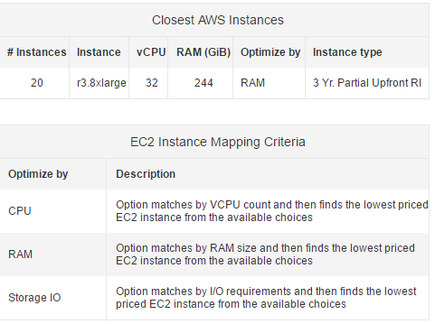
All of the cost calculations are as follows:
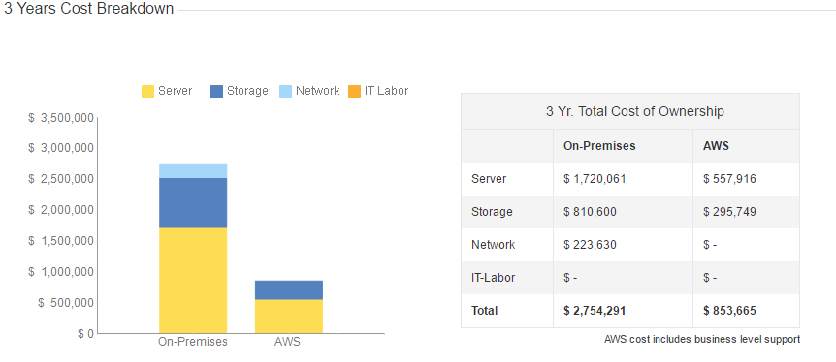
The estimations for the servers from Amazon put the cost if we were to build equivalent would cost almost $3,000,000 while using AWS would cost less than $900,000 over 3 years. The plan with AWS also includes on site support for any issues that would arise. Cloud computing offloads some risk from the user to the service provider (Book).
iii. Challenges (Jonathan Bogner)
There are many challenges when it comes to cloud computing. For instance you need software that runs on the cloud platform you are using. Say if you were running your development software on a Windows based machine, but your VM on the servers you were working on were Linux based, you would have a harder time trying to find software that you would ordinarily be able to do no problem. There are different solutions to solve this issue. You could spend a lot of extra money to build your own servers, or you can pay amazon to run Windows VMs on the servers instead of the usual Linux for a small added fee that could be up to $50,000+ a year, but still makes sense to run AWS thanks to the cost savings over running your own equivalent server. There are also power and security issues with using your own hardware. You need to have a large power source to feed your machines, and you need good security. Amazon’s data centers have incredibly high security due to the expense of the equipment and the data the servers are housing. They are also running the entire website for that region and if someone get into that location and hard-wires in, they can basically shut down that data-center with a complicated enough virus.
References
1.
https://en.wikipedia.org/wiki/Bethesda_Softworks
2.
https://en.wikipedia.org/wiki/The_Elder_Scrolls_V:_Skyrim#Sales
3.
http://www.statisticbrain.com/skyrim-the-elder-scrolls-v-statistics/
4. Platform as a service (PaaS)
https://en.wikipedia.org/wiki/Platform_as_a_service
5. Creation Engine
https://en.wikipedia.org/wiki/Creation_Engine
https://en.wikipedia.org/wiki/ProSiebenSat.1_Media
https://en.wikipedia.org/wiki/Leslie_Moonves
https://en.wikipedia.org/wiki/Cal_Ripken,_Jr.
https://aws.amazon.com/ec2/pricing/

