## Those Incredible Greeks!

In the seventh century B.C., Greece consisted of a collection of independent city-states covering a large area including modern day Greece, Turkey, and a multitude of Mediterranean islands. (This period is called Hellenic, to differentiate it from the later Hellenistic period of the empire resulting from the conquests of Alexander the Great.)

Greek merchant ships sailed the seas, which brought them into contact with the civilizations of Egypt, Phoenicia, and Babylon, to name just a few. This brought Magna Greece (“Greater Greece”) prosperity and a steady influx of cultural influences like Egyptian geometry and Babylonian algebra and commercial arithmetic. Moreover, prosperous Greek society accumulated enough wealth to support a leisure class, intellectuals, and artists with enough time on their hands to study mathematics for its own sake! It may come as a surprise that modern mathematics was born in that setting.

This raises a wonderful and timely question: What is *modern* mathematics? While the answer will require most of this book, let us say here that two major characteristics are obvious to any high school graduate:

* 1. Mathematical “truths” must be proven! A theorem is not a theorem until someone supplies a proof. Before that, it is merely a conjecture, a hypothesis, or a supposition.
* 2. Mathematics builds on itself. It has a structure. One begins with definitions, axiomatic truths, and basic assumptions and then moves on to consequences or theorems, which, in turn, are used to prove more theorems (often more advanced). An algebraic truth might be utilized to prove a geometric fact. A technique for solving an equation might be employed to find the *x*-intercept of a straight line whose slope and *y*-intercept are known. This continuity in mathematics often upsets students who in a college calculus course must recall trigonometric facts they learned in high school (a cruel twist of fate!).
* These properties of modern mathematics are a small part of the rich legacy of Ancient Greece. The man who set the ball rolling was a philosopher named Thales[**1**](https://jigsaw.vitalsource.com/books/9781323104927/content/id/ch03fn1) who flourished around 600 B.C. Although very little is known for certain about Thales, we can say he was the first to introduce the idea of skepticism and criticism into Greek philosophy, and it is this notion that separates the Greek thinkers from those of earlier civilizations. His philosophy has often been called monism – the belief that everything is one. Many pre-Socratic philosophers were monists, though they differed wildly about the nature of the one thing the entire universe consisted of. Thales observed that water could exist as ice and steam, as well as in a liquid state, leading him to the rather odd hypothesis that the stuff of the universe is water. Before you dismiss Thales as a lunatic, please remember that the oneness of the universe is a very popular idea in the philosophies of the orient to this very day.
* You must have heard of the guru who, upon arriving in Manhattan for the first time, points to a hot dog and says to the vendor, “Make me one with everything.” He hands the vendor a $20 bill and after waiting a minute inquires, “What about change?” The vendor, also a student of philosophy, replies, “Change must come from within.”
* Moving right along, Thales was also a mathematician of note.
* 1When Thales was asked what is most difficult, he said, “To know thyself.” And on being asked what is most easy, he replied, “To give advice.”
* 2You might call Thales a hydromonist!

He asserted that mathematical truths must be proven. They must be shown to follow from earlier truths. Among his assertions was the theorem taught today, as “vertical angles are equal.” Observe the angles in [**Figure 3-1**](https://jigsaw.vitalsource.com/books/9781323104927/content/id/ch03fig1) labeled *a*, *b*, and *c*. These letters aren’t names of the angles – they are their values in degrees. Now, clearly *a* + *b* = 180 ° and *b* + *c* = 180 °, since 180 ° (reminder: ° means degrees) is half of a complete rotation, and a straight line with a point on it chosen as the vertex of the angle can be thought of as the result of a “180-degree turn.” A simple transposition of the two equations yields *a* = 180 ° −*b* and *c* = 180 ° −*b*, forcing us to conclude that *a* = *c*. Amazing! Do you realize that no mention was made of the magnitude of the angles? We have a right to assign any values to *a*, *b*, and *c*, as long as *a* + *b* and *b* + *c* are 180 °.

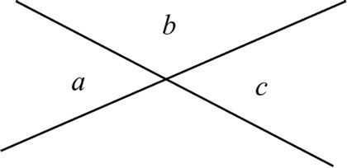

We cannot overemphasize the giant step that Thales took with this proof. He demonstrated the all-abiding truth of a general statement that encompasses infinitely many different situations. Two roads crossing in a yellow wood (if they are straight roads) yield a specific instance of this fact, as does a pair of crossed chopsticks lying on a table. The printed symbol *X* is a silent tribute to the equality of vertical angles! Perhaps the crossing of swords before a fencing match is a salute to Greek geometry. Point noted.

The fact itself was, no doubt, known to Egyptian and Babylonian geometers – but the Greeks *proved*it, and by doing so, advanced mathematics beyond the empirical stage to the theoretical. Geometers drew forth new truths from this one. They observed that a line crossing two given parallel lines, called a *transversal*, makes equal angles with them. Consider the angles labeled *a* and *b* in [**Figure 3-2**](https://jigsaw.vitalsource.com/books/9781323104927/content/id/ch03fig2). They are easily seen to be equal by moving one of the parallel lines slowly toward the other and keeping it parallel to the other given line until the point of intersection coincides with the latter’s and the angles come into coincidence. Since we already know that vertical angles are equal, we have that *b* = *c* and finally conclude that *a* = *c*. These angles are usually called “alternate interior angles.” We have, therefore, a proof that *alternate interior angles are equal*, which employs in its proof the prior fact (or theorem) that *vertical angles are equal*.

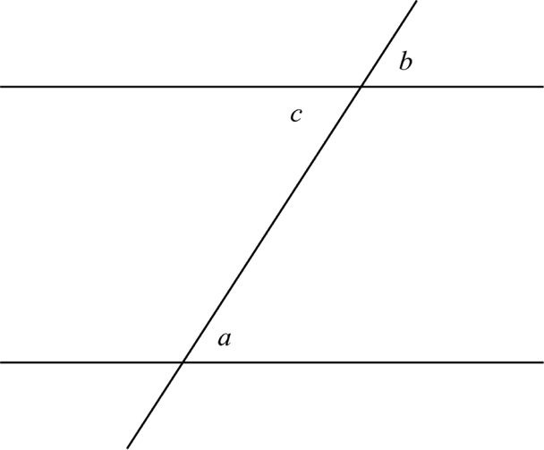

Have we made any other assumptions? Absolutely! In both proofs, we have assumed that the two equations *a* = *b* and *b* = *c* allow us to conclude that *a* = *c*. Mathematicians call this the *transitive law*. Euclid of Alexandria explicitly stated this some 300 years after Thales. More on this later, when we toast this great geometer, number theorist, and writer, who established the foundations of Greek geometry.[**3**](https://jigsaw.vitalsource.com/books/9781323104927/content/id/ch03fn3)

Since this last proof smacks of both geometry and algebra, one sees the influence of both Egyptian and Babylonian mathematics, that is, the geometry of the former and algebra of the latter.

Before proceeding to his next theorem, if you have trouble remembering which pairs of angles in[**Figure 3-2**](https://jigsaw.vitalsource.com/books/9781323104927/content/id/ch03fig2) (there are eight angles in this figure!) are alternate interior angles, regard the letter *Z*and try to find it in [**Figure 3-3**](https://jigsaw.vitalsource.com/books/9781323104927/content/id/ch03fig3). Its angles form a pair of alternating interior angles *a* and *d*. The angles of the first-grader backwards *Z* in the same figure yields the other pair *b* and *c*.

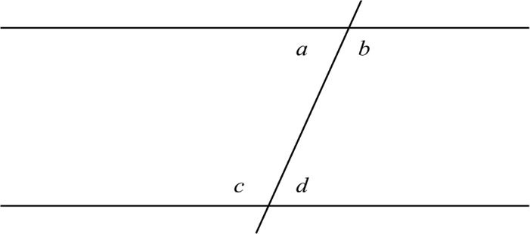

It is believed that Thales is also responsible for the incredibly clever and astonishing theorem that the sum of the angles of any triangle is 180 °. Consider the triangle of [**Figure 3-4**](https://jigsaw.vitalsource.com/books/9781323104927/content/id/ch03fig4), whose angles are labeled *a*, *b*, and *c*. We have drawn a line through the upper vertex parallel to the base. This diagram contains two pairs of alternate interior angles, justifying our labeling of the two angles outside of the triangle at the upper vertex *a* and *b*. It then follows that *a* + *b* + *c* = 180 °, since the outer rays of these angles form a straight line.

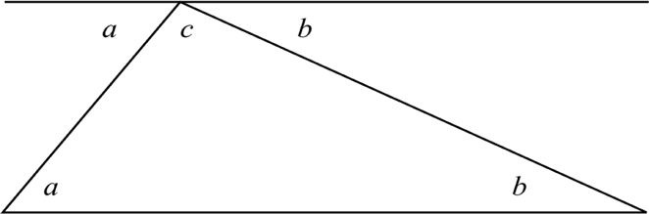

Lastly, Thales is alleged to have shown that an angle “inscribed” in a semicircle must be a right angle. The angle ∠*ACB* in [**Figure 3-5**](https://jigsaw.vitalsource.com/books/9781323104927/content/id/ch03fig5) demonstrates what we mean by “inscribed in a semicircle.” The center of the semicircle is denoted by *O* and we have drawn line  to assist in the proof. Now Thales also proved that if two sides of a triangle are equal, that is, if it is an *isosceles triangle*, then the base angles (the angles opposite them) are also equal. We shall deal with this when we discuss congruent triangles.

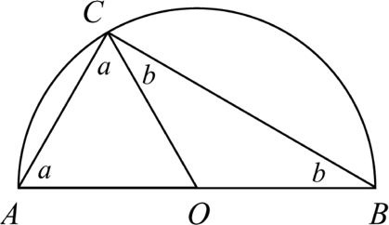

Notice that line segments , , and  in [**Figure 3-5**](https://jigsaw.vitalsource.com/books/9781323104927/content/id/ch03fig5) are equal since they are radii of the circle. Then triangles Δ*AOC* and Δ*BOC* are isosceles, which in turn allows us to label the two angles, which together comprise ∠*ACB*, *a* and *b*. Now we use the fact that the angle sum of triangle *ABC* is 180 ° to get the equation *a* + (*a* + *b*) + *b* = 180 °. The parentheses in this equation remind us that the middle angle (∠*ACB*) equals *a* + *b*. We can remove them, thereby changing the equation to *a* + *a* + *b* + *b* = 180 °. This becomes 2*a* + 2*b* = 180 °, or 2(*a* + *b*) = 180 °. Upon dividing both sides of this last equation by 2, we finally get *a* + *b* = 90 °. This, of course, implies that ∠*ACB* = 90 °, which is what Thales wanted to show. If you had trouble following this argument, be brave and try it again.[**4**](https://jigsaw.vitalsource.com/books/9781323104927/content/id/ch03fn4)



The twenty-first century mathematicians of today’s fast-paced world constantly do what Thales did. We develop and then *prove* theorems.

The next great hero of Greek mathematics is Pythagoras,[**5**](https://jigsaw.vitalsource.com/books/9781323104927/content/id/ch03fn5) who has been immortalized by the theorem named after him. He came from the island of Samos and probably studied under Thales. An approximate date for his theorem is 540 B.C. He lived during the time of Buddha in India, Lao-Tse in China, and Zoroaster in Persia.

4If at first you don’t succeed, perhaps skydiving is not for you, but mathematics is.

5Pythagoras believed in the transmigration of the soul at death into another body, animal or human. So the next time you see someone mistreating an animal, remember that it might be Pythagoras himself.

Historical dates, by the way, serve several purposes. Firstly, they put important events in chronological order – an especially important thing in the history of mathematics in which an idea depends on prior ideas. Secondly, they permit us to observe contemporaneous events in two countries or cultures. Thirdly, they make authors seem more scholarly. For most purposes, it suffices to have an approximate notion of dates and that is the way they are usually used in this book.