Screen shots/Output
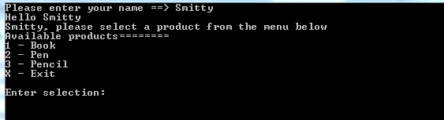
After name input, the program requires the user to selection a product from the menu.
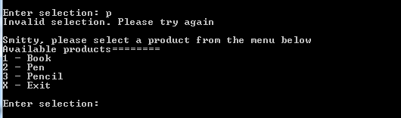
When a user selects a product which is not available, he/she is requested to try again.
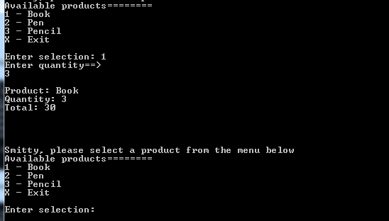
When a user selects a product, the program calculates and displays summary.
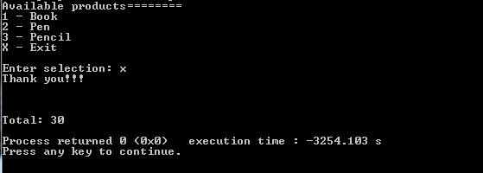
When user selects exit, the program displays total and exits.

