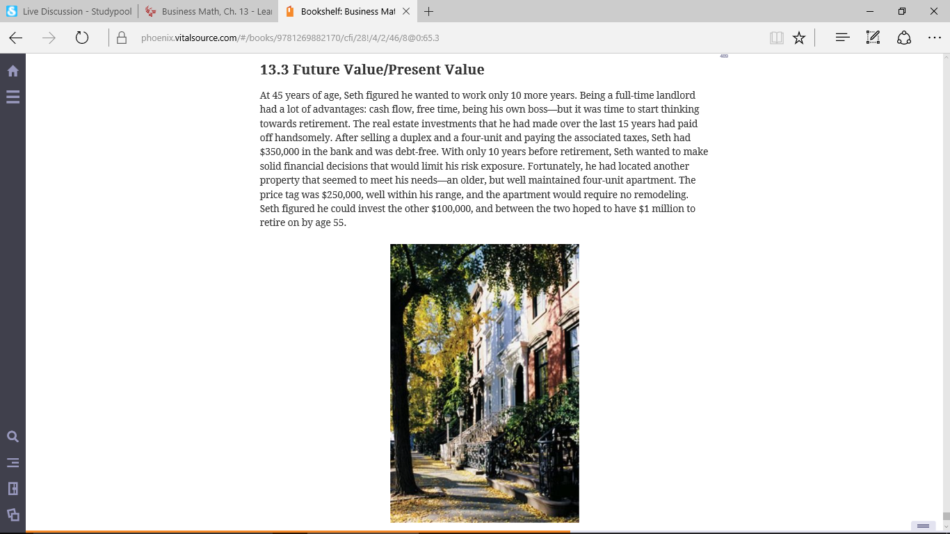

- 1. Seth read an article in the local newspaper stating the real estate in the area had appreciated by 5% per year over the last 30 years. Assuming the article is correct, what would the future value of the $250,000 apartment be in 10 years?
- 2. Seth’s current bank offers a 1-year certificate of deposit account paying 2% compounded semiannually. A competitor bank is also offering 2%, but compounded daily. If Seth invests the $100,000, how much more money will he have in the second bank after one year, due to the daily compounding?
- 3. A friend of Seth’s who is a real estate developer needs to borrow $80,000 to finish a development project. He is desperate for cash and offers Seth 18%, compounded monthly, for years. Find the future value of the loan using the future value table. Does this loan meet Seth’s goals of low risk? How could he reduce the risk associated with this loan?
- 4. After purchasing the apartment, Seth receives a street, sewer, and gutter assessment for $12,500 due in 2 years. How much would he have to invest today in a CD paying 2%, compounded semiannually, to fully pay the assessment in 2 years?

