GROUP PROJECT

Course Name and Code | Library and Information Science
Due Date: | Tuesday ( 25 Apr 2017)
Total Marks: | 100
Marked by:

Academic Integrity

Plagiarism
The practice of taking someone else’s work or ideas and passing them off as one’s own. An example of plagiarism is to use creative works of another, without appropriate acknowledgment of the author or source.
Collusion
Secret or illegal cooperation in order to deceive others. Collusion is the presentation of an assignment as one’s own which is in fact the result in whole or in part of unauthorized collaboration with other person(s). Collusion involves the cooperation of two or more individuals in plagiarism or other forms of academic misconduct.

Both plagiarism and collusion constitute cheating. Disciplinary action will be taken against students who engage in plagiarism and collusion.

Student Declaration
No. | Student ID | Student Name | Section | Marks Obtained
1.
2.
3.
I have read and understood the statement of academic integrity written above. I certify that the attached work is entirely my own except where work quoted is duly acknowledged in the text; that I have not worked with another person or persons except where specifically permitted by the teacher, and that this work has not been submitted for assessment by myself or any other person in any other time. I have retained a copy of my work.

LIS101 - LIBRARY INFORMATION SYSTEMS
SEMESTER 162
PROJECT INSTRUCTIONS
OVERALL MARK | - The Project carries 45% (100) of course marks
DUE DATE | - 10% from overall mark will be deducted per each day of late submission.
PROJECT FORMAT | - You are required to follow the given format:  - Type written  - Include all Headings  - Edited for typos and grammatical errors  - 1.5 spacing  - Font size - 11  - Lettering – Times New Roman  - Paragraphing – 1.5 spaces  - The Report is at least 5000 words, maximum 6000 words in length
Deliverables | - Each group must submit a hardcopy and softcopy of the project.

Project Description:

Working in groups of 2 to 3 students, find any topic that you are interested in from internet / library on the related information.

Task1:
- Write a research paper on the selected topic.
- Your paper should clearly follow the research process discussed in the class.

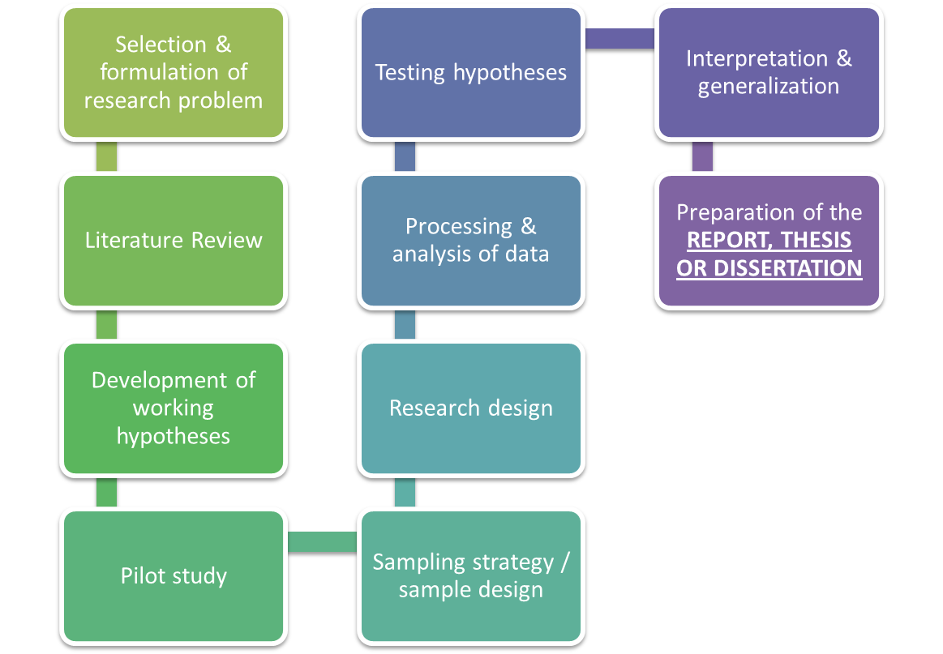

Figure 1 Research Process
- Your research should be supported and Cited by at least Six (6) sources.

TASK 2: Each group is to prepare a complete project report based on report outline given below.

REPORT OUTLINE:
CATEGORY | DESCRIPTION
1st PAGE | COVER PAGE ( state clearly your name, ID and section)
2nd PAGE | Report Assessment Rubric (see page 5)
3rd PAGE | Workload distribution (See page 8).
4th PAGE | Table of Content
5th PAGE | Abstract
6th PAGE ONWARDS | CONTENT  You should include:  - Introduction of your given title and scope.  - Body of Thesis (Topics that are related to information gathering that have been done based on generated questions).  - Conclusion.
Last Page | References

REPORT ASSESSMENT
Categories | Excellent | Good | Fair | Poor | Points
Communication Skills-2  Cover Page, Marking Scheme and Table of Contents | Meets or Exceeds Highest Expectations.  Completed all content for this area. | Above Expectations  Completed most content. | Meets Expectations  Missing most content. | Does not meet expectations  Missed Title Page or Table of Contents. | /3
Communication Skills-2  Abstract and Introduction | Clearly stated abstract and introduction, point of view is maintained throughout the research. | Stated them but it is not maintained throughout research. | The main idea needs to be guessed at. | There is no abstract and introduction to guide reader; student jumps into topic. | /4
Analytical Skills-4  Initial Study/Research | Outstanding range of knowledge and depth of research. Gathers extra information over the Web to add knowledge area. Able to critically analyze, evaluate and present understandings and ideas | Good knowledge and understanding of the topic and issues. Gathers some information over the Web to add knowledge area. Able generally to analyze, evaluate and present understandings and ideas | Some basic relevant information about the topic, but likely to contain confusion and factual errors. Poorly analyzed and evaluated the topic. | Severely limited knowledge and research of the topic; likely to contain serious factual errors or confusions or to be significantly dependent on others' work. NOT able to analyze and evaluate the topic. | /40
Analytical Skills-4  Use of Evidence | Outstanding capacity to engage closely with and evaluate evidence; ability to deploy evidence from wide areas | Good capacity to evaluate evidence; ability to deploy evidence from wide areas | Evidence deployed to some extent with some but not necessarily much of a critical analysis | Likely to fail to use evidence altogether | /8
Communication Skill-2  Organization and Style | Clear structure, points made in ordered manner; effective individual style; correct English and appropriate referencing of sources | Generally clear structure and reasonable style; mostly correct English and appropriate referencing | Mostly a coherent structure, though may be unclear in places; generally acceptable English and referencing of sources but likely to have some errors | May have no evident plan or structure; English likely to be very poor indeed; referencing may be poor or non-existent | /8
Communication Skill-2  Length | The essay is at least 4500 words, maximum 6000 words in length. | The essay is more than 4000 words in length. | The essay is about 4000 words in length. | The essay is less than 3500 words in length. | /8
Communication Skill-2  Conclusion | Conclusion clearly reinforces the research, reinforces the major points, and makes a broader statement about the topic. | Conclusion sums up the research and reinforces it well. | Conclusion does not sums up or reinforce the research. | Conclusion sums up the research poorly with little reinforcement. | /4
Ethical Skill-3  Citation ( in text citation)  References Style (List of minimum of Six (6) references ,Use proper APA referencing style on separate page) | All sources cited and conform to APA citation requirements. The Reference page, containing a minimum of 3 references, is alphabetized and formatted correctly, per APA. | All sources cited and conform to APA citation requirements with minor errors. The Reference page, containing a minimum of 3 references, is alphabetized and formatted correctly, per APA, although there may be minor errors. | Most sources cited but there are problems with the APA citation requirements: with incorrect information given either in the sentence or in the parenthetical references. The Reference page has constant errors in alphabetizing and/or formatting. | Many errors in citation and/or the Reference page. Citations and the Reference page may not match up, where a cited work isn’t found on the Reference page or a work on the Reference page is not cited. | /10
Ethical Skill-6  TurnitIn Report | Work has 5% plagiarism | Percentage of plagiarized work > 5% | Percentage of plagiarized work > 15% | Percentage of plagiarized work > 20% | /10
Total |  |  |  |  | /95

INDIVIDUAL ASSESSMENT
Categories | Excellent | Good | Fair | Poor | (1) | (2) | (3)
Communication Skill-2  Team Work and Contribution | Effectively provides useful ideas when participating in the group A leader who contributes a lot of effort. | Sufficiently provides useful ideas when participating in the group. A strong group member who tries hard. | Fairly provides useful ideas when participating in the group. A satisfactory group member who does what is required. | Poorly provides useful ideas when participating in the group. May refuse to participate.
Total |  |  |  |  | /5 | /5 | /5

WORKLOAD DISTRIBUTION

NO# | Student ID | Student Name | Workload / Delivery
1
2
3

