Instructions to Student | General Instructions:  - Font size 12.  - 1.5 spacing.  - Name and student number in a footer on every page  - Every answer must be referenced in APA style, a full reference list to be at the end of the assignment. Student must sign the student declaration on cover sheet  - If submitting online (Flexi Delivery), MUST be submitted in Word format, not PDF.  Number of Attempts:  You will receive two (2) attempts for this assessment. Should your 1st attempt be not satisfactory, your teacher will discuss the relevant questions with you and will arrange a 2nd attempt to be scheduled. Should your 2nd attempt not be successful, or you fail to undertake the 2nd attempt, you will be deemed “not satisfactory” for this assessment item. Only one re-assessment attempt may be granted for each assessment item.  Assessment Criteria:  To achieve a satisfactory result, your assessor will be looking for your ability to demonstrate the key knowledge to the Health Care Industry standard.
Evidence Required to be Submitted and Method of Submission | Completed assignment is to be handed to the teacher on or before the due date.  Assignments may be submitted on Connect if that is the required method. The teacher will advise
Instructions to Assessor | Work, Health and Safety: assessment not conducted in class time.
Note to Student | An Assessment Mapping Matrix is available from your teacher upon request. The mapping matrix shows how the knowledge and skills that you are being asked to demonstrate align to the requirements of each Unit of Competency.

ASSESSMENT INSTRUCTIONS

Relate your written responses to the scenario and related photographs provided below.
As an Enrolled Nurse you are caring for Mr Brown in ward 4B of the RBWH. He is being prepared for discharge next week.

Case Study –
Mr. Noah Brown- UR No 123456- DOB 1/11/1938
Mr. Brown is a 76 year old client –- who has a history of hypertension, chronic obstructive airways disease, rheumatoid arthritis and Type 2 diabetes. He is married and lives with his wife in a high set home. His wife is dependent on him for her care following a L) CVA in 2012, and relies on him to manage the family home. Their only daughter lives 500 kilometres away.

Medications:
- Metformin 500mg TDS
- Coversyl 2mg mane
- Prednisone- 10mg daily

Personal history
- Smoker – 15 cigarettes/day for 30 years – ceased 5 years ago
- Alcohol – 4 x stubbies/day continues
- 120 kg, 170cm
- No surgical history
- Diet – standard diet, continues with sugars, high fat
- Wound Diagnosis- Stage 2 – venous ulcer
- Colour – yellow with islands of white and red tissue, extremely red and inflamed outer areas, some areas appear green, while other surrounding tissues are white and soft.
- Odour – offensive
- Discharge- copious exudate, with pus visible and other haemoserous ooze.
- Pain – very painful- 8/10, 4/24 pain scale
- Ankle Brachial Index 0.9
- Infection – staphylococcus aureus organism (this being an anaerobic gram-positive cocci) isolated- when swab attended on the 1/6/2014. No antibiotics ordered. Cleansing with warmed Normal Saline.
- No surgical or mechanical debridement ordered by doctor. Medical review will be required prior to discharge
- Patient not able to manage own dressing due to exacerbation of Rheumatoid Arthritis. Will be for discharge in one week into care of Community Nurses.
- Measurements as per below photo- standard depth of wound 0.5cm

- Colour photo of Mr Brown’s wound to Left Lower Leg (below)- is stored in Clinical Images/ Recordings Envelope'

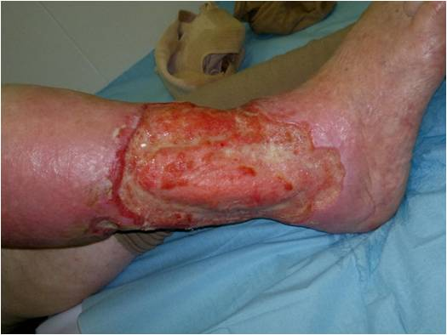
http://www.intechopen.com/books/skin-grafts/treatment-of-leg-chronic-wounds-with-dermal-substitutes-and-thin-skin-grafts

- Discuss the impact of this wound on the client- Include at least three (3) examples in discussion.
- Discuss the impact of this wound on his family- Include at least three (3) examples in discussion.
- Discuss at least six (6) factors related to the client and his lifestyle that might impact on the healing of his wound.

- Discuss the education related to the five (5) factors from the case study that you found in question 3 which needs to be provided to the client to improve the potential for the wound to heal.

- Provide at least two (2) resources that you could use to provide this education to the client (this may include the use of Health Team members). Give:
a. The name of the resource
  - Where to find the resource- or how to access or contact this resource.
- Give two (2) resources, from educational sources or professional organizations that you might access to provide/increase your knowledge in relation to the wound care of the client. Give:
a. The name of the resource
  - Where to find the resource or how to access or contact this resource.
- Provide at least three (3) risk control measures you would implement for this wound dressing in the hospital/ward environment to reduce infection risk, related to specific practices you would use to reduce infection.
- Provide at least three (3) risk control measures you would educate the client about so that he might reduce his infection risk. (What you need to tell him to reduce the risk of infection in the hospital and later in the home).
- Discuss the two (2) products given for each level of dressing that may be suitable for use in dressing this client’s wound, why use the specific product and the benefits, of this specific product.
a. 2-Wound Cleansing Products
  - 2-Primary Dressing Product/s
  - 2-Secondary Dressing Product/s

- Discuss the services you will need to organise for this client while attending to his discharge planning. Include the rationale for organising each service.

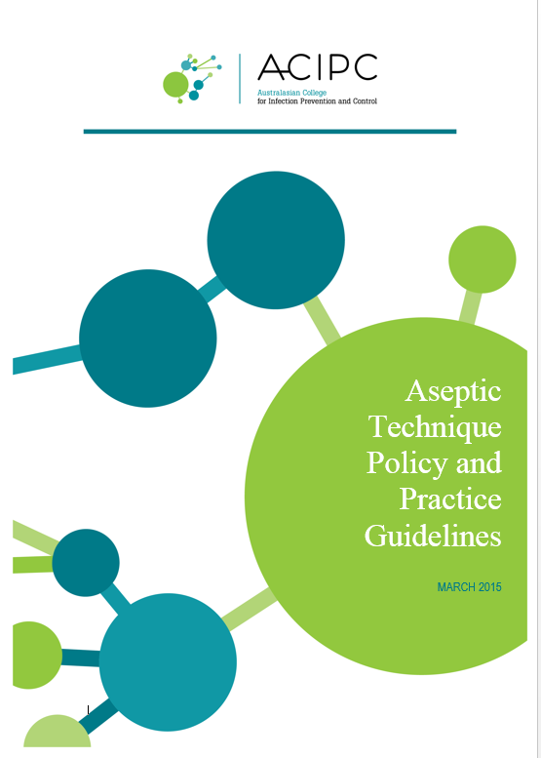

This workbook has been developed to provide you with the theoretical knowledge in aseptic technique prior to attempting to gain practical competency in procedures requiring surgical and/or standard aseptic technique.

You are required to read and review all content, complete the short answer assessment questions and submit as part of this assessment.

Table of Contents
What is Aseptic Technique? 3
What is “AT”? 3
Why practice AT? 3
Aseptic Techniqueand HAI 3
What are Key Sites? 3
What are Key Parts? 3
Preventing Infections using Aseptic Technique 3
Environmental Control 3
Hand Hygiene 4
Protective Personal Equipment 4
Aseptic Field Management 5
Non-touch Technique 5
Sequencing 5
Types of Procedures 5
Performing an Aseptic Procedure 6
1. Preparation 6
2. Procedure 6
3. Decontamination 6
Self Assessment 7

What is Aseptic Technique?
Aseptic technique aims to prevent pathogenic organisms, in sufficient quantity to cause infection, from being introduced to susceptible sites by hands, surfaces and equipment. (NHMRC Guidelines)

Aseptic technique protects patients during invasive clinical procedures by employing infection control measures that minimise, as far as practicably possible, the presence of pathogenic microorganisms.

What is “AT”?
“AT” or Aseptic Technique is an evidenced based practice that provides clinicians with a standardised approach to procedures ensuring adherence to the principles of aseptic technique.

Why practice AT?
Aseptic Technique reduces the risk of health care associated infections and has been shown to significantly improve the practices of clinicians performing procedures and reduce the risk of infection. It is required for all invasive procedures.

Aseptic Technique and HAI
HAIs are infections acquired in healthcare facilities and occur as a result of healthcare interventions, they are caused by the transfer of pathogens to a patient during a healthcare intervention.
Correct Aseptic Technique prevents contamination and transfer of pathogens from hands, surfaces and equipment to the patient during procedures. This is achieved by:
- Identifying key parts and key sites and protecting them at all times
- Key parts must only come into contact with other key parts and/or key sites.

What are Key Sites?
Key sites include any non-intact skin and insertion or access sites for medical devices connected to the patient.

Examples include insertion/access sites of intravenous devices, urinary devices, open wounds etc.

What are Key Parts?
Key parts are the sterile components of equipment used during the procedure.
Examples include bungs, needle hubs, syringe tips, dressing packs etc.

Preventing Infections using Aseptic Technique
There are several key Infection Control Components to consider when performing any invasive procedure:
Environmental Control Non-touch technique
- Hand Hygiene Sequencing
- PPE Selection Aseptic Field management

Environmental Control
Prior to aseptic procedures, healthcare workers must ensure that there are no avoidable nearby environmental risk factors, this might include (but is not limited to):
- Bed making
- Patients using commodes
- Waste management
- Cleaning of the nearby environment
- Patient bed curtains across work area.

Hand Hygiene

Effective hand hygiene is an essential component of AT.

Dependant on the procedure about to be performed either routine or surgical hand hygiene is required. Routine Hand Hygiene refers to the use of soap/solution and water or an alcohol based hand rub. Surgical hand scrub requires the use of an approved antimicrobial skin cleanser or waterless hand rub formulation

Routine Hand Hygiene
Use of alcohol-based hand rub
- Apply the amount of alcohol-based hand rub recommended by the manufacturer onto dry hands.
- Rub hands together so that the solution comes into contact with all surfaces of the hand, paying particular attention to the tips of the fingers, the thumbs and the areas between the fingers.
- Continue rubbing until the solution has evaporated and the hands are dry (approx. 20-30 secs).
Using soap (including antimicrobial soap) and water
- Wet hands under tepid running water and apply the recommended amount of liquid soap.
- Rub hands together for a minimum of 15 seconds so that the solution comes into contact with all surfaces of the hand, paying particular attention to the tips of the fingers, the thumbs and the areas between the fingers.
- Rinse hands thoroughly under running water, pat dry with single-use towels.

Surgical Hand Hygiene
Surgical hand preparations reduce the release of skin bacteria from the hands for the duration of the procedure. Surgical hand preparation must eliminate the transient and reduce the resident flora.

See your facilities specific policies and procedures on which product and methods of surgical hand hygiene must be followed.

Protective Personal Equipment

Glove use:
Gloves are single-use items.
- If it is necessary to touch key parts or key sites directly, sterile gloves must be used to minimise the risk of contamination
- If key parts or key sites are not touched directly non-sterile gloves may be necessary to protect the clinician from blood or body fluids or exposure to toxic drugs during administration
- Selection of sterile or non-sterile gloves is also dependent upon healthcare worker competency. When preparing for the procedure healthcare workers should assess their own competence and experience in performing the procedure and determine whether touching of key parts or sites is required. If touching may take place sterile gloves are required.
Gloves do not replace the need for hand hygiene. Hand hygiene must be performed before and after glove use.

Other PPE:
Other PPE should be worn in line with standard precautions to reduce the risk of blood and body fluid exposure to the clinician.

Maximum barrier precautions

Maximum barrier precautions may be required during invasive procedures to reduce the risk to the patient of acquiring a healthcare associated infection If Maximum barrier precautions are required a mask, cap, sterile gown and sterile gloves must be worn and large sterile drape/s used; any person assisting with the procedure must wear a cap and mask. Refer to local policy and procedures to determine if maximum barrier precautions are necessary.

Aseptic Field Management
Prior to commencing a procedure requiring AT, it is imperative the clinician determines the aseptic field required and how that field will need to be managed.

General aseptic fields are used when-
- Key parts are easily protected by critical micro aseptic fields and non-touch technique
- The main aseptic field does not have to be managed as a key part.
Management of the general aseptic field requires key parts be protected by Critical Micro Aseptic field (critical micro aseptic fields are those key parts protected by syringe caps, sheathed needles, covers or packaging). Asepsis of the immediate procedure environment is therefore promoted by general aseptic field management.
Critical aseptic fields are used when-
- Key parts/sites are large or numerous and can’t be easily protected by covers or caps or can’t be handled with a non-touch technique.
- Invasive procedures require a large aseptic working area.
Management of the critical aseptic field requires only sterilised equipment to be placed in the aseptic field; sterile gloves are required to maintain asepsis.

The aseptic field must be managed to ensure that key parts and key sites are protected. The aseptic field should be prepared as close as possible to the time of actual use. The clinician should select a tray or trolley of an appropriate size to ensure key parts are adequately contained within the aseptic field.

The tray or trolley must be disinfected with an appropriate disinfectant wipe and allow to dry before placing any items in or on the tray or trolley. If a surface remains wet then asepsis will be compromised.

The aseptic field may also need to be extended by draping the patient. The sterile drape will provide additional work space where sterile equipment may be placed as well as protecting the key site from contamination.

Non-touch Technique
Non-touch technique is an important component of AT, even when sterile gloves are used. It is well documented that hand hygiene is not always correctly performed and that even correctly performed hand hygiene cannot always remove all pathogenic organisms. Therefore, a non-touch technique is a vital component of achieving asepsis. Non-touch technique is a technique where the clinician’s hands do not touch, and thereby contaminate key parts and key sites. The safest way to protect a key part is not to touch it.

Sequencing
When performing a procedure practice must be sequenced to ensure an efficient, logical and safe order of procedure events. Practice guidelines provide direction as to the correct order in which preparation and completion of the procedure should be undertaken. Clinicians should be familiar with the sequence of these events prior to commencing the procedure to ensure preparation for the procedure is complete and to ensure adherence to AT.

Types of Procedures
There are two different applications of Aseptic Technique which help guide practice, performance and equipment dependent on the procedure about to be performed.

Standard AT
Standard Aseptic Technique is required for clinical procedures that are technically simple, short in duration (approximately less than 20 minutes), and involve relatively few and small key sites and key parts. Standard Aseptic Technique requires a main general aseptic field and may require non-sterile gloves only (this can be dependent on clinician competence in performing the procedure). The use of critical micro aseptic fields and a non-touch technique is essential to protect key parts and key sites.

Surgical AT

Surgical Aseptic Technique is required when procedures are technically complex, involve extended periods of time, large open key sites or large or numerous key parts. To counter these risks, a main critical aseptic field and sterile gloves are required and often maximum barrier precautions.

Surgical Aseptic Technique should still utilise critical micro aseptic fields and non-touch technique where practical to do so.

Performing an Aseptic Procedure

Risk Assessment
Prior to commencing the procedure, the clinician should consider the potential risks to either the patient or themselves as a result of the procedure.

A risk assessment should be performed using the following steps:

- Determine the type and complexity of the procedure.
- Determine what are the key parts and key sites.
- Determine whether the key parts or key sites need to be touched.
- Determine the appropriate infection prevention measures to protect key parts and key sites.

Preparation
Once the clinician has determined whether the procedure requires standard or surgical Aseptic Technique they should apply any environmental control measures required and ensure access to the appropriate PPE.

The clinician should then perform hand hygiene, clean the tray/trolley/work surface with detergent and water or detergent wipe and then identify and gather equipment for procedure. It is important to inspect packaging for damage; check sterility indicators and expiry dates and ensure any additional equipment, such as a tourniquet, is clean.

Once the clinician is positioned where they will undertake the procedure they should again perform hand hygiene and prepare the critical or general aseptic field, dependant on whether the procedure requires standard or surgical AT. They should then position and prepare patient, using gloves where appropriate to protect from potential body fluid exposure or harmful substances. If gloves are used in preparation for the procedure, these must be removed prior to performing hand hygiene for the procedure.
- Procedure
When the clinician has ensured they are ready to commence the procedure and have the required equipment they should again perform hand hygiene (for standard aseptic procedure, clean hands effectively with soap and water or ABHR, if performing a surgical aseptic procedure a surgical hand scrub is required).

Apply gloves. If the procedure requires surgical Aseptic Technique OR it is likely key parts or key sites will be needed to be touched directly, sterile gloves MUST be used to minimise the risk of contamination. Otherwise, non-sterile gloves are typically the gloves of choice for standard aseptic procedures where potential body fluid exposure or contact with harmful substances may occur.

Perform the procedure ensuring all key parts/components are protected at all times. Sterile items must only be used once and disposed into waste bag. Only sterile items may come in contact with key sites and sterile items must not come into contact with non-sterile items.

- Decontamination
On completion of the procedure the clinician should remove their gloves and perform hand hygiene, dispose of all waste (including sharps), and clean equipment and again perform hand hygiene

Self-Assessment
You are now ready to complete the following theoretical assessment. You should complete this assessment prior to undertaking your practical assessment for Standard and Surgical Aseptic Technique.

- What is Aseptic Technique?

- When is an aseptic technique required?

- Why is Aseptic Technique important?

- What is the difference between Key Sites and Key Parts?

- Name 3 Infection Control Components of AT?

- What are some potential Environmental risks that should be avoided when performing a procedure?

- What are the two different types of Aseptic Technique which help guide practice and Infection Control components?

- Describe two methods of performing routine hand hygiene?

- If Surgical Aseptic Technique is required for a procedure what method of hand hygiene is acceptable?

- If key parts or sites will be touched during a procedure what gloves are required?

- What considerations should be taken if there is a risk of a body fluid exposure during a procedure?

- Name the two different types of Aseptic Fields

- When should a general aseptic field be used?

- When is a Critical Aseptic field required?

- What is a critical micro aseptic field?

- What is Non-Touch Technique?

- Why is the order in which the procedure is undertaken important when considering aseptic technique?

- What is the initial step that should be undertaken prior to preparing for a procedure?

- When performing a procedure what are some key components to maintaining asepsis?

- What activities are required on completion of the procedure?

