Week 6: Defend the Modern Leadership Role of Minority Leaders

Instructions (5 pages):

Modern Leadership Styles
To explore and illuminate the various traits for each modern leadership style, as well as the differences and similarities between them, create a four-quadrant matrix or chart that includes each of these styles. Using brief bullet points or in each chart cell, list the key traits associated with each style: note where the traits converge and diverge between styles.
Your matrix/chart will serve as a quick reference as you analyze well-known modern leaders.
Given all of the attention on transformational leader over any other modern leadership style, it stands to reason those traits transformational leader would include most, if not all, of the traits associated with all other modern leadership styles. What do you think? View this video to learn more about Transformational Leadership (transcript attached) from Dr. Peter Earley.
Does your matrix/chart provide evidence for this?
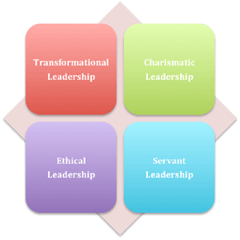
Culture and Leadership

Modern leaders come in all colors, shapes, and sizes. Consider the issues related to minorities (based on gender, ethnicity, and sexual orientation) and the well-documented glass ceiling that has plagued and continues to affect certain populations. It is no secret that Caucasian men fill the majority of leadership positions, particularly in business, and while women have made advances in this arena, they and other minority groups still struggle to be recognized as leaders in their fields.

- Identify at least four (4) minority leaders (in any industry) who exhibit traits from each modern leadership style. Develop an inventory for each leader in which you provide concrete, evidence-based examples (found in press releases, news articles, websites, etc.) of traits from these leadership styles for each leader. Use any format that can be inserted into Word as an appendix to the reflection. Here is one example:
 | Leader 1 | Leader 2 | Leader 3 | Leader 4
Transformational | - trait & evidence  - trait & evidence  - trait & evidence
Charismatic
Ethical
Servant

- Reflect on the findings of this discovery exercise in the context of defending the need for diversity in organizational leadership, factoring in organizational culture, ethics, and leading diverse workforces. Be sure to touch on the struggles minorities have faced in securing leadership roles in organizations despite the modern leadership styles evidenced in current minority leaders.
Support your reflection with minimum of five resources. In addition to these specified resources, other appropriate scholarly resources, including older articles, may be included.
Resources (all MANDATORY sources for this assignment are attached on Zip File)

