Part I
Here is a table of road miles (via most direct routes) and flight time among five cities.
Green cells (above diagonal): Highway miles
Blue cells (below diagonal): Flight time (hrs:mins)
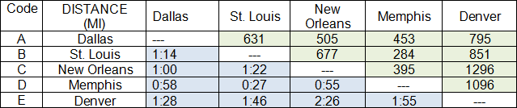
A traveler wants to visit all these cities by car, beginning and ending in Dallas. Find the round trip with the fewest miles. To simplify your work, please use the one-letter codes instead of city names; for example, A=Dallas. Use the “by-hand” scheme described on the module Home page.
- How many non-redundant routes are there, total? Use the formula.
- List them.
Help for 2, above.  Here’s a partial solution. →  The first figure is the flowchart used to find all possible routes, and the second figure is the list of routes and mirror routes used to find the redundancies.  We’re giving you this head start because the purpose of the problem is not to waste hours, but rather to introduce you to the complexity of the general TSP. Five stops is near the upper practical limit for hand solutions. Anything larger requires a computer app. | 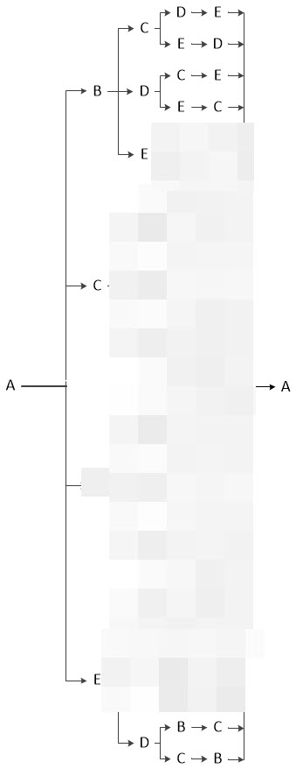
- Which is the shortest route?

Help for 3, above.  You may use the Excel app →  TSP Route Calculator.xlsx | 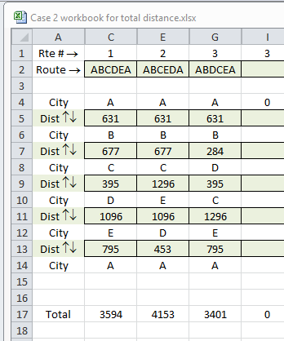

Part II
For all of its complexity, given more than four or five cities, the TSP may still be unable to deal with the real world. Consider the “too simple” problem of three cities, mentioned on the Module 3 Home page. A is an airline hub, such as Atlanta; B and C are satellite cities. There are flights between A and B, and also between A and C; but there are no flights between B and C, other than through A. Here’s the relevant information.
Via Air: | Flying Time (hrs:mins) | Airfare
A→B | 1:30 | $500
B→A | 1:30 | $420
A→C | 0:50 | $380
C→A | 0:50 | $300
C→B (via A) | 2:30 (incl. layover at A) | $400
B→C (via A) | 3:50 (incl. layover at B) | $590
Via rental car | Driving time | Mileage + drop-off fee
B→C | 3:45 | $120
C→B | 3:45 | $100
A salesman wants to visit all three cities on one day, starting and finishing in A.
- What’s his best plan, if he wants to minimize time?
- What’s his best plan if he wants to minimize cost?
Part III
This part of the Case drives home the following point: The TSP may be easy to describe, but it’s hard to solve for other than simple problems. But in addition to that, it’s sometimes difficult to decide which data to use when setting up the problem.
- Go to any online travel site. Fill in the following table for daily, weekday (M-F) one-way flights between New York and Los Angeles. Include data for at least two different airlines, two different classes of service (Coach/Tourist and Business/First), and two different departure times.
WEEKDAY FLIGHTS FROM JFK TO LAX (One way non-refundable)
 | Airline | Class | Depart (EDT) | Arrive (PDT) | Time Enrt (HH:MM) | Intermediate stops (if any) | Price (undiscounted)
1
2
3
4
5
6
7
8
- Assume you’re planning a business trip. What business-related factors would you consider, when choosing one of the flights listed above? Feel free to make up hypothetical factors affecting an imaginary business. (Have fun!)

Assignment Expectations
- There are no page limits. Write what you need to write, neither more nor less. Make each sentence count! (Having said that; it’s unlikely that one page would be enough, and very likely that eight pages would be too much.)
- Ensure that your answer reflects your detailed understanding of the theory and techniques taught in this module.
- References and citations are required. This requirement can be satisfied by citing the module Home page.
- Follow the instructions in the Writing Style Guide.

