Week Five - Intellectual Elaboration
Within Week Five, there is a continued focus on the ethics of justice, critique, care and the profession. This week also incorporates collaborative decision making as it relates to ethical leadership qualities.
The phrase “a seat at the table” has become a common description for the empowerment and inclusion of underrepresented stakeholders while enhancing their capacity to communicate and hold power. A seat at the table includes “the practice of consulting and involving members of the public in the agenda-setting, decision-making, and policy-forming activities of organizations or institutions responsible for policy development” (Rowe and Frewer, 2004). A major responsibility of an ethical educational leader is to invite, receive, and encourage a diverse group of stakeholders to have a seat at the table. Figure 1 shows key elements the ethical educational leader exercises by including all stakeholders at the table through shared and distributed leadership.

Figure 1: Shared Leadership
Success as a leader is often determined by one’s ability to work collaboratively with all relevant stakeholders. According to Huxam and Vangen (2004), collaborative design is made up two elements: structure and process. Structure refers to having the right people at the table and ensuring meaningful representation (Huxam & Vangen, 2004). This means that people are not just asked to participate, but that their opinions are given voice and valued. No one person is more important than the others nor can those in positions of power assert their own voices above the rest. Process refers to how people at the table interact. The strength of these interactions is often dependent upon trust and honest dialogue (Huxam & Vangen, 2004). When successful structure and processes are in place, collaborative design can lead to prolonged, coordinated action and communication.
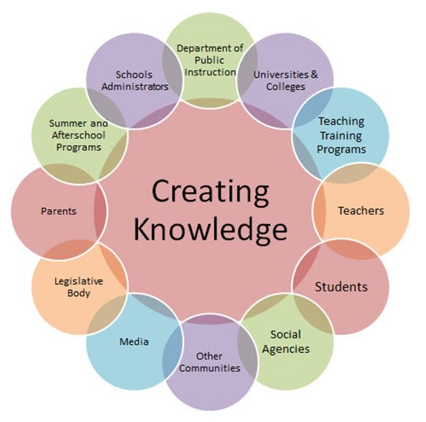
Figure 2: Common Education Stakeholders (Adapted from Pan American Consulting Services, 2011)
Because schools can often be seen as exclusionary rather than inclusionary, especially in regards to important decision making processes, it is essential that educational leaders ensure all stakeholders are considered and included in decision making. Collaborative decision making includes information from the ethics of justice, critique, and care (Weeks One-Three) and Data-Driven Decision Making (Week Four).
Figure 2 includes a list of educational stakeholders. While not exhaustive, it captures some of the common stakeholders the education system includes.
Teachers and educational leaders should ensure that the voices of their students are also given value and are well received within and outside of the classroom. The following video is a great motivator for educators who seek to be advocates for positive change and to make real and personal connections with their students.
- Pierson, R. (2013, May). Rita Pierson: Every kid needs a champion (Links to an external site.)Links to an external site. [Video File] Retrieved from http://www.ted.com/talks/rita_pierson_every_kid_needs_a_champion

Week Five Assessment Guidance
Within Week Five, different dilemmas pertaining to the field of education are considered using the all the previously explored lenses of ethical leadership as well as collaborative decision making. The following guidance provides detailed support as you participate in discussions and complete the assignment. Be sure to read through this guidance as well as review the individual links for each assignment and their corresponding rubrics.
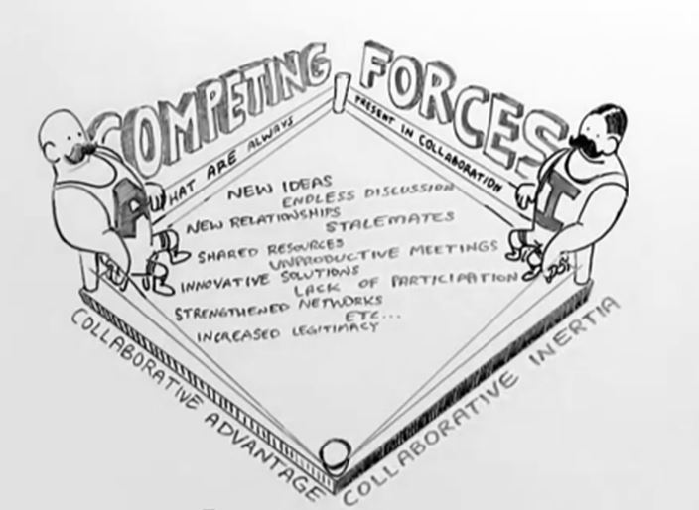
Figure 3: Competing Forces in Collaboration, Koschmann (2012)
Discussion: Collaborative Decision Making
View the Koschmann (2012) video in order to complete Week Five’s discussion. In the video, Koschmann uses the work of Huxam and Vangen (2004) to describe the competing forces within collaborative efforts as collaborative advantage and collaborative inertia.
A great analogy for this is that of a boulder at the top of a mountain. Collaborative advantage is what holds the boulder up whereas collaborative inertia is what tries to pull the boulder down. If continual effort is not put into the collaborative effort and the boulder is left to its own devices, it will succumb to gravity and roll down the mountain on its own (Koschman, 2012).
For the initial discussion post, you will describe the terms collaborative advantage and inertia in relation to educational leadership, provide examples from work experience, and describe the ways in which the decision was carried out and sustained.
Assignment: Case Study: Plan of Action
This week’s assignment is a follow-up on the case-based dilemmas presented in Weeks One-Three. For this assignment, there are two options. You can either choose a case study from the textbook that was not previously used in any of the discussion posts or a case from personal experience can be utilized. If the second option is chosen, then it is up to you to ensure that the case has a definitive ethical issue to discuss and that complete anonymity is guaranteed. As this is going to be a multimedia presentation, required elements include speaker notes, in-text citations, use of media, and a length of approximately eight-to-ten slides. Software such as PowerPoint or Google Docs may be used or digital presentation tools such as SlideRocket, Present.me, or others.
This assignment will be shared in the Week Six Discussion by either attaching your presentation or providing a link to a digital presentation if used.

Looking Ahead in EDU689!
As mentioned, the presentation you create this week will be shared in the Discussion next week. The purpose is to receive and use constructive feedback from your fellow classmates when making modifications for improvement to the presentation as required in the Final Project.

References
Strategy on blackboard [Figure 1]. Retrieved from http://i.istockimg.com/file_thumbview_approve/27242128/2/stock-photo-27242128-strategy-on-blackboard.jpg
Huxham, C. & Vangen, S. (2004). Doing things collaboratively: Realizing the advantage or succumbing to inertia? Organizational Dynamics, 33(2): 190-201.
Koschmann, M. (2012, December 13). The collaborative challenge: Making quality decisions together in the age of complexity [Video File]. Retrieved from https://www.youtube.com/watch?v=iN_A7keXtVg
Rowe, G. & Frewer, L. J. (2004). Evaluating public-participation exercises: A research agenda. Science, Technology, and Human Values, 29(4), 512-556.

