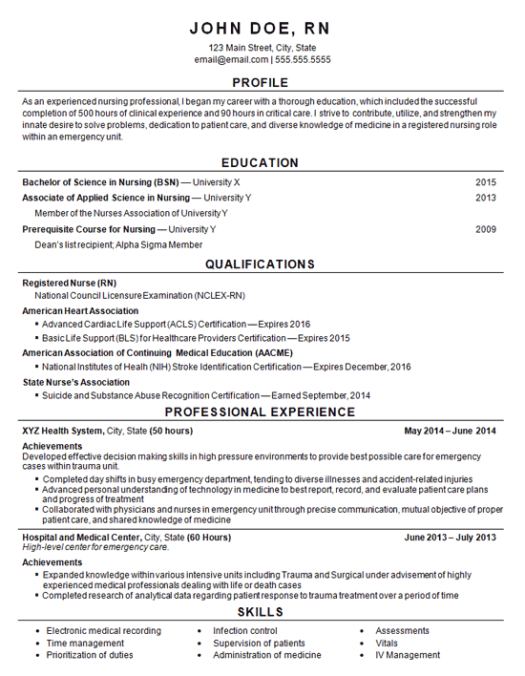

My Information to Add In resume
Education
Currently enrolled in Bachelors of Science in Nursing in Grand Canyon university
Diploma In General Nursing and Midwifery 2003-2006
Qualification
Registerd Professional Nurse 2016
Licensed Practical nurse 2014
Certification
- IV certified
- CPR certified
Professional Experience
Amar hospital Patiala, India
- Medications
- Wound dressing
- Tube feedings
- Bedside patient care

Amrit Clinic Malerkotla India
- Care for pediatrics
- Assisted doctors in surgeries
Maxim health Care North Brunswick, Nj
- Care for clients at their home
- Tracheostomy care- suctioning, tracheostomy change
- G-tube care-tube medications and feeding
- Accompany clients to physician’s appointment
- Complete nursing care and documentation

Bayada Home Health Care

- Care for clients at their home
- NG tube insertion- NG tube feeding and medications
- G-tube feeding, medication and care
- Care for Quadriplegic patients
- Open New cases for home care
- Supervisory visits to patients at their home
- Complete nursing care and documentation

Awards Received
- Care Giver of the Quarter in Maxim Health care
Language
- English, Hindi and Punjabi
Licensure -Registered Professional Nurse in New Jersey
Expire Date 05/31/2019

