BUS-660 Lecture 2
Introduction
Decision analysis models generally present expected results associated with several possible alternatives that face the decision maker so that the alternative with the best-expected result can be chosen.
An important point to keep in mind is that decision analysis models should be used only when the number of alternatives is finite. Another point to note is that decision analysis models sometimes deal with situations in which there is uncertainty and risk, and their goal is then to reduce, or eliminate when possible, the risk. A final important point is that decision analysis models are usually used to make a one-time decision, but the method can be extended to address dynamic or sequential decisions made at multiple points in time.
One advantage of decision analysis models is that most of these models can actually be solved manually by hand, perhaps with the use of a calculator. In more complicated situations, one can use Excel to perform the calculations.
The Typical Structure of Decision Analysis Models
Most decision analysis models are characterized by the following four elements:
- Alternatives - options or courses of action.
- States of nature - scenarios, usually future scenarios.
- Probabilities - of the states of nature.
- Payoffs - that quantify the outcomes of the various alternatives for each state of nature.
The following illustrates the approach using a concrete example: Consider the case where two types of toasters were manufactured: Model A (realizing a gross profit of $5/toaster) and Model B (realizing a gross profit of $8/toaster). In 2009, the business is humming along nicely and the owner, Bob, is delighted with the $14,400/month (or $172,800/year) profit that will be realized in the coming year.
The marketing analyst, Jean, follows the toaster market carefully, and has developed long-range scenarios for the next four years. It turns out that the market for toasters is highly dependent on the average disposable household income, a fact that she determined using a regression analysis. Jean has found out from delving into long-range financial forecasts that three scenarios are relevant to toaster demand in the next 4 years:
Scenario 1: Average disposable household income will see a sharp rise (adjusted for inflation). The likelihood of this happening is 30 percent (or 0.3).
Scenario 2: Average disposable household income will stay roughly the same (adjusted for inflation). The likelihood of this happening is 50 percent (or 0.5).
Scenario 3: Average disposable household income will drop significantly (adjusted for inflation). The likelihood of this happening is 20 percent (or 0.2).
The analysis leads her to the following average monthly demand forecast for Model A and Model B toasters (assuming that the profit/unit does not change):
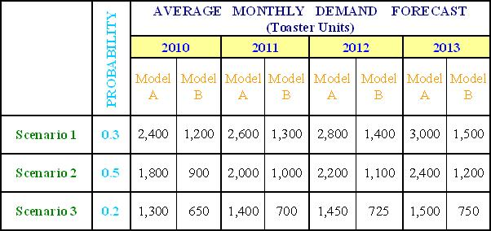
The business presently has enough capacity (people, space, machines, etc.) to produce only 1,600 Model A and 800 Model B toasters. Bob can add or reduce capacity in increments (moving up or down a certain number of “levels”). The operations manager, Ted, has come up with four alternatives and their associated cost and production implications are shown below.
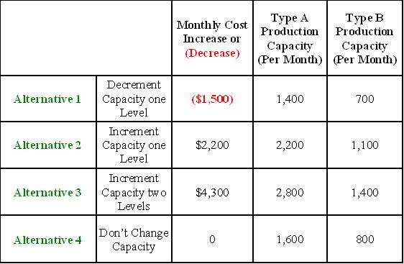
Bob enters the office on the morning of September 26 and sees two reports on his desk – one from Jean and the other from Ted. They essentially contain the respective tables shown above, along with some related clarifying information. He realizes that in order to implement any of Ted's first three alternatives, preparations must begin by October 15 to be ready by January 1 in order to operate at the new level of production. What decision should Bob make and why? This decision is too important to delegate to someone else, so he resolves to tackle the situation on his own.
First, Bob realizes that the decision is not obvious, and he needs to determine how each alternative (identified by the operations manager) plays off against each scenario (identified by the market analyst). Bob, however, is still not sure which modeling technique to use until he realizes that the first three of the four steps of the decision analysis modeling procedure have already been done:
- Alternatives (options or courses of action): Four alternatives already identified by Ted.
- States of nature (scenarios, usually future scenarios): Three scenarios already identified by Jean.
- Probabilities (of the states of nature): Jean provided these.
- Payoffs (that quantify the outcomes of the various alternatives for each state of nature).
Bob is delighted that all that is left to compute are the payoffs. That means that he must first determine how many toasters will sell under each scenario and alternative. Using Excel, creates a table as follows:
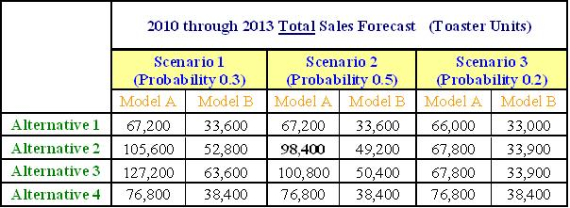
To compute total Model A unit sales per month under Scenario 2, Alternative 2, note that Alternative 2 allows for production of 2,200 Type A toasters per month (per Ted's analysis). Next, Jean's analysis shows that Scenario 2 forecast for Model A toasters is 1,800/month in 2010; 2,000/month in 2011; 2,200/month in 2012, and 2,400/month in 2013
In 2010 (under Alternative 2), the number of toasters that can be produced per month is 2,200, but the demand is only 1,800 so it makes sense to produce only 1,800 (and sell all of them) per month even though it means that some capacity is wasted. Likewise, in 2011 and 2012, the numbers produced would be 2,000 and 2,200 (respectively) and all would sell. In 2012 however, 2,400 could sell per month but only 2,200 can be produced, so the 2,200 number has to be used in 2012. That yields a total of 98,400 unit sales of Model A toasters from 2010-2012 in the Scenario 2, Alternative 2 case.
Now convert the table into profit dollars for the period. This is easy, knowing that each Model A yields $5 gross profit and each Model B yields $8 gross profit. Hence, the gross profit table looks as follows:
 | 2010 through 2013 Total Gross Profit Forecast (Thousands of $)
 | Scenario 1 (Probability 0.3) |  | Scenario 2 (Probability 0.5) |  | Scenario 3 (Probability 0.2)
 | Model A | Model B | Model A | Model B | Model A | Model B
Alternative 1 | 336.0 | 268.8 | 336.0 | 268.8 | 330.0 | 264.0
Alternative 2 | 528.0 | 422.4 | 492.0 | 393.6 | 339.0 | 271.2
Alternative 3 | 636.0 | 508.8 | 504.0 | 403.2 | 339.0 | 271.2
Alternative 4 | 384.0 | 307.2 | 384.0 | 307.2 | 384.0 | 307.2
The costs associated with the four alternatives have not been factored in: the table shows gross profit but not operating profit. That is, it shows the profit derived from sales of the toasters but does not factor in the operating costs or savings associated with each alternative. Under Alternative 1, Scenario 1, for example, the gross profit is 336,000 plus 268,800 equals $604,800. However, there is also a saving of $1,500 per month in operating expenses, so that the operating profit would be $604,800 plus 48(1,500) equals $676,800 over the four year (or 48 month) period. For Alternatives 2 and 3, the numbers in the above table would have to be reduced because of the extra operating costs. Of course, for Alternative 4 the operating cost neither increases nor decreases.

Applying this reasoning, the table is as follows:
2010 through 2013 Total Operating Profit
(in thousands of $)
 | Scenario 1  (Probability 0.3) |  |  | Scenario 2  (Probability 0.5) |  |  | Scenario 3  (Probability 0.2)
 | Gross Profit | Operating Expense Increase or Decrease | Operating Profit | Gross Profit | Operating Expense Increase or Decrease | Operating Profit | Gross Profit | Operating Expense Increase or Decrease | Operating Profit
Alternative 1 | 604.8 | (72.0) | 676.8 | 604.8 | (72.0) | 676.8 | 594.0 | (72.0) | 666.0
Alternative 2 | 950.4 | 105.6 | 844.8 | 885.6 | 105.6 | 780.0 | 610.2 | 105.6 | 504.6
Alternative 3 | 1,144.8 | 206.4 | 938.4 | 907.2 | 206.4 | 700.8 | 610.2 | 206.4 | 403.8
Alternative 4 | 691.2 | 0.0 | 691.2 | 691.2 | 0.0 | 691.2 | 691.2 | 0.0 | 691.2
Note that, until now, we have not used the probabilities associated with each of the three scenarios. It may be noted from the study of probability that when there are several outcomes, each of which has a known probability of occurrence and a known payoff, the expected payoff is simply the sum of the products of probability and payoff. Hence, the expected operating profit associated with Alternative 1 is 676.8 times 0.3 plus 676.8 times 0.5 plus 666 times 0.2 equals 674.64K or $674,640. The expected payoffs for Alternative 2, Alternative 3 and Alternative 4 are computed similarly and shown below:
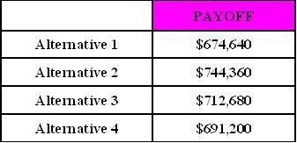
Clearly, Alternative 2 has the highest payoff, and hence is the preferred alternative.
This example essentially illustrates all the key concepts associated with decision analysis. There are many types and flavors of decision analysis, but, in one way or another, the thought process involved resembles that of this example very closely, even though some types and flavors may be less complicated and some more complicated.
Finally, note that a tabular approach was used in this example. Sometimes, a tree approach is used, hence the term decision tree. Despite the differences in terminology, the ideas remain the same. It is recommended that students rework the example above using a decision tree approach. Using the tree approach may add some visual clarity to the approach but really does not change the computations or complexity of the solution.

Conclusion
This lecture explored how to set up and solve decision analysis models, most of which involve identifying alternatives (options) in the light of certain scenarios (sometimes referred to as states of nature). The probability of the scenarios is then assessed and these are used to calculate the expected payoffs of the various alternatives. The choice is often a matter of individual preference. In general, the decision is made in favor of the alternative with the best payoff. The actual computational setup lends itself to either a tabular approach or a tree approach. Students should also recognize that much of decision theory is based on the assumption that rational decision making occurs. Moreover, quantitative models often reflect the axiom “garbage in – garbage out.” For example, probabilities can be objective or subjective. The probability of precipitation in a given location is objective since it is based on National Weather Service historical data. The probability assigned to a competitor's reaction in the marketplace may be more subjective. Similarly, the universe of states of nature may not be entirely known.
Copyright 2015. Grand Canyon University. All Rights Reserved.

