Answer /discuss the following 5 questions. Your answers should be 2-3 sentences long with detailed explanations. Also solve the following 4 problems and include detailed formulations, calculations and explanations.
Questions:
1) What doping means in a semiconductor?
2) What are the majority carriers in an n-type semiconductor and why?
3) Are there any "Holes" in conductor materials? Why not?
4) How do you forward-bias a diode?
5) How do you reverse-bias a diode?
Problems:
1) Determine the voltage across each diode assuming an ideal diode.
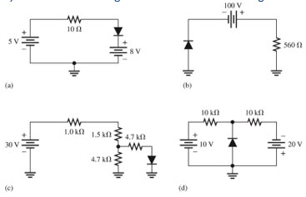
Floyd, T. (2011). Electronic Devices (Conventional version). 9th Edition. Prentice Hall.
2) show the voltage waveforms across each half of the secondary winding and across rl when a 100 v peak sine wave is applied to the primary winding
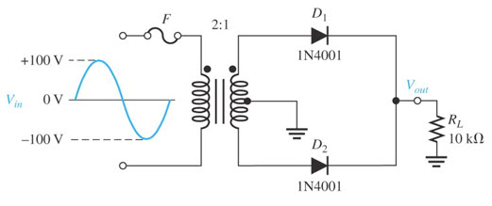
Floyd, T. (2011). Electronic Devices (Conventional version). 9th Edition. Prentice Hall.
3) determine the peak forward current through each diode
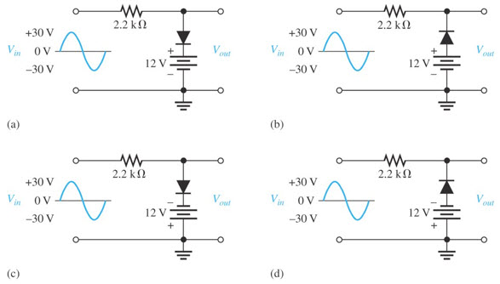
Floyd, T. (2011). Electronic Devices (Conventional version). 9th Edition. Prentice Hall.
4) Consider the meter indications in each circuit, determine whether the diode is functioning properly, or whether it is open or shorted. Assume the ideal model.
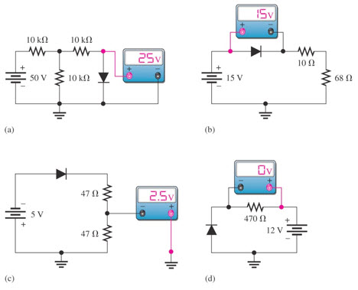
Floyd, T. (2011). Electronic Devices (Conventional version). 9th Edition. Prentice Hall.

