Walmart’s Research Analysis for Business
ECO/561 - ECONOMICS
June 26, 2017

Introduction
Walmart was founded by Sam Walton and is now the leading global industry world-wide. Walton’s vision and mission for Walmart was impacted by the success and failures of other companies. Walmart’s competitive market structure consists of multiple buyers and sellers in the market to sell or purchase a variety of goods and services. As seen over the years no other company has been able to duplicate the success and marketing strategies of Walmart stores. Even though, Walmart’s business strategies are apparent throughout the store there marketing strategies are the driving forces behind their continued success of their stores. Walmart reportedly gained the highest increase on sales, net income and dividends last year. One would say Walmart’s founder has created an industry that will probably be everlasting.
The revenue of Walmart is significantly affected by microeconomic factors like consumer choice, preference of products, employees, shareholders, creditors, and media. The macroeconomic factors affecting Walmart business could be the GDP of the economy, inflation rate, federal fund rate and prime rate. Thus, both microeconomic and macroeconomic factors play a pivotal role in reshaping the business strategy so that it can survive in the long run. The paper seeks to apply the tools of microeconomic and macroeconomic data to provide marketing analysis of Walmart’s competitive structure, trends in the demand for Walmart, price elasticity of demand, fixed and variable cost and recommendations of how to maximize revenue, profit and market sharing.

Market Analysis
Walmart believes that the main force that can drive its sustainability is its product quality and operational sustainability. Walmart’s market share operates under a monopolistic market. The marketing structure of Walmart is unbelievably strong that the opening of Walmart in a particular area leads to the closure of three retail stores in two years and the loss of 250 jobs in a given area. However, “it takes the form of both monopolistic market structure and oligopoly market structure because other retail stores and similar firms do operate like Walmart (Longo, 2009).”
The environment of the store is simple and any competitor can copy and produce the same design and offer the same price point. However, many competitors have found it difficult to imitate Walmart’s marking structure because of its overall configuration. Most consumers that shop at Walmart consider price differences alone. Buyers and sellers within Walmart’s market structure use the prices that are presented to them to influence the overall price of their products and services. Walmart’s production in retail trade is outstanding due to the sale of various products and the consumption of the consumer’s ability to buy. “The world's largest retailer Walmart shrugs off the controversy for a simple reason: The stuff it sells is cheap (Kenny, 2013).” Keeping retail strategies low and the inclusion of technology and corporate cultures Walmart is able to provide the best possible price. In the 1st quarter of 2017, the company market share was 40.72% with other competitive firm had a total market share of 59.28%. (www.csimarket.com, 2017).”
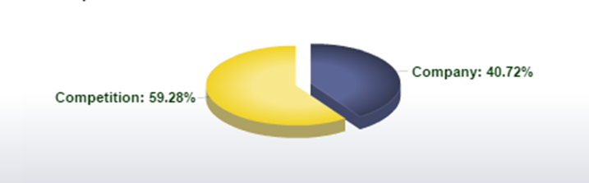
Figure 1. -- Image showing the market share of Walmart in blue compared to another firm.
The biggest competitors of Walmart include Target, Amazon Inc., Best Buy, Apple Inc. Netflix etc. Walmart is involved in the monopolistic competition therefore it has fewer barriers which include the high cost of starting a retail business and high competition from the competitor. Lower margins are prevalent due to the company’s ability to offer lower prices. Also, new start-ups would have to overcome the loyal customer of the incumbent retail store which is a difficult task to intimate.
Trends in Current Macroeconomic Indicators
The macroeconomic indicators like the current stage of the business cycle, real GDP, inflation as measured by CPI, unemployment rate, federal fund rate and prime rate is described below.
Current Stage of Business Cycle
The stage of business cycle represents the natural rise and fall of economic growth over time. The phases of the business cycle include expansion, contraction, peak, and trough. The last three year of the business cycle shows the expansion phase of US which started after the end of the economic recession (2007-2009).
Real GDP
It is one of the macroeconomic indicators which show the value of the economic output after adjusting price changes for inflation, deflation, etc. Figure 2 below shows the trend of GDP of US for the past three years (quarterly). The figure shows GDP is increasing with respect to time
Fig. 2 - Real GDP trend of US from 2014 to 2016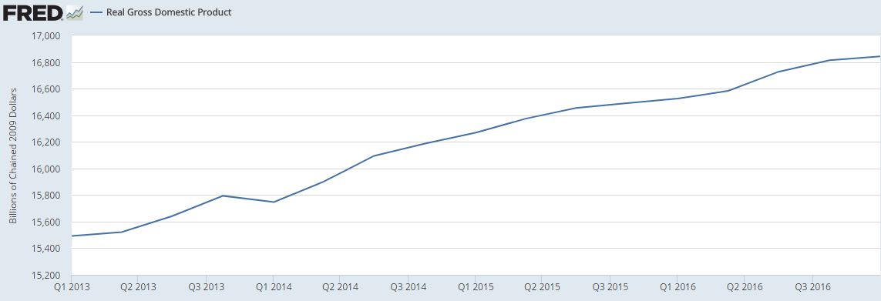
Reference: https://www.fred.stlouisfed.org
Inflation measured with CPIAUCSL
Inflation is measured as a percent change in CPI. The inflation as measured by the CPI shows that it was at the minimum in 2015 and shortly after increased continuously.
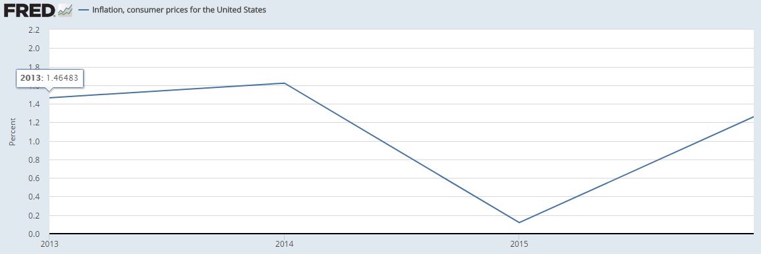
Figure 3 - Inflation as measured by CPI Reference: https://www.fred.stlouisfed.org

Unemployment rate
The unemployment rate graph shows that there is an overall decreasing trend in unemployment rate in the last three years beginning from 2014.
Figure 4 - Unemployment rate from 2014 to Jan 2017
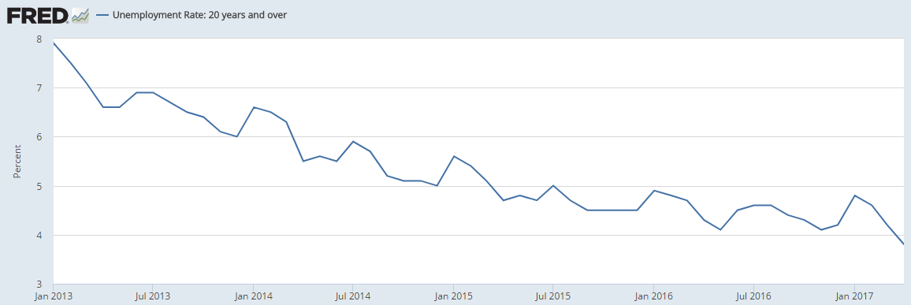
Reference: https://www.fred.stlouisfed.org

Federal Fund Rate
In the U.S. the Federal Fund Rate is the interest rate which depository establishment lend reserves balances to other banks overnight on an uncollateralized basis. The trend of the federal fund's rate is shown in Figure 5 it shows an increasing trend to January 2017.
Fig. 5 - Effective Federal Fund Rate from Jan 2014 till Jan 2017
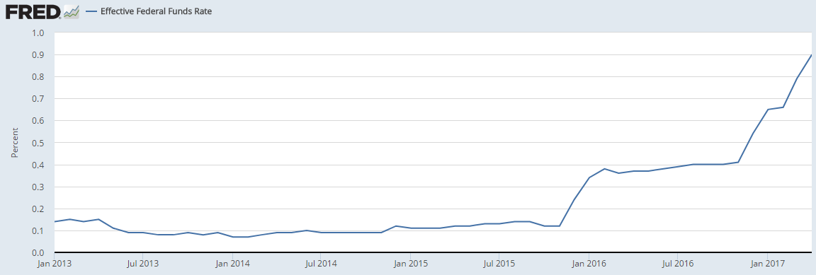
Prime Rate
It is the lowermost rate of interest at which currency can be borrowed commercially. The prime rate was constant till Sept 2016 and then showed an increasing trend as shown in Figure 6.
Fig. 6 - Prime rate trend from Jan 2014 till Jan 2017
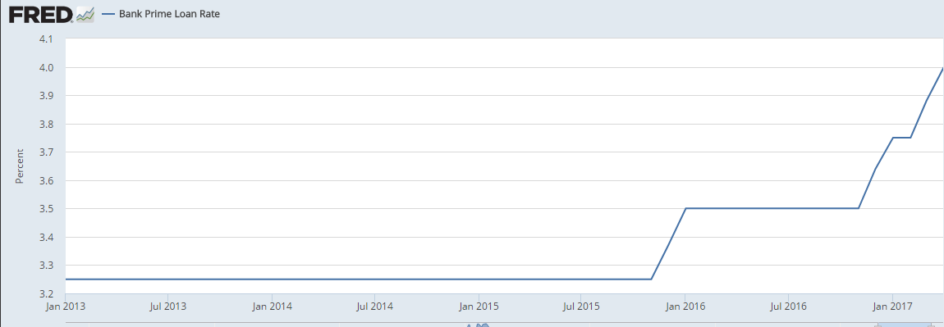

Trend in Demand for Walmart
The domestic demand of US people can be recognised through their consumption expenditure pattern. On the average US, people spend $55,978 according to Bureau of Labor statistics. The external environment of Walmart tends to lend itself towards the technological, legal, social and economic implications of the economy. Shopping at Walmart is consumer budget friendly with little or minimal effect on its profit revenue during economic shifts in the economy.
“Walmart is known for offering low prices for their goods and services especially during inflation. It is the largest firm that experiences abnormal profits from services and products that are provided to the customers (Longo, 2009).” Walmart is constantly changing their marketing strategies to evolve in the 21st century which is becoming more and more technologically advance therefore operations of the store are influenced by the demand of the consumer and macroeconomics. Walmart recognizes the consumer and not the many firms in which they operate. They are able to set their own pricing unlike many of their competitors.
Table 1 - Personal Consumption Expenditure of US
Year | PCE(Billions of dollar) | % change
2013 | 11361.2
2014 | 11863.4 | 4.42%
2015 | 12283.7 | 3.54%
2016 | 12757.9 | 3.86%

Revenue Generated by Walmart
The figure below shows the trend in revenue for Walmart. The figure below depicts the amount of revenue in 2014 increased by 9.36 billion dollars in 2015. The annual sales show that in 2014 the amount of revenue was $476 billion dollars and in another year it increased to $485 billion dollars in 2015 and decreased to $482 billion dollars in 2016. Further, the revenue earned in the second quarter of 2017 was $117.54 billion which decreased from the revenue sales of first quarter of 2017 by approximately 10%.

Price Elasticity of Demand
The price elasticity of demand is associated with how much less and how much more consumers will buy with a change in prices. It measures how quantity demanded correlates to a change in price. Elasticity of demand equals a percent change in quantity divided by a percent change in price. A small change in quantity resulting from an increase in price causes inelastic demand that is less than 1. In elastic demand prices and quantity are flexible due to the consumer taste or ability to substitute the item for another or cheaper product. “Elasticity of Demand equals a percent change in quantity divided by a percent change in price which equals a decrease in quantity divided by increase in price that is equal to 1 which represents the unit of elastic demand. When the price is inelastic the demand is perfect causing no effect (Wheelen & Hunger, 2010).” Zero percent change in quantity divided by zero percent change in price. To sum up the price elasticity of demand is when the price goes up total revenue goes down. When the price elasticity of demand goes down the total revenue goes up.
The main factor that drives or generates revenue for Walmart is the low price of retail goods compared to its competitor. The lower prices at Walmart stores encourages the consumer to purchase more products from their stores. It has been seen that Walmart follows an everyday low-pricing strategy where prices of goods are lowered every day without having any real sales for a particular product. The low pricing strategy helps the company to generate revenue and put its strong hold in the market economy.
Fixed and Variable Cost
The variable and fixed cost determines the output decision of any business organization. Fixed cost can be defined as the cost that remains fixed and does not change with the level of production, whereas variable cost change with the production or output level of the firm. Marginal cost is defined as the cost added by generating one additional unit of a product or service. In some cases when there is an abrupt change in quantity produced the marginal cost is affected. “When the marginal revenue exceeds marginal cost then a profit can be maximized (Huddlestun & Kaliski, 2007).” When the company considers increasing the supply of Walmart products, then the fixed and variable cost will increase.
Also, the opening of new retail stores will increase land and labor cost as the company has to pay more for additional land and labor. Walmart variable cost also includes spending money on research and development. Walmart spends on R&D every year to make products more competitive and efficient in the global market. The labor, research and development and raw materials are a variable cost which significantly affects the output decisions. The fixed cost of the Walmart includes the rent paid which can also affect the output or level of production.
Recommendations for Profit Maximization
The Walmart operates in a monopolistically competitive market where there are many competitors operating in the same retail sectors. The pricing strategy should be based on lower pricing strategy where R&D needs to focus to make retail products cheaper in comparison to other retail stores. Walmart should also focus on customer satisfaction and employee preservation. Further, “Walmart should also consider the macroeconomic factors as the elasticity of demand for the retail product is sensitive and hence increase or decrease in GDP, inflation; the prime rate may affect the demand from the consumer (Wal-Mart Stores Inc., 2009).”
Conclusion
Finally, the long-term sustainability of Walmart can be achieved by maintaining and improving its market share, following corporate social responsibility, developing quality products and observing the set standard, policies and regulations. Walmart’s perfect competition allows it to set prices according to the quantity of their supply and demand curve. However, the demand and supply of products are analyzed to reflect the effectiveness of their operational strategies.
Like any corporation constant and regular assessment of your marketing structure must change regularly to maximize profits and gauge the effectiveness of your strategic plan. “And the absence of any effective entry barriers permits the entry of a very large number of firms, which provide the basis of pure competition. So barriers to entry are pertinent not only to the extreme case of pure monopoly but also to other market structures in which there are monopoly-like characteristics or monopoly-like behaviors (McConnell, Brue, & Flynn, 2015).”

Reference(s):
Consumer Price Index for All Urban Consumers: All Items (2017). Retrieved Jun. 22, 2017 from: https://fred.stlouisfed.org/.
Effective Federal Funds Rate(2017). Retrieved Jun. 22, 2017 from: https://fred.stlouisfed.org/.
Kenny, C. (2013, May/Jun). Give Sam Walton the Nobel Prize. Foreign Policy, 22-23.
Longo, D. (2009). New generation of exec's leads Wal-Mart into the next century. Discount Store News, pp. 45-47.
Huddlestun, L. & Kaliski, B. (2007). Macroeconomics/Microeconomics (2nd ed.) Detroit:, USA: Gale Cengage Learning.
McConnell, C., Brue, S. & Flynn, S. (2015). Economics: Principles, Problems, and Policies (20th Ed.). New York, NY: McGraw-Hill Education.
Real Gross Domestic Product (2017). Retrieved Jun. 23, 2017 from: https://fred.stlouisfed.org/.
Unemployment Rate: 20 Years and Over(2017). Retrieved Jun. 23, 2017 from: https://fred.stlouisfed.org/.
Wal-Mart Stores, Inc. (2009). The story of Wal-Mart. Bentonville, Arkansas: Corporate Offices of Walmart Stores, Inc.
Walmart Stores Inc. Profitability Comparisons. Retrieved Jun. 24, 2017 from: http://csimarket.com/stocks/Profitability.php?code=WMT.
Wheelen, T. L., & Hunger, J. D. (2010). Concepts in Strategic Management & Business Policy Achieving Sustainability (12th ed.): Pearson Education.

Content | Met | Partially Met | Not Met |  | Comments:
Identified the market structure student’s chosen firm operates in, analyzed student’s chosen firm’s current market share, and identified the firm’s local/global competitors. Analyzed the barriers to entry in this market to illustrate the potential for new competition and its impact on firm’s future in the market. |  | X |  |  | Identified as fitting in multiple structures, need to clarify
Identified and explained trends in current macroeconomic indicators for last three years including:  - Current stage of the business cycle.  - Real gross domestic product (GDP).  - Inflation as measured by the consumer price index (CPI).  - Unemployment rate.  - Federal funds rate.  - Current rate for borrowing funds such as the so-called “prime rate.” | X |  |  |  | Identified, how do these impact Walmart’s business or is there an inverse relationship with some?
Evaluated trends in demand over last three years and explained their impact on the industry and the firm. Included quarterly (last two quarters) and annual sales (last three years) figures for the product student’s firm sells. Created business strategies by analyzing information and data related to the demand for and supply of firm’s product(s) to support student’s recommendation for the firm’s actions. Included a graphical representation of the data and information used in student’s analysis. |  | X |  |  | Trends noted, strategies? Maintain low-price leader?
Examined available, current data and information, such as pricing and the availability of substitutes, and explained how student could determine the price elasticity of demand for firm’s product. Assessed how the price elasticity of demand impacts the firm’s pricing decisions and revenue growth. |  | X |  |  | Walmart uses the idea of low-price and elasticity to increase volume of sales, lower the price below others and see a big increase in quantity.
Applied the concepts of variable and fixed costs to firm for informing its output decisions. Analyzed how different kinds of costs (labor, research and development, raw materials) affect the firm’s level of output. |  | X |  |  | Addressed, need to clarify what fixed and variable costs mean
Based on the data gathered and analysis performed student’s conclusion included:  - Business strategies, including price and non-price strategies, based on market structure to ensure the market share and potential market expansions. Also included exploration of global opportunities for student’s business in a dynamic business environment and provided recommendations.  - A recommendation for how the firm can manage its future production by synthesizing the macroeconomic and microeconomic data presented.  - Proposal for how the firm’s position within the market and among its competitors will allow it to take your recommended action.  - Recommended strategies for the firm to sustain its success going forward by evaluating the findings from demand trends, price elasticity, current stage of the business cycle, and government policies. | X |  |  |  | Noted additional stores
Cited a minimum of three peer-reviewed references and a minimum of two government economic data sources/references. | X
The analysis is a minimum of 1,050 words in length. | X
 |  | Total Available | Total Earned
 |  | 6 | 4.8/6
Writing Guidelines | Met | Partially Met | Not Met |  | Comments:
The paper—including tables and graphs, headings, title page, and reference page—is consistent with APA formatting guidelines and meets course-level requirements. |  | X |  |  | See library for APA format requirements
Intellectual property is recognized with in-text citations and a reference page. | X
Paragraph and sentence transitions are present, logical, and maintain the flow throughout the paper. | X
Sentences are complete, clear, and concise. |  | X
Rules of grammar and usage are followed including spelling and punctuation. | X
 |  | Total Available | Total Earned
 |  | 2 | 1.6/2
Assignment Total | # | 8 |  | 6.4/8
Additional comments:
Good information on Walmart, clarify market structure and incorporate information about the overall economy into analysis.

