Network Proposal Paper

Depicted below is a corporate network.

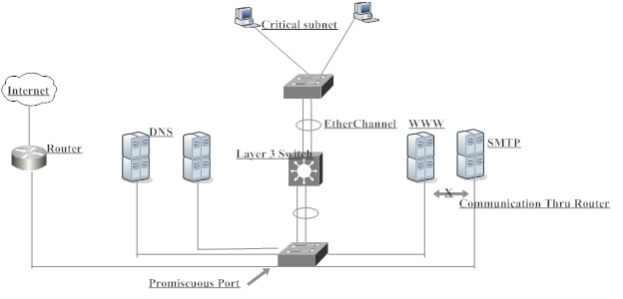

A corporation has two domain system servers (DNS), one web server, and SMTP server. All servers and their connecting routers are in the same subnet. A layer 3 switch is connected thru EtherChannel to another subnet.

The webserver and SMTP server are needed to communicate with Internet.

For security purposes, web access to SMTP and DNS servers are denied. The DNS servers should communicate only with each other and the Internet.

For this network, you are required to implement the following Layer 2 and Layer 3 services

Implement a switch to switch connectivity using Trunking and aggregating links
- Implement a PVLAN solution hosting DNS WWW and SMTP servers
- For security implement VACL and PACL in Critical Subnet
- Provide a verification plan for the above solution
- Implement a redundancy protocol

Provide a technical proposal that addresses all issues described above.

The proposal should contain:
- Cover page
- Table of Contents
- Executive summary
- Technical details (including any assumptions)
- Conclusion
- Reference page

Writing Instructions
Your paper must have a minimum of 5 pages and a maximum of 10 pages of text, excluding the required title page and bibliography, Index page, Reference page, and optional tables. Text must be Times New Roman, 12 font, 1" margin on all sides, and double spaced.

Students must follow "Publication Manual of the American Psychological Association, Fifth Edition (APA- 5)", also known as APA style or format. Only a Microsoft Word file will be accepted as the final submission; no HTML or PDF files allowed.

All sources must be properly cited and must be credible. At least two sources must be Internet sources (for help in evaluating the credibility of web sources, go to www.umuc.edu/library/guides/evaluate.shtml). Once you have completed a good draft, it is strongly advised that you submit it to UMUC's Effective Writing Center (EWC). In order to allow sufficient time for their review, you need to submit the draft to EWC two weeks prior to the paper's due date.

