Company Description
The main offering will be gelato, Italian ice cream, as well as additional dessert items that can be purchased in single servings for consumption at the restaurant located in Medford, Oregon.

While Medford does have several ice cream and frozen yogurt restaurants, it does not have any gelato focused restaurants (Yelp, n.d.). Gelato is like ice cream but has a couple differences that ultimately result in a cleaner or stronger flavor. First, gelato is made with more milk than cream allowing the flavor to not be muddied by the stronger flavor of cream. It is also turned at a slower speed than ice cream resulting in less air being mixed into the custard and a denser product overall (Poon, 2015).

Because of a stronger, denser, product people are able to enjoy a smaller helping, while still satisfying a sweet tooth (Bloom, 2016). By focusing on fresh, natural, locally-sourced products when possible, the gelato parlor will be able to distinguish itself from competitors and offer a compelling option for consumers who want to enjoy cold treats while also being mindful of their health.

Industry Analysis
Size and Maturity
In 2017, an estimated $14.8 billion will be spent on food in the semi-service industry. It currently accounts for 36% of the coffee and snack shop industry and the food segment has increased its share of the over $41.2 billion industry in the past five years as food has a higher margin (Alvaraz, 2017). Restaurants, bars, coffee shops, and other fast-casual dining choices currently employ in excess of 11 million employees. The industry is in track to surpass manufacturing employment by 2020 (Lee, 2016). The frozen-dessert industry is split into two main sectors: retail (grocery store) and restaurants. In 2016 it is estimated that the restaurant portion outpaced the retail by upwards of $3 million and both are expected to continue to see growth into 2020 (Prepared Foods, 2017).
Seasonality and Economic Cycle
While the general coffee and snack shop industry is not largely seasonal and volatility is very low (Alvaraz, 2017). The ice cream trade specifically is a very seasonal industry relying on weather. Most sales take place between March and September, with June being the strongest performing month (IDFA, 2015).

Sensitivity to the economic cycle is a concern as people tighten their discretionary spending during recessions or low ends of the cycle, they are less likely to eat out. However, in the operating conditions section, “volatility has decreased over the past five years as consumers have resumed normal spending habits” (Alvarez, 2017). Additionally, consumers attitudes towards eating out are not as closely tied to the economy as it once was. The current rebound from the recession is showing growth in most areas to be much slower than in past rebounds, however the restaurant sector has seen a much steadier growth (Lee, 2016).
Socio-cultural Concerns
Health concerns lead the reasons for cutting back on ice cream and frozen novelties. However, selling indulgence and organic and natural buzzwords continue to perform well (Bloom, 2016). Specifically, gelato seems to be performing well for those that are health conscious with a sweet tooth as it has 30% less fat and less air than the ice cream counterpart, packing a stronger flavor in a smaller package (Zhu, 2016). Additionally, the average consumer may not differentiate gelato from ice cream or frozen yogurt.
Economic Condition
With the passing of Senate Bill 1532 in 2016, the minimum wage in Oregon is now on a tiered system with annual increases in Jackson county to $13.50/hour by July 2022 (Theen, 2016).The restaurant industry is largely dependent on minimum wage workers and employs a higher percentage of minimum wage workers than any other industry (Maze, 2017). The effects of the higher minimum wage on Jackson counter are not yet known, but there have been mixed results in other cities like Seattle and San Francisco. While Seattle has not seen a large decrease in restaurants (Sherman, 2017), the San Francisco market has seen increases in restaurants closing as much as 14% in some sectors. While it is not solely a result of the increased minimum wage, for every $1 increase in minimum wage, the number of new restaurants falls by roughly 5% (Maze, 2017).

Target Market
Geographic area
The city of Medford has a population of 79,805 as of July 2015 and a land area of 25.73 miles (U.S. Census Bureau, 2016). The specific location being considered is at Roberts Road & Crater Lake Avenue and a three-mile radius around the address.
Target Customers
The target customers in this radius are those labelled as “Middleburg” (ESRI, 2017c), with a median age of 35.3 and income of $55,000. This falls nearly in the middle of the two groups above, so a target age group would consist of families, aged 25-44, accounting for 25.3% of households in the three-mile radius of the proposed location (ESRI, 2017a). A secondary target is students attending North Medford High School (NMHS) due to the proximity to the proposed location. NMHS has 1,750 enrolled students (Medford School District, 2017).

The ice cream market drivers are “premium” and “flavor,” while health plays a role for 19% of frozen treat buyers (Bloom, 2016). In other words, people are willing to spend more for a quality product in the name of indulgence. The Middleburg group generally spends their entertainment budget on family-oriented activities and restaurants (ESRI, 2017b). They also prefer to buy American when possible, and are comfortable with technology. This group makes up for 6.5%, or 1,759 households in the target area (ESRI, 2017c).

The Middleburg set prefers SUVs and trucks, enjoys country music, and likes to focus on family friendly television. This group can be young couples, but most likely has at least one child. They are generally conservative and a higher percentage are home-owners compared to the United States as a whole. They are thrifty, but are more willing to spend on activities they can do with the whole family rather than things (ESRI, 2017b).
Market Potential
Given the total sales of $860,000 (Bizminer, 2016), spread among five businesses, if things were split equally at 20% they would each have revenues of $172,000. This does include a business or two outside of Medford. Using a breakeven analysis tool, it is estimated that the business will need to have at least $60,000 in gross sales to stay profitable. Assuming an average sales price of $3, roughly 20,000 sales would need to be completed in the year to meet the above benchmark. Sales will be heavier in the summer months versus the cold season, however average sales per day would need to be 55. Considering the target customer, sales forecast would be for 50% in the Middleburg group, 15% students at NMHS, and 35% other.

For the Middleburg group explored above, that would require 10,000 sales. Assuming an average group of 3 people, that would be about 3,300 annual visits. Within a three-mile radius, there are an estimated 3,640 Middleburg adults (ESRI, 2017c). This requires less than 1 visit annually by each adult which is well within feasibility.

For the high school group, gross sales of $9,000 would be required. At $3 per sale, 3000 annual visits would be needed. This is less than 2 visits per student at the school. Assuming even half of students visit the shop, only 3 annual visits would be necessary.

The remaining $21,000 gross sales, or 7,000 individual sales will be made up of miscellaneous demographics in surrounding areas. Within the three-mile radius, there are an additional 48,625 adults. It should not be difficult to capture 7,000 sales from this population annually.

Competition Analysis
Primary and Secondary Competitors
Primary competitors comprise of businesses whose primary focus is cold desserts. In Medford, this includes Cold Stone Creamery, Baskin Robbins, 2 Yogurt Huts, Sweet Cream, and All-American Ice Cream & Frozen Yogurt. Secondary competitors include general dessert businesses, or fast-food restaurants that emphasize their dessert menu. This includes Dairy Queen, Sonic, The Cupcake Company and Cookie Connection in Medford. See a more detailed breakdown of the competitors in Appendix A. External competition also includes full-service restaurants that offer a more friendly dining experience or consumers deciding to make the product at home (Alvaraz, 2017).
Competitive Strength Assessment
A table breaking down multiple success factors amount competition is located in Appendix B.

Much of these ratings were arrived upon by reading customer ratings on Yelp (2017) and their feelings about the product. For manufacturing, businesses that sold by the pint, gallon, or sold additional options (i.e. ice cream cakes) were given a higher rating than those that just sold the basics. This was also applied to new product innovation as there is not much differentiation in the market among the businesses from the consumer’s eye. All the businesses have websites, take credit cards, and utilize a Facebook account apart from Cookie Connection and All American Ice Cream. Many of these businesses are franchises of larger national corporations and their pages are monitored and run by the corporation and not the local stores. Virtually all these companies are local franchises or small businesses and thus their financials were not available so an educated guess was used.

The closest companies to the proposed gelataria on the assessment are Cold Stone Creamery and Sweet Cream. Sweet Cream’s downside is that it is not open on the weekends or for full evening business hours like most competitors. Both companies have a strong emphasis on fresh ice cream with both making their ice cream on premises (Cold Stone Creamery, 2017; Sweet Cream, n.d.). In order to compete with them, marketing must focus on making the product on site, focusing on local and fresh ingredients whenever possible, and having regular business hours. Sweet Cream especially had a strong rating from consumers regarding customer service, so focusing on making sure consumers walk away happy with the service they receive is paramount. Continuing to try new flavors is also important to keep customers interested, so a base set of flavors with several rotating options may be the way to go.
Barriers to Entry
In this industry, the barrier to entry is quite low as one can rent equipment, storefront, and furniture leading to a low start-up cost however they are increasing (Alvaraz, 2017). However, due to the lack of differentiation between frozen treat options, that doesn’t mean it would be simple to pull away market share from existing companies. Therefore, a strong marketing and social media plan is necessary to get consumers interested in a new frozen treat option. Focusing on words like “indulgence,” “premium” and “natural” sway consumers towards well-performing brands (Bloom, 2016).

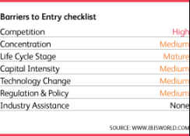

Regarding the chart above (Alvaraz, 2017), competition is by far the highest barrier to entry as companies just starting out are trying to get a piece of the pie that has already been given to the other companies. Roughly half of new businesses in this industry are sold within the first three years (Alvaraz, 2017).

Competitors are able to add products to their line-up to widen their pull. For example, Baskin Robbins already carries frozen yogurt, sorbet, and low-fat ice cream options in addition to the usual ice cream options (Baskin Robbins, n.d.). They can also experiment with new fads like rolled custard (Krader, 2016) to get the consumer’s attention. Since several of the competitors are franchises of large corporations, they have the benefit of research divisions to come up with new, exciting flavors which is another area consumers are interested in (Bloom, 2016).
The proposed company will not have the benefit of large research divisions, but being a new company has the opportunity to hit the market with both long-time favorites like chocolate, vanilla, and strawberry, while leaving room on the menu for some food trends like lavender lemonade. In order to enter the market, a business will need to get necessary restaurant and business licenses, secure a location and purchase equipment with the most cost prohibitive being an industrial gelato machine, along with other kitchen equipment and furniture for the parlor. A significant cash investment or the ability to secure a start-up loan to help finance getting the business open.

Appendix A – Market Competition
Below is a list of all primary and secondary competitors in Medford. Due to the short lifespan of ice cream, businesses in surrounding cities have not been included. Additionally, average ratings between 1 and 5 have been included from Yelp (n.d.) along with how many reviews are averaged to come up with that rating.
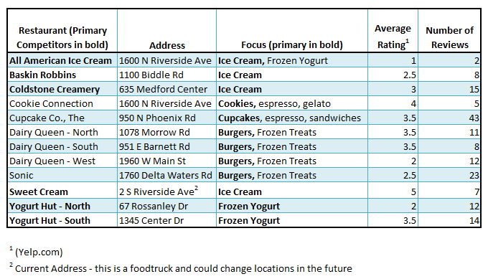
Summary
Highest rated companies include Sweet Cream and Cookie Connection, while All American Ice Cream and the north Medford location of Yogurt Hut with low scores (Yelp, n.d.). In general, local companies garnered more favorable reviews while franchises suffered from a higher quota of negative reviews.

Below is a map with the 12 local competitors pinpointed to show concentration of businesses (Google, 2017).
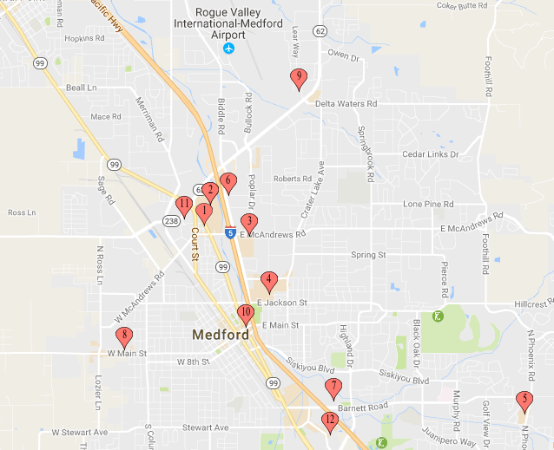

1 – All American
2 – Cookie Connection
3 – Baskin Robbins
4 – Cold Stone Creamery
5 – The Cupcake Co.
6 – Dairy Queen
7 – Dairy Queen
8 – Dairy Queen
9 – Sonic
10 – Sweet Cream
11 – Yogurt Hut
12 – Yogurt Hut

Summary
There is a high level of saturation in the area surrounding the mall. Other locations are more spread out. One location to consider may be the Crater Lake Ave & Roberts Rd area as there is a large residential area nearby (east of the location) that could be better served by a business in closer proximity for convenience to residents.

Appendix B – Competitive Strength Matrix
Introduction
In the following tables, the proposed business is compared to the 9 competitors identified above. Multiple locations of the same business have been consolidated into one column.

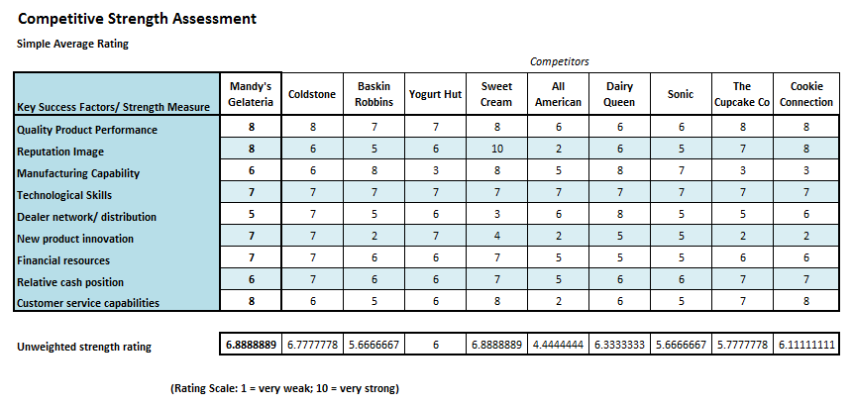
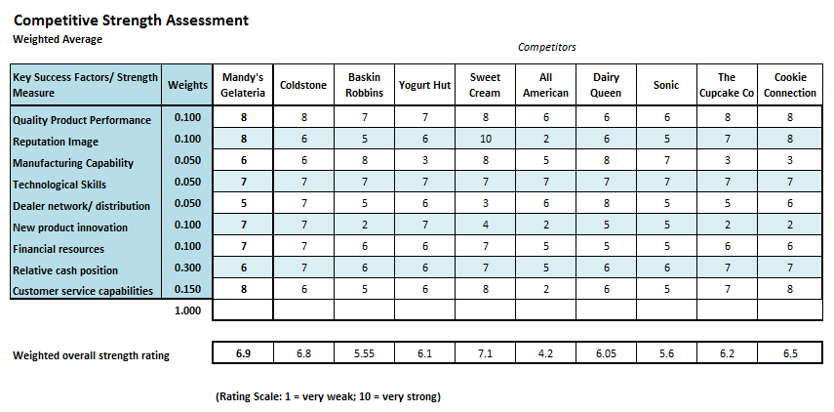

References
Alvaraz, A. (2017, February). IBISWorld industry report 72221b: Coffee & snack shops in the US. Retrieved from IBISWorld: http://clients1.ibisworld.com.glacier.sou.edu/reports/us/industry/default.aspx?entid=1973
Baskin Robbins. (n.d.). Ice Cream Flavors. Retrieved from Baskin Robbins: https://www.baskinrobbins.com/content/baskinrobbins/en/products/icecream/flavors.html
Bizminer. (2016, November). Industry market research by zip codes; [722515.03] Ice cream parlors; Sector: Accommodation-food services. Retrieved from Bizminer.
Bloom, B. (2016, July). Ice cream and frozen novelties - US. Retrieved from Mintel.
ESRI. (2017a). Demographic and income comparison profile: 2049 Roberts Rd, Medford, OR 97504. Retrieved from Business Analyst Online Database: https://bao.arcgis.com/esriBAO/index.html?portal=sou.maps.arcgis.com#
ESRI. (2017b). LifeMode group: Family Landscapes: Middleburg. Retrieved from Business Online Analyst Database: https://bao.arcgis.com/esriBAO/index.html?portal=sou.maps.arcgis.com#
ESRI. (2017c). Tapestry segmentation area profile: 2049 Roberts Rd, Medford, OR, 97504. Retrieved from Business Analyst Online Database: https://bao.arcgis.com/esriBAO/index.html?portal=sou.maps.arcgis.com#
IDFA. (2015). Ice cream sales & trends. Retrieved from International Dairy Foods Association: http://www.idfa.org/news-views/media-kits/ice-cream/ice-cream-sales-trends
Krader, K. (2016, August 31). Is 2016 the most important year for ice cream ever? Retrieved from Bloomberg.
Lee, D. (2016, February 17). Restaurants are booming despite financial market turmoil. LA Times. Retrieved from http://www.latimes.com/business/la-fi-restaurants-boom-20160217-story.html
Maze, J. (2017, April 20). Higher minimum wages lead more restaurant failures. Retrieved from Nation's Restaurant News: http://www.nrn.com/workforce/higher-minimum-wages-lead-more-restaurant-failures
Medford School District. (2017). North Medford High. Retrieved from Medford School District: www.medford.k12.or.us/domain/251
Poon, L. (2015, June 16). Why scream for gelato instead of ice cream? Here's the scoop. Retrieved from NPR: http://www.npr.org/sections/thesalt/2015/06/16/413223571/why-scream-for-gelato-instead-of-ice-cream-heres-the-scoop
Prepared Foods. (2017, February 7). ‘Free from’ ice cream trends in $28 billion market. NUTRA Solutions. Retrieved from http://www.preparedfoods.com/articles/119376-free-from-ice-cream-trends-in-28-billion-market
Sherman, E. (2017, January 7). Higher Seattle minimum wage hasn't hurt restaurant jobs growth after a year. Retrieved from Forbes: https://www.forbes.com/sites/eriksherman/2017/01/07/seattle-restaurant-jobs-keep-growing-with-higher-minimum-wages-after-a-year/#73e1cb5d3579
Theen, A. (2016, June 5). 6 things to know about Oregon's new minimum wage law. Retrieved from Oregon.gov: http://www.oregonlive.com/education/index.ssf/2016/06/5_things_to_know_about_oregons.html
U.S. Census Bureau. (2016). QuickFacts: Medford city, Oregon. Retrieved from U.S. Census Bureau: https://www.census.gov/quickfacts/table/PST045216/4147000,00
Yelp. (n.d.). Retrieved from Yelp: http://www.yelp.com
Zhu, Y. (2016, August 12). Amid gelato boom, the hottest thing in ice cream is Talenti. Retrieved from Forbes: https://www.forbes.com/sites/yehongzhu/2016/08/12/amid-gelato-boom-the-hottest-thing-in-ice-cream-is-talenti/#2bf4d9d4156a

