SURRENDERING INFORMATION THROUGH THE LOOKING GLASS:
TRANSPARENCY, TRUST, AND PROTECTION

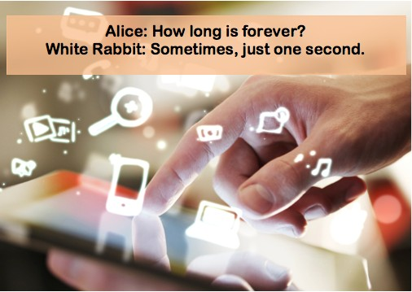Kristen Walker, Ph.D.
PROFESSOR OF MARKETING CALIFORNIA STATE UNIVERSITY NORTHRIDGE

OVERVIEW

- Last slides
  - Consumerism
  - Privacy Policies; System 1 and System 2
  - Information as a resource

- Today
  - Information as a resource (food)
    - Types of Information
  - Surrendering vs Sharing information

  - Coming up
    - Protection FROM what/whom BY whom/what
    - Legal and policy ramifications for information

Thank you for using www.freepdfconvert.com service!

Only two pages are converted. Please Sign Up to convert all pages. https://www.freepdfconvert.com/membership

